
THE ANGLICAN PARISH OF ST. MARK
138 Hoylake Road, Qualicum Beach, BC V9K 1K3
The Reverend Diana Boland
Twenty-fourth Sunday after Pentecost, 10:00 am, Nov. 8, 2026
HOLY EUCHARIST — Book of Alternative Services
In a state of openness, and with a desire to learn the truth of our shared history, we acknowledge that we worship on the unceded territory of the Qualicum First Nation. We give thanks for their careful stewardship of the forests, rivers, oceans, lands and air, so that we might walk with them and celebrate the gift of the Creator. We commit to a lifelong journey of respectful understanding.

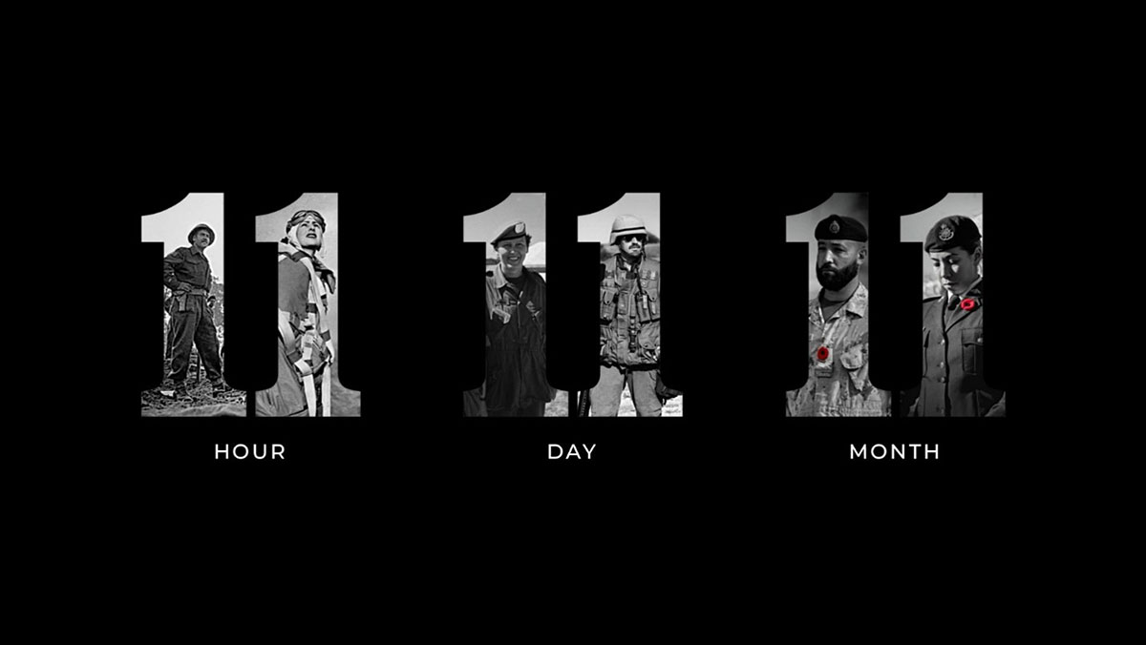
Welcome & Announcements
Reading of “In Flanders Fields” By John McCrae
In Flanders fields the poppies blow
Between the crosses, row on row,
That mark our place; and in the sky
The larks, still bravely singing, fly
Scarce heard amid the guns below.

We are the Dead. Short days ago
We lived, felt dawn, saw sunset glow,
Loved and were loved, and now we lie,
In Flanders fields.
Take up our quarrel with the foe:
To you from failing hands we throw
The torch; be yours to hold it high.
If ye break faith with us who die
We shall not sleep, though poppies grow
In Flanders fields.
“GOD SAVE OUR GRACIOUS KING”
Opening Hymn: CP #576 “For the Healing of the Nations”
Celebrant: The grace of our Lord Jesus Christ, and the love of God, and the fellowship of the Holy Spirit, be with you all.
People: And also with you.
People: Almighty God, to you all hearts are open, all desires known, and from you no secrets are hidden.
Cleanse the thoughts of our hearts by the inspiration of your Holy Spirit, that we may perfectly love you, and worthily magnify your holy name; through Christ our Lord. Amen.
Collect of the Day (together): page 391
Eternal God, who caused all holy scriptures
to be written for our learning, grant us so to hear them,
read, mark, learn, and inwardly digest them,
that we may embrace and ever hold fast
the blessed hope of everlasting life,
which you have given us in our Saviour Jesus Christ,
who lives and reigns with you and the Holy Spirit,
one God, for ever and ever.
The Proclamation of the Word
First Reading: Wisdom of Solomon 6:12-16
Psalm 116:1–8 page 864
Second Reading: 1 Peter 1: 3-9
Gradual Hymn: CP #481 “May the Grace of Christ our Saviour” (vv. 1)
Reader: The Lord be with you
People: And also with you
Reader: The Holy Gospel of our Lord, Jesus Christ, according to John
People: Glory to you Lord Jesus Christ
The Gospel: JOHN 11:21-27
Martha said to Jesus, ‘Lord, if you had been here, my brother would not have died. But even now I know that God will give you whatever you ask of him.’ Jesus said to her, ‘Your brother will rise again.’ Martha said to him, ‘I know that he will rise again in the resurrection on the last day.’
Jesus said to her, ‘I am the resurrection and the life. Those who believe in me, even though they die, will live, and everyone who lives and believes in me will never die. Do you believe this?’ She said to him, ‘Yes, Lord, I believe that you are the Messiah, the Son of God, the one coming into the world.’
Reader: This is the Gospel of Christ;
People: Praise to you Lord Jesus Christ
Gradual Hymn: CP #481 “May the Grace of Christ our Saviour” (vv. 2-3)
Sermon: The Rev. Diana Boland
Anthem: “God! As with Silent Hearts Words”
Music by Ron Klusmeier; Words by Fred Kaan
God! As with silent hearts we bring to mind
how hate and war diminish humankind.
We pause and seek in worship to increase
our knowledge of the things that make for peace.
Hallow our will as humbly we recall
the lives of those who gave and give their all.
We thank you, God, for women, children, men
who seek to serve in love today as then.
Give us deep faith to comfort those who mourn,
high hope to share with all the newly born,
strong love in our pursuit of human worth,
“lest we forget” the future of this earth.
So, Prince of Peace, disarm our trust in power,
teach us to coax the plant of peace to flower.
May we, impassioned by your living word,
remember forward to a world restored.
Prayers of the People
Celebrant : Dear friends in Christ, God is steadfast in love and infinite in mercy; he welcomes sinners and invites them to his table.
Let us confess our sins, confident in God’s forgiveness.
Silence is kept.

Celebrant: Most merciful God,
All we confess that we have sinned against you in thought, word and deed, by what we have done, and by what we have left undone.
We have not loved you with our whole heart; we have not loved our neighbours as ourselves. We are truly sorry and we humbly repent.
For the sake of your Son Jesus Christ, have mercy on us and forgive us, that we may delight in your will, and walk in your ways,
to the glory of your name. Amen.
Celebrant Almighty God have mercy upon you, pardon and deliver you from all your sins, confirm and strengthen you in all goodness, and keep you in eternal life; through Jesus Christ our Lord.
People: Amen.
Celebrant: The peace of the Lord be always with you.
People: And also with you.
Offertory Hymn: CP #56 “I am the Bread, the Bread of Life”
The Celebration of the Eucharist
Prayer over the Gifts:
Gracious God, your word to us is food indeed. Receive all we offer you this day, and let your loving-kindness be our comfort, for the sake of Jesus Christ, your living Word.
Celebrant: May God be with you.
All: And also with you.
Celebrant: Lift up your hearts.
All: We lift them to the Holy One.
Celebrant: Let us give thanks to our loving God.
All: It is right to offer thanks and praise.
Celebrant: Blessed are you, gracious God, creator of heaven and earth; we give you thanks and praise through Jesus Christ our Lord. In fulfilment of your promise you pour forth your Spirit upon us, filling us with gifts and leading us into all truth. You give us power to proclaim your gospel to all nations and to serve you as a royal priesthood. Therefore we join our voices with angels and archangels, and with all those in whom the spirit dwells, to proclaim the glory of your name.
Sanctus (Holy, Holy) — (sung — music CP #719)
Celebrant: We give thanks to you, Lord our God, for the goodness and love you have made known to us in creation; in calling Israel to be your people; in your Word made flesh, Jesus your Son.
For in these last days you sent him to be incarnate from the Virgin Mary, to be the Saviour and Redeemer of the world. In him, you have delivered us from evil, and made us worthy to stand before you. In him, you have brought us out of error into truth, out of sin into righteousness, out of death into life.
On the night he was handed over to suffering and death, a death he freely accepted, our Lord Jesus Christ took bread; and when he had given thanks to you, he broke it, and gave it to his disciples, and said, “Take, eat; this is my body which is given for you. Do this for the remembrance of me.”
After supper he took the cup of wine; and when he had given thanks, he gave it to them, and said, “Drink this, all of you: this is my blood of the new covenant, which is shed for you and for many for the forgiveness of sins. Whenever you drink it, do this for the remembrance of me.”
Therefore, Loving God, according to his command,
All We remember his death,
we proclaim his resurrection,
we await his coming in glory;
Celebrant: and we offer our sacrifice of praise and thanksgiving to you, Lord of all; presenting to you, from your creation, this bread and this wine.
We pray you, gracious God, to send your Holy Spirit upon these gifts, that
they may be the sacrament of the body of Christ and his blood of the new covenant. Unite us to your Son in his sacrifice, that we, made acceptable in him, may be sanctified by the Holy Spirit.
In the fullness of time, reconcile all things in Christ, and make them new, and bring us to that city of light where you dwell with all your sons and
daughters; through Jesus Christ our Lord, the firstborn of all creation, the head of the Church, and the author of our salvation;
By whom, and with whom, and in whom, in the unity of the Holy Spirit, all honor and glory are yours, almighty Father, now and forever. Amen.
The Lord’s Prayer – (sung)
Celebrant: “I am the bread of life’” says the Lord. “Whoever comes to me will never be hungry; whoever believes in me will never thirst.”
All: Taste and see that the Lord is good; happy are they who trust in him!
Leader: The gifts of God for the People of God.
People: Thanks be to God.
Our Prayer Ministry
Our healing prayer team invites you to join them to pray or give thanks to God in the narthex (entrance) during or after communion, or in the alcove under the Exit sign after the service. Confidentiality is assured.

Post Communion Hymn: CP #572 “Let There Be Light”
- Let there be light,
let there be understanding,
let all the nations gather,
let them be face to face.
- Open our lips,
open our minds to ponder,
open the door of concord
opening into grace.
- hallow our love,
hallow the deaths of martyrs,
hallow their holy freedom,
hallowed by thy name;
- thy kingdom come,
thy spirit turn to language,
thy people speak together,
thy spirit never fade;
- Let there be light,
open our hearts to wonder,
perish the way of terror,
hallow the world God made.
ACT OF REMEMBRANCE
“The Last Post” David Bamford
Silence
“Reveille” David Bamford
Officiant: Let us remember and commend to sure keeping, those who have died for their country in war and in the cause of peace; those whom we knew, and those whose memory we treasure; and all who have lived and died in the service of others.
They shall not grow old as we that are left grow old; age shall not weary them, nor the years condemn. At the going down of the sun and in the morning, we will remember them.
All: We will remember them.
Officiant: Almighty and eternal God, from whose love in Christ we cannot be parted, either by death or life; Hear our prayers and thanksgiving for all whom we remember this day; fulfil in them the purpose of your love; and bring us all, with them, to your eternal joy; through Jesus Christ our Lord. Amen.
THE NATIONAL ANTHEM – “O Canada”
ACT OF COMMITMENT
All: Lord God our heavenly Creator,
We pledge ourselves to serve you and all people,
in the cause of peace, for the relief of suffering,
and for the praise of your name.
Guide us by your Spirit; give us wisdom;
give us courage; give us hope;
and keep us faithful now and always. Amen

People Living God, in the eucharist you fill us with new hope. May the power of your love, which we have known in word and sacrament, continue your saving work among us, and bring us to the joy you promise. We ask this in the name of Jesus Christ our Lord. Amen.
Celebrant Glory to God.
All whose power, working in us, can do infinitely more than we can ask or imagine. Glory to God from generation to generation, in the Church and in Christ Jesus, for ever and ever. Amen.
Final Blessing
Recessional Hymn: CP #529 “God my Help on You is Founded”
Celebrant Go in peace to love and serve the Lord.
People Thanks be to God
ALTAR FLOWERS
The flowers on the altar are given by Kate Knappett.
In remembrance, Lest we Forget.

EMERGENCY CONTACTS FOR PASTORAL CARE
Cynthia Preyser: 250-954-9122

ANNOUNCEMENTS
Welcome to St. Mark’s this morning, especially any who are visiting. Join us for coffee and conversation in the hall following the service. Everyone is welcome!!
Hope you had fun at our Pub Night last evening! Many thanks go to Lally Grauer, Michael King, Dave Hitchcock, John Smith, Cynthia Preyser, Jennifer and Terry Roberts, Wendy Carriere and Ryan Geboers for their efforts in making the evening a success.
The Memorial Service and reception for Nina Antoniuk will take place on Saturday, November 21. Please join her family in honouring Nina.
All are invited to the St. Mark’s Men’s Club meeting on Thursday, November 26, beginning at 9:30 to hear Corey Jefferies, a clinical pharmacologist, speak on the latest vaccine recommendations in BC. He will review both older and newer vaccines. Coffee and goodies will be available.
Thank you to all for your generous response to the SOCKTOBER challenge! And thanks go also to Bob Goos who spearheaded the efforts! We are happy to report 191 pairs of new socks (as well as a few used socks) were collected at St. Mark’s! Including the socks collected in the community, we have been able to make 638 pairs a new pairs of socks and 17 pairs of gloves available to the Manna Homeless Society for distribution in Oceanside to those living rough during the wet & cold winter months when St. Mark's serves the Manna lunch on November 14th. We also collected 36 pairs of lightly used socks that will go to a different agency. Thank you and God Bless the people of St. Mark's for their generosity. BE assured that these socks will make a difference for our vulnerable neighbours during the coming winter.

The 2026 Christmas Bazaar is fast approaching
Saturday, November 28, 9am-12:00pm
The next rainy day, put on the Christmas music and get in the kitchen! We are particularly looking for donations of Christmas cakes and puddings, mincemeat or mincemeat tarts (fruit based, without suet), shortbread, Almond Roca, Fudge and candy, Christmas cookies and gingerbread.
The Café is looking for muffins and scones.
Any questions? Speak to Caroline Adam or Louise Kelsey.

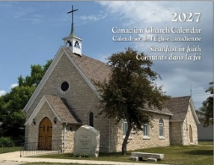
CHURCH CALENDARS FOR 2027 are now available for purchase ($10) at the church office (Tues. – Thurs.).

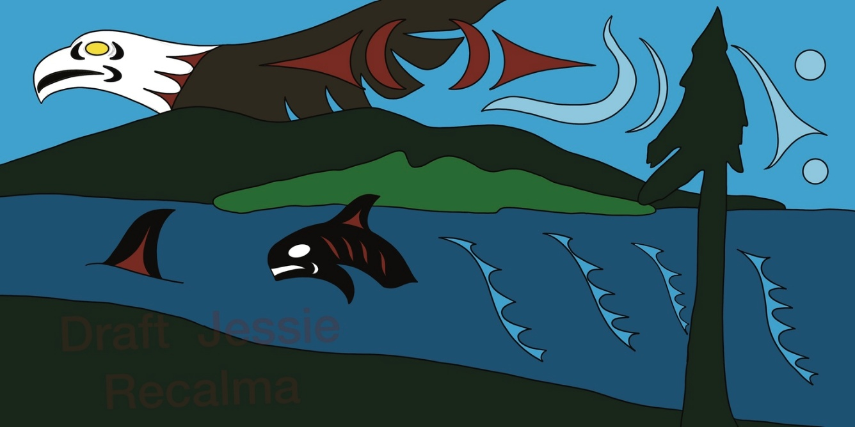

The CENTENNIAL WINDOW campaign continues. Thanks to your support, total revenue to date is $13,320, realized from donations and concert fundraising. Envelopes are available in the office or at the back of the church at the back of the church for tax-deductible contributions. Please make cheques payable to St. Mark’s Anglican Church with “Centennial Window” on the memo line. Include either your offering envelope number or mailing address.
Please keep in mind that our coffee fund is facing a financial deficit. If you are able, please put in a little extra each week to try to get us into a breakeven position.

Advanced Notice
February 12 and 13, 2027. 7:30pm. at Christ Church Cathedral, Victoria
Anna Lapwood, the official organist at the Royal Albert Hall in London, is coming to perform on the Hellmuth Wolff organ at Christ Church Cathedral. Tickets $70 on eventbrite.ca.

CALENDAR: NOVEMBER 9 – NOVEMBER 15

Tuesday, November 10
9:15 – 11:00 am — Men’s Study Group
9:00 am – 3:00 pm — Seaside Quilters
4:00 – 5:00 pm — Handbells

Wednesday, November 11
R
10:00 – 11:00 am — Sermon Circle
11:30 am – 12:00 pm — BAS Holy Eucharist
12:30 – 2:30 pm — The Chosen
5:30 pm — NAC (downstairs)

Thursday, November 12
9:00 am – 12:00 pm — Holly Roller Pie Makers
11:15 am — Choir Practice
12:30 – 4:00 pm — MIFAC

Friday, November 13
10:00 am – 1:00 pm — Jenny Vincent Practice
1:30 – 3:00 pm — Outreach
4:00 pm — Manna preparation

Saturday, November 14
9:00 am – 4:00 pm — Parksville Quilters’ Guild Workshop

Sunday, November 15
8:30 am — BCP — Holy Eucharist with Rev. Kirsten Evenden
10:00 am — BAS — Holy Eucharist with Rev. Kirsten Evenden

