Parkside Lutheran Church
Rediscovering the Radical Love of Jesus
Gathering All
Serving All
Caring For All

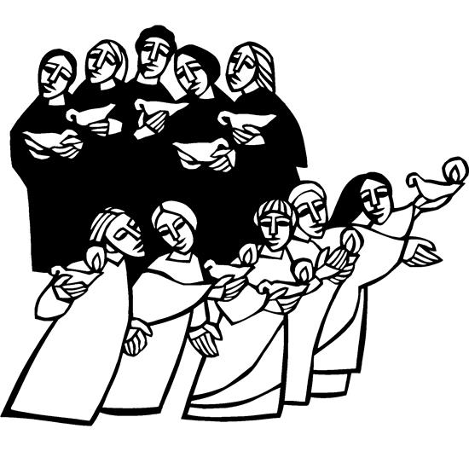

November 8th, 2026
Time after Pentecost
Holy Communion 10:00am
The Rev. Jeremiah Smith
Parkside Lutheran Values

Proclaiming Grace - Jesus shared and lived out a message of grace, love, and new life. We believe these promises come from God freely, as a gift for all. We are loved and the Spirit inspires us to share this good news in accessible, relevant, and new ways. Luke 4:17-19, John 1:16-17, John 3:16-17, Ephesians 2:8-9

Practicing Hospitality – Jesus welcomed the little children, broke bread with outcasts, and proclaimed the Good News to all. Whether you are strong in faith, wrestling with doubt, or somewhere in between, we affirm that you are welcome here. Jesus is for everyone. Leviticus 19:34, Matthew 9:10, Matthew 19:14, Hebrews 13:2

Loving Boldly - Jesus challenged traditions to demonstrate God’s justice and love of neighbor. His compassionate and sacrificial love inspires us to take risks. Striving to follow his command to love neighbor, our ministries serve, transform, and advocate for folks near and far. Micah 6:8, Mark 11:15-17, Luke 10:25-28, John 15:12-13

Cultivating Community - Jesus built communities that transformed lives. We are the body of Christ and we are called to continue this ministry of transformation. Guided by the Holy Spirit, we build connections within and outside of these walls, and with all of God’s creation. Ecclesiastes 4:9-12, Matthew 28:16-20, 1 Corinthians 12:12-14, Galatians 3:26-29

Welcome Visitors!
Please use QR code to let us know you were here today or to sign up for our weekly enewsletter. Find us on Facebook & Instagram
WIFI: Balcony password: FreeGrace

For your safety in the event of an emergency: In addition to the three exits in the back of the sanctuary, there are exits on either side of the altar (on left side: floor level near piano and up steps past altar. On right side: up steps to the altar, past band area)

Contact us: (716) 836-1361
2 Wallace Ave. Buffalo, NY 14214
parksidelutheran.org | parksidelutheran@gmail.com

GATHER
The Holy Spirit calls us together as the people of God.
Introduction to the Day: Today the prophet Amos calls for justice to roll down like waters. Paul urges us to encourage one another with the promised coming of the Lord. Jesus tells the parable of the wise and foolish bridesmaids. Surrounded by the faithful of every time and place, we celebrate Christ’s coming in our midst in the word of life and the feast of victory—the marriage feast of the lamb.

Prelude Michael Hooker, Music Director

Please stand as you are able

Call to Worship
WA: Are you awake? Are you alert?
C: Christ is coming into our lives in a new way.
WA: Are you watching the signs? Are you interpreting what is happening today?
C: Christ is coming into our lives in a new way.
WA: Do you see opportunities for ministry? Do you see the poor, the homeless, the hungry, the needy?
C: Christ is coming into our lives in a new way.
WA: Come, let us worship and let us work in the reign of God.
C: Christ has extended the invitation: let us work together in the reign of God on earth.

+Gathering Hymn: My Lord, What a Morning ELW #438
(printed next page)

Welcome and Announcements

+Confession and Forgiveness
P: Blessed be the holy Trinity, ☩ one God, our dwelling place for all generations, whose compassion never slumbers. C: Amen.
P: Let us confess our sin in the presence of God and of one another.
(a brief silence)
P: Holy God,
C: we confess that we have trusted in our preparation instead of your invitation. We prioritize our piety over care for your beloved. We trust the voice of our shame and fear, which keeps us from entering fully into relationship with you and others. We are not awake to the coming of your reign. Rouse us and rescue us, that we may enter into your joy. Amen.
P: Inherit the riches of God’s grace. ☩ Jesus, the good shepherd, feeds you with his mercy. You are forgiven. Blessed are you. C: Amen.

Greeting
WA: The grace of our Lord, Jesus Christ, the love of God, and the communion of the Holy Spirit be with you all. C: And also with you.

This is the Feast Setting 4 (p. 149)
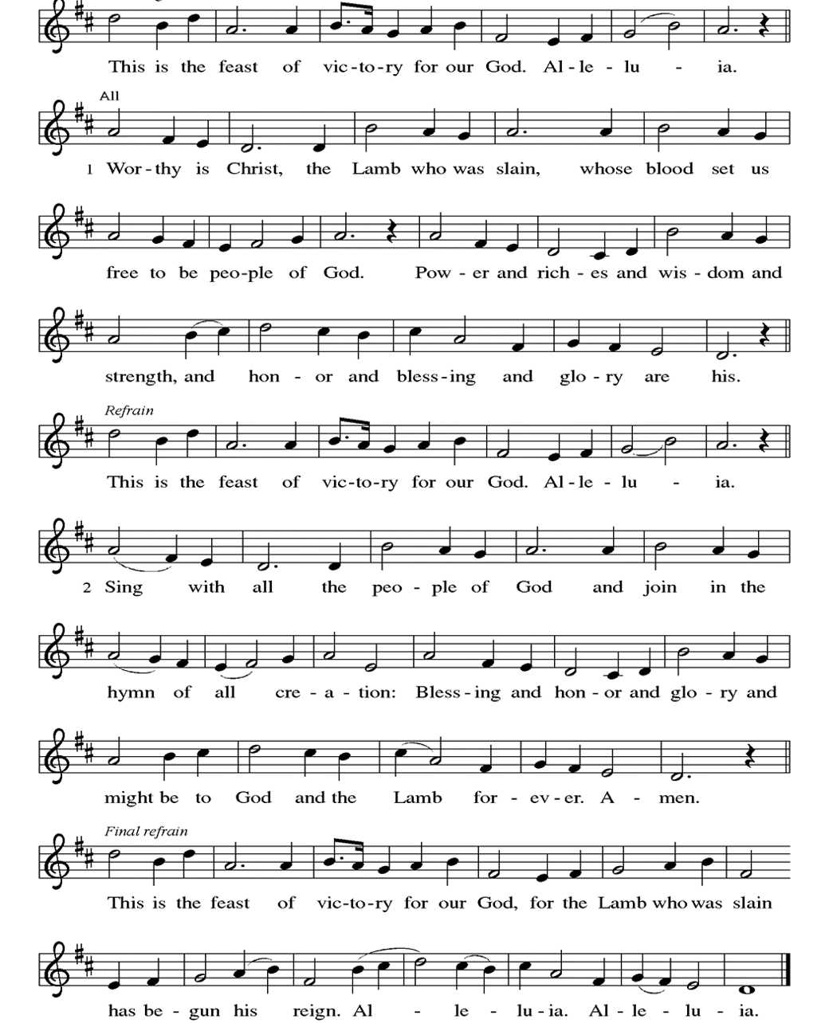

Prayer of the Day
WA: Let us pray together.
C: O God of justice and love, you illumine our way through life with the words of your Son. Give us the light we need, and awaken us to the needs of others, through Jesus Christ, our Savior and Lord. Amen.

Children’s Sermon: Jesus said, “Let the little children come to me!”
We welcome children in worship.

WORD
God speaks to us in scripture readings, preaching and song.

First Reading: Amos 5:18-24
In the days of Amos, people thought that the day of the Lord would be a time of great victory, but Amos announced that it would be a day of darkness, not light. He said liturgy is no substitute for obedience. The Lord demands justice and righteousness in the community.
L: ¹⁸ Woe to you who desire the day of the Lord! Why do you want the day of the Lord? It is darkness, not light, ¹⁹ as if someone fled from a lion and was met by a bear or went into the house and rested a hand against the wall and was bitten by a snake. ²⁰ Is not the day of the Lord darkness, not light, and gloom with no brightness in it?
²¹ I hate, I despise your festivals, and I take no delight in your solemn assemblies. ²² Even though you offer me your burnt offerings and grain offerings, I will not accept them, and the offerings of well-being of your fatted animals I will not look upon. ²³ Take away from me the noise of your songs; I will not listen to the melody of your harps. ²⁴ But let justice roll down like water and righteousness like an ever-flowing stream.
L: Word of God, word of life. C: Thanks be to God.

Psalm: Psalm 70 You are my helper and my deliverer, O Lord. Do not tarry. (Ps. 70:7)
L: ¹ Be pleased, O God, to deliver me; O Lord, make haste to help me.
C: ² Let those who seek my life be put to shame and confounded;
let those who take pleasure in my misfortune draw back and be disgraced.
L: ³ Let those who say to me “Aha!” and gloat over me
turn back because of their shame.
C: ⁴ Let all who seek you rejoice and be glad in you;
let those who love your salvation say forever, “Great is the Lord!”
L: ⁵ But as for me, I am poor and needy; come to me quickly, O God.
You are my helper and my deliverer; O Lord, do not tarry.
L: Word of God, word of life. C: Thanks be to God.

Second Reading: 1 Thessalonians 4:13-18
Some of the Thessalonians are worried that dead Christians will be excluded from the resurrection to eternal life when Christ comes again. Paul reassures them with the word of hope that all Christians, living or dead, will be raised into everlasting life with Christ.
L: ¹³ We do not want you to be uninformed, brothers and sisters, about those who have died, so that you may not grieve as others do who have no hope. ¹⁴ For since we believe that Jesus died and rose again, even so, through Jesus, God will bring with him those who have died. ¹⁵ For this we declare to you by the word of the Lord, that we who are alive, who are left until the coming of the Lord, will by no means precede those who have died. ¹⁶ For the Lord himself, with a cry of command, with the archangel’s call and with the sound of God’s trumpet, will descend from heaven, and the dead in Christ will rise first. ¹⁷ Then we who are alive, who are left, will be caught up in the clouds together with them to meet the Lord in the air, and so we will be with the Lord forever. ¹⁸ Therefore encourage one another with these words.
L: Word of God, word of life. C: Thanks be to God.

Please stand as you are able

Gospel Acclamation Setting 4 (p. 151)
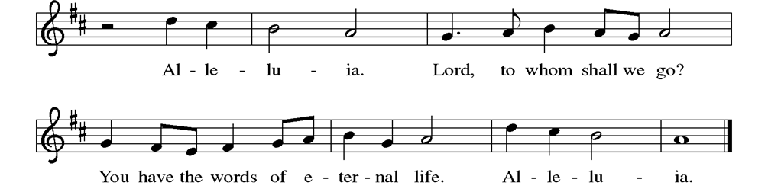

Gospel Reading: Matthew 25:1-13
Jesus tells a parable about his own second coming, emphasizing the need for readiness at all times.
P: The Holy Gospel according to Matthew. C: Glory to you, O Lord.
P: [Jesus said to the disciples:] ¹ “Then the kingdom of heaven will be like this. Ten young women took their lamps and went to meet the bridegroom. ² Five of them were foolish, and five were wise. ³ When the foolish took their lamps, they took no oil with them, ⁴ but the wise took flasks of oil with their lamps. ⁵ As the bridegroom was delayed, all of them became drowsy and slept. ⁶ But at midnight there was a shout, ‘Look! Here is the bridegroom! Come out to meet him.’ ⁷ Then all those young women got up and trimmed their lamps. ⁸ The foolish said to the wise, ‘Give us some of your oil, for our lamps are going out.’ ⁹ But the wise replied, ‘No! there will not be enough for you and for us; you had better go to the dealers and buy some for yourselves.’ ¹⁰ And while they went to buy it, the bridegroom came, and those who were ready went with him into the wedding banquet, and the door was shut. ¹¹ Later the other young women came also, saying, ‘Lord, lord, open to us.’ ¹² But he replied, ‘Truly I tell you, I do not know you.’ ¹³ Keep awake, therefore, for you know neither the day nor the hour.”
P: The Gospel of the Lord. C: Praise to you, O Christ.

Sermon The Rev. Jeremiah Smith

Please stand as you are able

+Hymn of the Day: Keep Your Lamps Trimmed and burning ACS #949
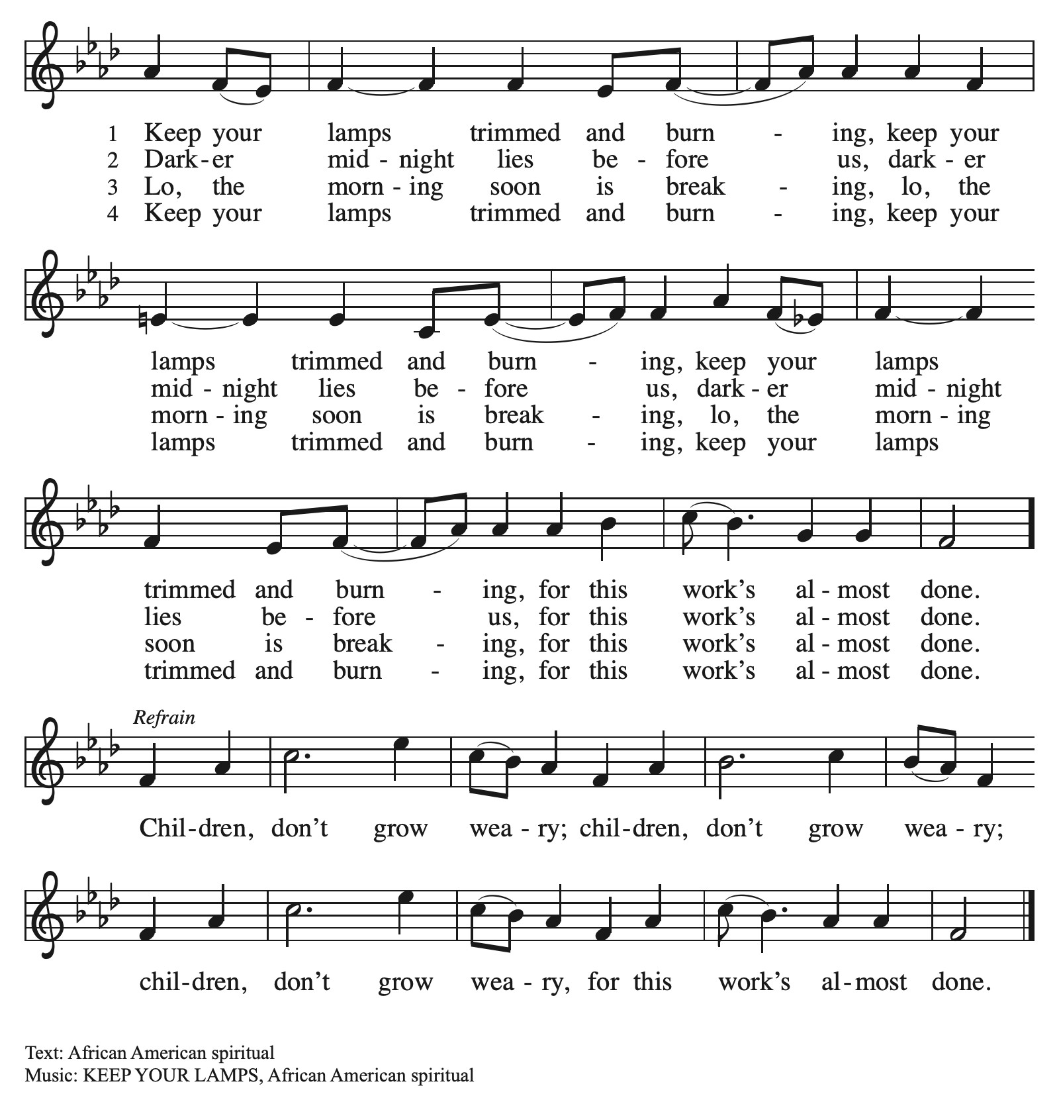

Apostles’ Creed
WA: Let us confess the faith using the words of the Apostles’ Creed.
C: I believe in God, the Father almighty, creator of heaven and earth.
I believe in Jesus Christ, God’s only Son, our Lord, who was conceived by the Holy Spirit, born of the virgin Mary, suffered under Pontius Pilate, was crucified, died, and was buried; he descended to the dead. On the third day he rose again; he ascended into heaven, he is seated at the right hand of the Father, and he will come to judge the living and the dead.
I believe in the Holy Spirit, the holy catholic church, the communion of saints, the forgiveness of sins, the resurrection of the body, and the life everlasting. Amen.

Prayers of the People WA: United with the great cloud of witnesses, we offer our prayers for the church, the world, and all of creation. (a brief silence)
WA: You illumine the church with the hope of your new day. Prepare our hearts and minds for the inbreaking of your kingdom, that we might awaken to your transforming love at work all around us. God, in your mercy, C: hear our prayer.

WA: You make justice roll down in all places and among all nations. Encourage all who protect vulnerable communities and help rebuild in the aftermath of conflict. Uphold veterans and those who care for them. God, in your mercy,
C: hear our prayer.

WA: You hasten to heal our wounds and make whole what is broken. Comfort individuals facing a difficult diagnosis, receiving palliative care, facing uncertain treatment options, and those in any need, especially those we name aloud or in the silence of our hearts…. God, in your mercy, C: hear our prayer.

WA: You give rest to weary hearts and bodies. As the days grow shorter in the north, help us to move more slowly and intentionally through our days, honoring the need for quiet and stillness. God, in your mercy, C: hear our prayer.

WA: You welcome those who have come before us in faith into the joys of heaven. Sustain us by your grace and guide us into the promise of everlasting life. God, in your mercy, C: hear our prayer.

WA: Into your steadfast love, faithful God, we entrust all for whom we pray, in the name of Jesus, your beloved. C: Amen.

Peace
P: The peace of Christ be with you always. C: And also with you.

Meal - God feeds us with the presence of Jesus Christ

Offering
We are grateful to those who help sustain our mission. To donate online, please use QR code:


Please stand as you are able

+ Offering Prayer
WA: Let us pray together:
C: Eternal God, our time, talents, and treasurers are gifts from you. Receive what we offer, and all that you entrust to us, until hungry no more, all the world is fed, through Jesus Christ, our Savior and Lord. Amen.

+ Offertory Song “We are an Offering” ELW 692
We lift our voices, we lift our hands, we lift our lives up to you;
We are an offering. Lord, use our voices, Lord, use our hands,
Lord, use our lives, they are yours; We are an offering.
All that we have, all that we are, all that we hope to be-
we give to you, we give to you.
We lift our voices, we lift our hands, we lift our lives up to you;
We are an offering. We are an offering.

Great Thanksgiving
P: The Lord be with you. C: And also with you.
P: Lift up your hearts. C: We lift them to the Lord.
P: Let us give thanks to the Lord our God.
C: It is right to give our thanks and praise.

Preface
P: It is indeed right, our duty and our joy, that we should at all times and in all places give thanks and praise to you, almighty and merciful God, through our Savior Jesus Christ; who on this day overcame death and the grave, and by his glorious resurrection opened to us the way of everlasting life. And so, with all the choirs of angels, with the church on earth and the host of heaven, we praise your name and join their unending hymn:

Holy Holy Holy ELW setting 4 (p. 153)
(printed next page)
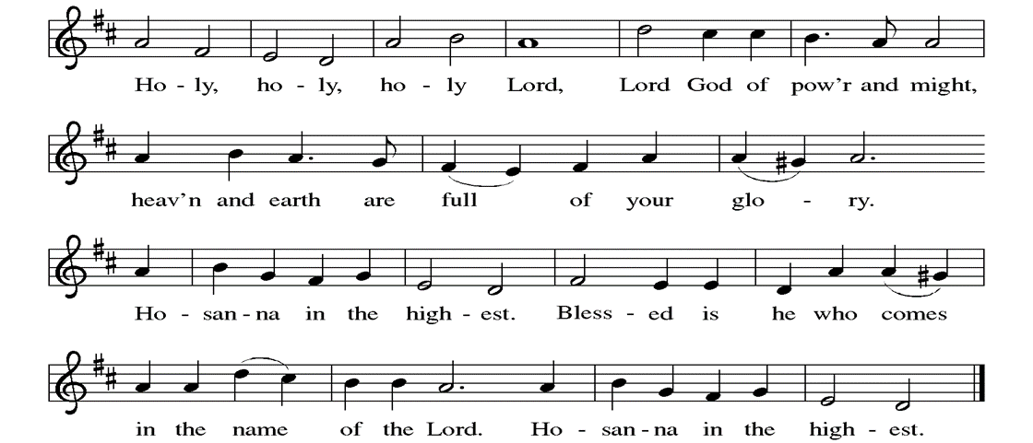

Thanksgiving at the Table
P: In the night in which he was betrayed, our Lord Jesus took bread, and gave thanks; broke it, and gave it to his disciples, saying: Take and eat; this is my body, given for you. Do this for the remembrance of me.
Again, after supper, he took the cup, gave thanks, and gave it for all to drink, saying: This cup is the new covenant in my blood, shed for you and for all people for the forgiveness of sin. Do this for the remembrance of me.

Lord’s Prayer
P: Lord, remember us in your kingdom and teach us to pray.
C: Our Father, who art in heaven, hallowed be thy name, thy kingdom come, thy will be done, on earth as it is in heaven. Give us this day our daily bread; and forgive us our trespasses, as we forgive those who trespass against us; and lead us not into temptation, but deliver us from evil. For thine is the kingdom, and the power, and the glory, forever and ever. Amen.

Invitation to the Table
At Parkside Lutheran Church we have an open table. We believe the invitation to receive comes from Jesus himself and all are welcome at Christ’s table. More than just Bread and Wine these are tangible signs of God’s love for you! If you do not wish to receive communion but would like a blessing, come forward and cross your arms over your chest. The Pastor will give you a blessing before you return to your seat via the side aisle. You’ll receive a communion wafer* in your hands. You may dip it in the cup of wine or juice. When giving the bread and cup, the communion ministers say: “The body of Christ, given for you. The blood of Christ, shed for you.”
and each person may respond: Amen
*Please let Pastor know if you need a gluten-free wafer
P: In bread and cup the reign of Christ is breaking in. Come, receive what Christ has prepared.

The Communion Distribution

Communion Song ELW setting 4 (p. 154)
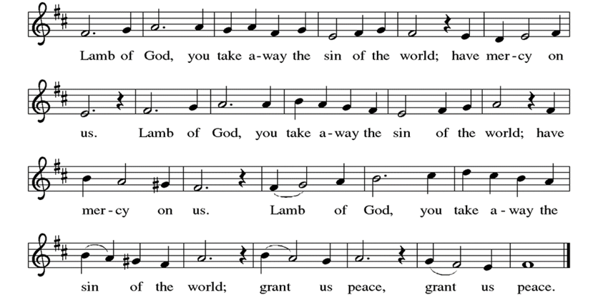

Communion Song: Give Thanks
(printed next page)
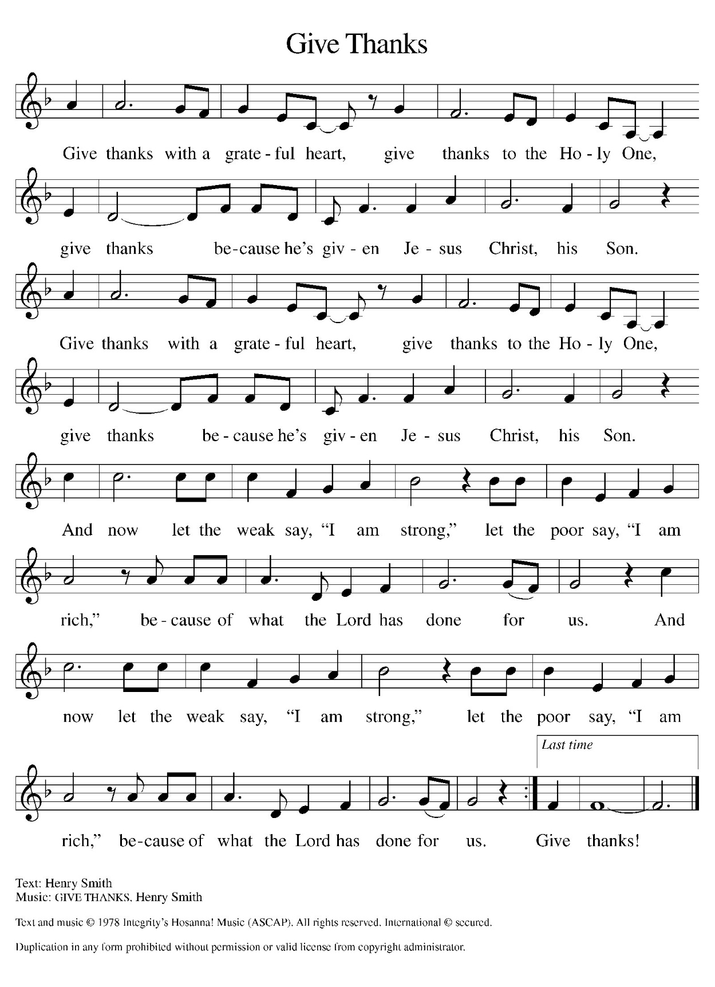

Communion Song: Lord, Listen to Your Children Praying ELW #752
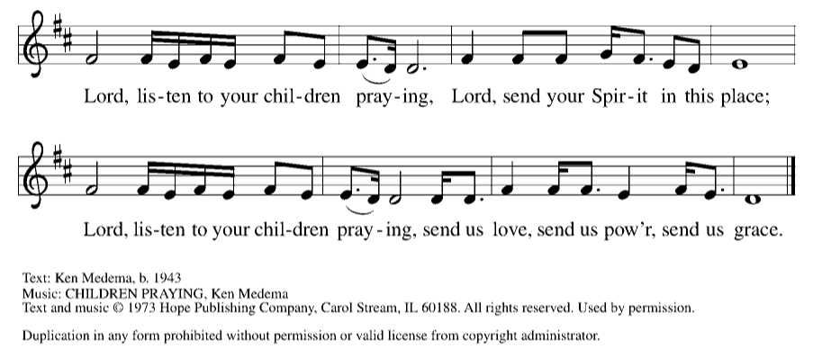
Post Communion Blessing
P: The Body and Blood of our Lord and Savior, Jesus Christ, strengthen you and keep you in God's grace. C: Amen.

Prayer After Communion
WA: Let us pray together.
C: Holy God, we have received your never-ending mercy in this meal. You continuously seek the lost, bind the injured, and feed your people abundantly. Now send us out, awake to your presence, now and forever. Amen.

Sending - God blesses us and sends us in mission to the world.

Blessing
P: The holy Trinity, Father, ☩ Son, and Holy Spirit, bless you with wisdom to welcome the reign of God, today and always. C: Amen.

Sending Hymn: Blessed Assurance ELW #638
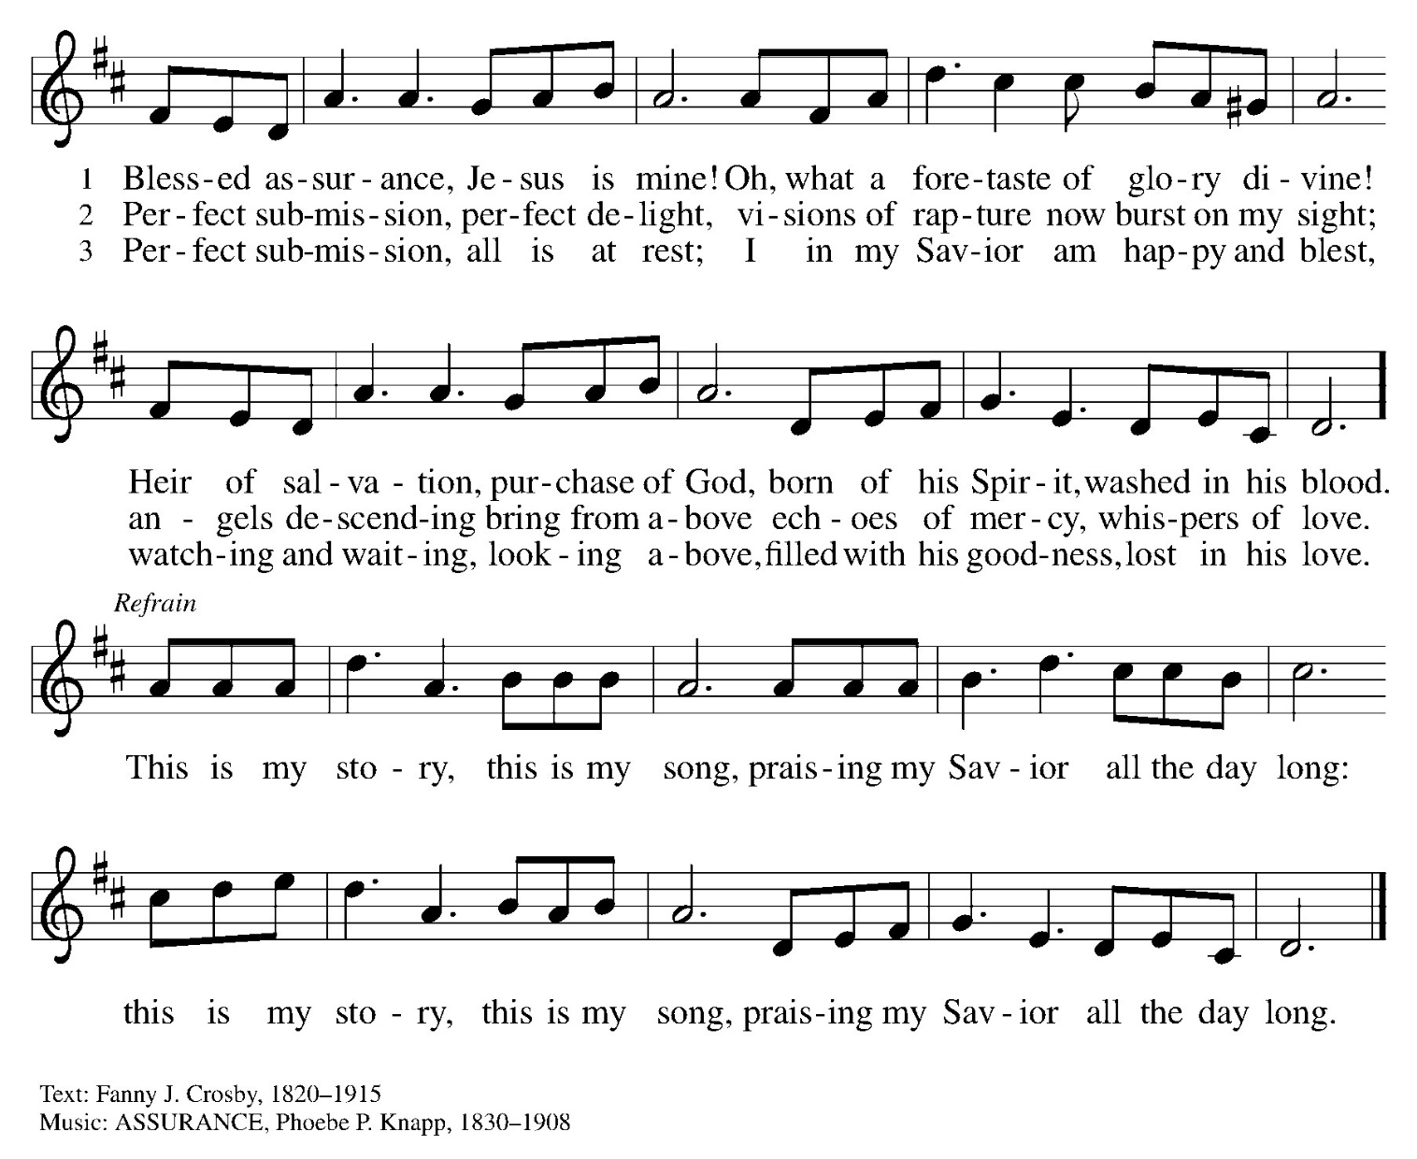

Dismissal and Postlude
WA: Parkside Lutheran Church is rediscovering the radical love of Jesus.
C: Gathering All, Serving All, Caring for All
WA: Go in peace. Encourage one another. C: Thanks be to God.

ELW Music licensed from Sundays & Seasons, Augsburg Fortress CCLI MUSIC License # 11440069 , CCLI Streaming License#21835523 Do not duplicate any music or Liturgy herein without license and permission
scripture readings adapted and written by susan lukey

PARKSIDE STAFF:
• The Rev. Jeremiah Smith: prjeremiahpsmith@gmail.com
• Kris Pope & Suzanne Gracie, Admin. Assistants (Church Office): parksidelutheran@gmail.com
• Mike Hooker, Music Director: mrhooker@me.com
CHURCH OFFICE HOURS: M/T/R 10:00am-3:00pm (716)836-1361
SCHEDULES and Events:
Acolytes: |  | Worship Assistants:
11/8 – Franklin & Hudson |  | 11/8 - Onda
11/15 – Chris & Katie |  | 11/15 - John
Readers: |  | Ushers:
11/8 – Josiah |  | 11/8 – Kaitlyn, Gary S, Kathy
11/15 – Dave P |  | 11/15 - Nick, Tom, John, Charlie
Coming up:
November 17th – Brewing Theology 7pm – Nowhere Lounge
November 18th – International Thanksgiving Dinner 5:30pm in Fellowship Hall
International Thanksgiving Dinner - We are collecting the following items to distribute at the dinner. Donations can be left in the bin, located in the Narthex. If you would like to volunteer, or bring a dish to the event, you can sign-up using the link on our website, or the QR Code below.

- Rice

- Pasta
- Bread
- Pita bread
- Flour
- Sugar
- Cornmeal
- Vegetable or corn oil
- Tea
- Dried or canned beans (black, red, kidney, garbanzo, etc.)
- Dried lentils
- Canned fruits and vegetables
- Tomato paste

