
Message Outline
New Heaven, New Earth
Revelation 21

Intro: Bible Project review of Revelation…
- Q&A to close out series…
- Lake of fire from last week (Rev.19-20)…

v.1a—“New” not “second”…shows quality/freshness, not time.
- Entrance right after smoke/fire…
v.1b—God’s not anti-water (cf.22:1)…
- Sea as chaos and disorder (cf.13:1, 20:13)..
v.2-5—From the garden (Gen.2), to the city (Rev.21)…Eden’s presence remains.
- Wedding day imagery (v.2)!
- Heaven’s defining feature: God’s presence!!! (Gen.2, Ex.40:34ff., Jn.1:14)
v.6-8—FREE WATER for the thirsty (cf. Jn.4:14, 7:37ff.)…alternative fates too.
v.9-10—A command to tour the city…
v.11-14—Significant stones and numbers (cf. Rev.4:3)…
v.15-21—The splendor and size of the city…
- 12s and 10s and their meaning…
- Imagining 12,000 stadia…
- Pearly gates…
v.22—No temple…
v.23-24—No sun…
v.25-26—No lock…
v.27—No evil…
- Importance of the book of life once again (cf. Rev.3:5, 20:12, 20:15)…

_____________________________________
- Seeing a trailer, wanting the full footage!
- cf. 2 Corinthians 4:17-18
- Importance of book of life: walking with Jesus, dressing in His clothes (cf.3:4-5, 19:8)…
- Drinking from His free spring (21:6-7)…

Reading Plan Next Week: Revelation 22
Message Outline
New Heaven, New Earth
Revelation 21

Intro: Bible Project review of Revelation…
- Q&A to close out series…
- Lake of fire from last week (Rev.19-20)…

v.1a—“New” not “second”…shows quality/freshness, not time.
- Entrance right after smoke/fire…
v.1b—God’s not anti-water (cf.22:1)…
- Sea as chaos and disorder (cf.13:1, 20:13)..
v.2-5—From the garden (Gen.2), to the city (Rev.21)…Eden’s presence remains.
- Wedding day imagery (v.2)!
- Heaven’s defining feature: God’s presence!!! (Gen.2, Ex.40:34ff., Jn.1:14)
v.6-8—FREE WATER for the thirsty (cf. Jn.4:14, 7:37ff.)…alternative fates too.
v.9-10—A command to tour the city…
v.11-14—Significant stones and numbers (cf. Rev.4:3)…
v.15-21—The splendor and size of the city…
- 12s and 10s and their meaning…
- Imagining 12,000 stadia…
- Pearly gates…
v.22—No temple…
v.23-24—No sun…
v.25-26—No lock…
v.27—No evil…
- Importance of the book of life once again (cf. Rev.3:5, 20:12, 20:15)…

_____________________________________
- Seeing a trailer, wanting the full footage!
- cf. 2 Corinthians 4:17-18
- Importance of book of life: walking with Jesus, dressing in His clothes (cf.3:4-5, 19:8)…
- Drinking from His free spring (21:6-7)…

Reading Plan Next Week: Revelation 22
Message Outline
New Heaven, New Earth
Revelation 21

Intro: Bible Project review of Revelation…
- Q&A to close out series…
- Lake of fire from last week (Rev.19-20)…

v.1a—“New” not “second”…shows quality/freshness, not time.
- Entrance right after smoke/fire…
v.1b—God’s not anti-water (cf.22:1)…
- Sea as chaos and disorder (cf.13:1, 20:13)..
v.2-5—From the garden (Gen.2), to the city (Rev.21)…Eden’s presence remains.
- Wedding day imagery (v.2)!
- Heaven’s defining feature: God’s presence!!! (Gen.2, Ex.40:34ff., Jn.1:14)
v.6-8—FREE WATER for the thirsty (cf. Jn.4:14, 7:37ff.)…alternative fates too.
v.9-10—A command to tour the city…
v.11-14—Significant stones and numbers (cf. Rev.4:3)…
v.15-21—The splendor and size of the city…
- 12s and 10s and their meaning…
- Imagining 12,000 stadia…
- Pearly gates…
v.22—No temple…
v.23-24—No sun…
v.25-26—No lock…
v.27—No evil…
- Importance of the book of life once again (cf. Rev.3:5, 20:12, 20:15)…

_____________________________________
- Seeing a trailer, wanting the full footage!
- cf. 2 Corinthians 4:17-18
- Importance of book of life: walking with Jesus, dressing in His clothes (cf.3:4-5, 19:8)…
- Drinking from His free spring (21:6-7)…

Reading Plan Next Week: Revelation 22

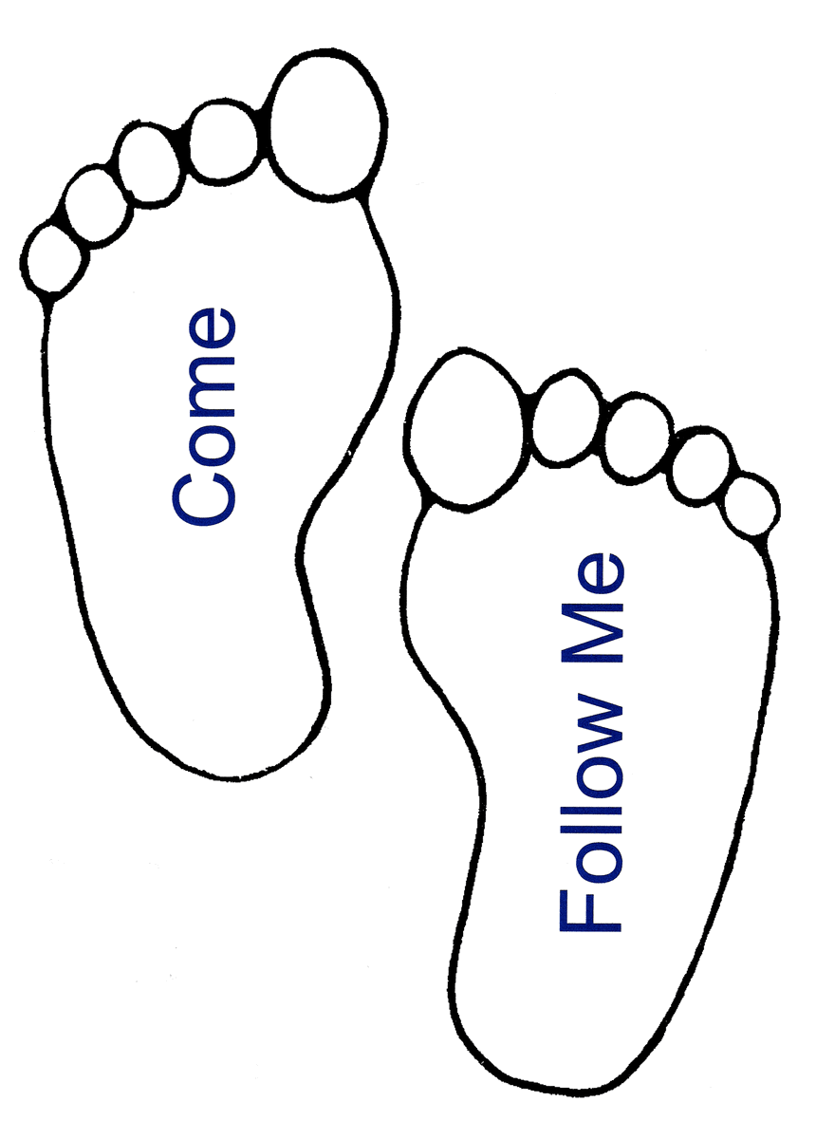
Small Group
Reflection Questions
(Please take time to ponder and pencil in
to prep for this week’s small group session.)

*Reflect on Last Week’s Practice: Confession
How was your practice of confession? How did it go? What did you feel? Where did you sense God?

Watch: Video Session #7: Crafting a Rule of Life

*What makes up your current Rule of Life? What practices do you want to include in your new Rule of Life?

*As you think about designing a Rule of Life, how would you describe the spiritual needs of your personality and current season of life (ie. alone, in community, doing, not doing)?

*React to these quotes:
“There is no formation without repetition.”

“A Rule of Life is a way to put friendship with Jesus at the center of our life, not our habits.”

“A Rule of Life is a way to be present for the healing and helping hand of God to access your life.”

This Week’s Practice: Crafting a Rule of Life
*What are some daily, weekly, monthly practices you want to practice in order to practice your faith more intentionally? Make a list.
Small Group
Reflection Questions
(Please take time to ponder and pencil in
to prep for this week’s small group session.)

*Reflect on Last Week’s Practice: Confession
How was your practice of confession? How did it go? What did you feel? Where did you sense God?

Watch: Video Session #7: Crafting a Rule of Life

*What makes up your current Rule of Life? What practices do you want to include in your new Rule of Life?

*As you think about designing a Rule of Life, how would you describe the spiritual needs of your personality and current season of life (ie. alone, in community, doing, not doing)?

*React to these quotes:
“There is no formation without repetition.”

“A Rule of Life is a way to put friendship with Jesus at the center of our life, not our habits.”

“A Rule of Life is a way to be present for the healing and helping hand of God to access your life.”

This Week’s Practice: Crafting a Rule of Life
*What are some daily, weekly, monthly practices you want to practice in order to practice your faith more intentionally? Make a list.
Small Group
Reflection Questions
(Please take time to ponder and pencil in
to prep for this week’s small group session.)

*Reflect on Last Week’s Practice: Confession
How was your practice of confession? How did it go? What did you feel? Where did you sense God?

Watch: Video Session #7: Crafting a Rule of Life

*What makes up your current Rule of Life? What practices do you want to include in your new Rule of Life?

*As you think about designing a Rule of Life, how would you describe the spiritual needs of your personality and current season of life (ie. alone, in community, doing, not doing)?

*React to these quotes:
“There is no formation without repetition.”

“A Rule of Life is a way to put friendship with Jesus at the center of our life, not our habits.”

“A Rule of Life is a way to be present for the healing and helping hand of God to access your life.”

This Week’s Practice: Crafting a Rule of Life
*What are some daily, weekly, monthly practices you want to practice in order to practice your faith more intentionally? Make a list.

