Colington United Methodist Church
We are a Lighthouse Congregation, committed to offering safety and stability to United Methodists who have been displaced or wounded through disaffiliation.



November 1, 2026
All Saints

welcome
prelude and lighting of altar candles
Resting in God’s Arms Hayes
call to praise and prayer
Since we are surrounded by a cloud of witnesses,
let us also lay aside every weight
and the sin that clings so closely,
and let us run with perseverance the race.
introit
On Jordan’s Stormy Banks I Stand
opening prayer ǀ UMH 713
†opening hymn
For All the Saints ǀ UMH 711
prayer for illumination
Almighty God, we thank you for the gift of your holy word. May it be a lantern to our feet, a light to our paths, and a strength to our lives. Take us and use us to love and serve all people in the power of the Holy Spirit and in the name of your
Son, Jesus Christ our Lord. Amen.
the first lesson
Micah 3:5-12
the psalter
Psalm 43 ǀ UMH 778
the gospel
Matthew 23:1-12
sermon
“All Saints”
†affirmation of praise
Shall We Gather at the River ǀ UMH 723
prayers of the people
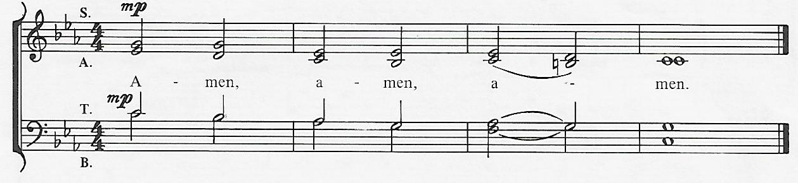
response

anthem
We Remember You
the great thanksgiving ǀ UMH 23
†closing hymn
Rejoice in God’s Saints ǀ UMH 708
__________________________________________

this week at colington
These opportunities to serve as the Body of Christ are available.
Monday – 2:15pm - MAT starts at FFES. Contact Gail Hendricks or Frances Veal to volunteer.
Tuesday – 9 am – Prayer Group
Wed., Nov. 4 – 12pm – Veterans lunch at Spring Arbor.
coming up
Next Sunday – 8:15am – choir practice
9:30 am – Worship, in-person and Facebook Live and YouTube.
Wed., Nov. 11 –10am - Knitter and crocheters.
Thurs., Nov.12 – 4pm – Mobile food pantry at FFES.
Sat., Nov.14 – 9am – UWF breakfast meeting.
Thurs., Nov. 19 – 7:30am – FCA breakfast at FFMS.
Sat., Nov. 21 – 12pm - Church cookout. Hamburgers and hot dogs, drinks provided. Please sign-up for sides and desserts on sheet in fellowship room and to RSVP.
Wed., Nov. 25 – 10am - Knitters and crocheters.
1:45pm - Volunteers to Beach Food Pantry.
Thurs., Nov. 26 – Thanksgiving.
Sun., Nov. 29 – Manna meal following worship.
Mon., Nov. 30 – 8am – Student of the month at FFES.

*Important note – Pledge cards are sorted in baskets on the counter in the fellowship room. Please take yours, complete it and return it by Dec. 1. Thank you.
Thanks to today’s volunteers!
Ushers – Steve Knowles/Ozzie Gray
Scripture Reader – Pat Hansen
Communion Assistant – Debby Garber

The flowers on the altar are given by Merinda DeHart in memory of her husband Jack’s birthday.

Last week’s attendance – 57.

