City Road United Methodist Church
A Lighthouse Congregation
Rev. Tim Nicholson, Pastor

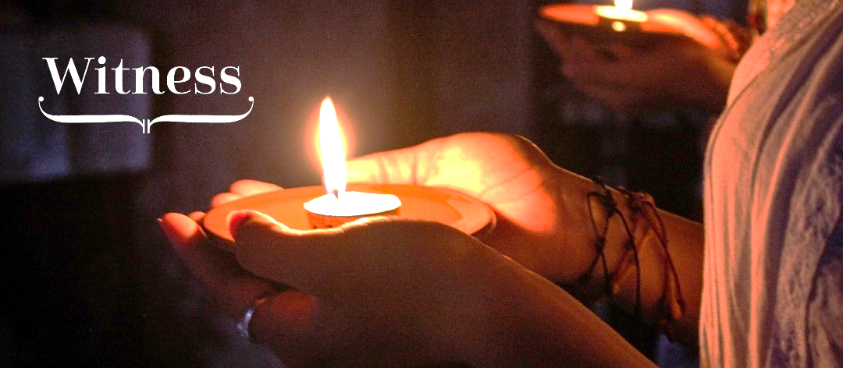

Office: (252) 335-2658
Office Hours: 12:00 pm – 3:00 pm Wednesday & Thursday
Pastor Hours: 10:00 am – 4:00 pm Wednesday & Thursday
Contact Tim for appointments

cityroadec.net crumcec@gmail.com
Facebook: https://www.facebook.com/CityRoadUMC
YouTube: https://www.youtube.com/@CityRoadUMC/streams

Sunday School: 10:00 a.m. Worship: 11:00 a.m.

Tommy Venters- Organist/Choir Director
Dawn Baker- Secretary/Technology Specialist
Jo Ann Herring- We Care
Service of Word & Table
All Saints Sunday
November 1st, 2026 11:00 am
Gathering
Prelude
Words of Welcome
*Call to Worship
Psalm 107: 1-9, 33-43 UMH 830

*Opening Hymn “For All The Saints” UMH 711
Vs. 1-3 & 6

Proclamation & Response

Epistle Reading 1 Thessalonians 2:9-13
Message “Witness” Pastor Tim Nicholson

Invitation to Christ’s Table UMH 12
Prayer of Confession UMH 12
In the name of Jesus Christ, you are forgiven.
In the name of Jesus Christ, you are forgiven.
Glory to God, Amen!

Sharing Peace

Call to the Offering
Offertory
*Doxology UMH 95
*Prayer of Dedication

Holy Communion
Prayer of Great Thanksgiving UMH 13
The Lord’s Prayer
*Receiving the Bread and Cup

Anthem Chancel Choir

Sending Forth
*Sending Hymn “On Jordan’s Stormy Banks I Stand” UMH 724
*Benediction
*Postlude
* Stand as you are able.

