
THE ANGLICAN PARISH OF ST. MARK
138 Hoylake Road, Qualicum Beach, BC V9K 1K3
The Reverend Diana Boland
All Saints’ Day, 10:00 am, November 1, 2026
HOLY EUCHARIST — Book of Book of Common Prayer
In a state of openness, and with a desire to learn the truth of our shared history, we acknowledge that we worship on the unceded territory of the Qualicum First Nation. We give thanks for their careful stewardship of the forests, rivers, oceans, lands and air, so that we might walk with them and celebrate the gift of the Creator. We commit to a lifelong journey of respectful understanding.

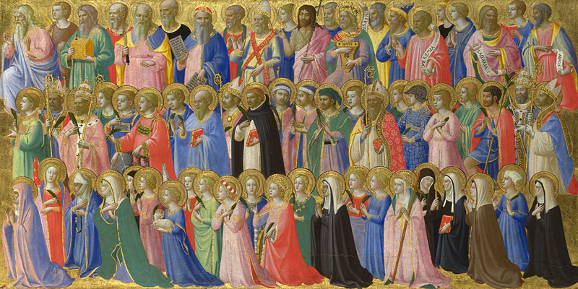
Fra Angelico, The Forerunners of Christ with Saints and Martyrs, c. 1424, National Gallery, London.
Welcome & Announcements
Processional Hymn: CP #276 — “For All the Saints” (vvs. 1, 2, 4, 7 & 8)
The service begins with the COLLECT for Purity page 67
ALMIGHTY God, unto whom all hearts be open, it all desires known, and from whom no secrets are hid: Cleanse the thoughts of our hearts by the inspiration of thy Holy Spirit, that we may perfectly love thee, and worthily magnify thy holy Name; through Christ our Lord. Amen.
Priest: Two Great Commandments of the Law page 69
People: Lord, have mercy upon us, and write both these thy laws in our hearts, we beseech thee
Kyrie: Lord, have mercy upon us.
Christ, have mercy upon us.
Lord, have mercy upon us.
Priest: The Lord be with you;
People: And with thy spirit.
Priest: Let us pray.
The Collect: Almighty God,
whose chosen servant Abraham obeyed your call,
Rejoicing in your promise
That in him the family of the earth is fulfilled;
Through Jesus Christ our Lord,
Who lives and reigns with you and the Holy Spirit,
One God, now and for ever. Amen.
First Lesson: REVELATION 7:9-17
Psalm 34:1-10, 22 page 369
Second Lesson: 1 JOHN 3:1-3
Gradual Hymn: CP #284 – “Blessed Feasts of Blessed Martyrs” (vv. 1)
Before the Gospel: Glory be to thee, O Lord
The Gospel: Matthew 5:1-12
After the Gospel: Praise be to thee, O Christ
Gradual Hymn: CP#284 – “Blessed Feasts of Blessed Martyrs” (vvs. 2 & 3)
The Nicene Creed (Said together) page 71
Sermon: The Rev. Diana Boland
Offertory sentence
Offertory Hymn: CP #278 “Jerusalem the Golden”
Blessed be thou, LORD God of Israel, for ever and ever. All that is in the heaven and in the earth is thine. All things come of thee, and of thine own have we given thee.
Intercessions: page 75
Invitation to Confession: page 76
Confession (Said together) page 77
Absolution
Comfortable Words
Thanksgiving and Consecration page 78
Sanctus and Benedictus page 79
Eucharistic Prayer page 82
The Peace
Priest: The peace of the Lord be always with you;
People. And with thy spirit.
Prayer of Humble Access page 83
Agnus Dei page 84
O Lamb of God, that takest away the sin of the world, have mercy upon us.
O Lamb of God, that takest away the sin of the world, have mercy upon us.
O Lamb of God, that takest away the sin of the world, grant us thy peace.
The Communion
Our Prayer Ministry
Our healing prayer team invites you to join them to pray or give thanks to God in the narthex (entrance) during or after communion, or in the alcove under the Exit sign after the service. Confidentiality is assured.
Post Communion Hymn: CP #397 “Praise the One Who Breaks”
The Lord’s Prayer page 85
Gloria (Please stand) page 86
The Blessing:
Recessional Hymn: CP #378 “Crown Him with Many Crowns”
Dismissal

EMERGENCY CONTACTS FOR PASTORAL CARE
Morag Atherstone: 250-240-6731
Cynthia Preyser: 250-954-9122

CALENDAR: NOVEMBER 2 – NOVEMBER 8

Monday, November 2
10:15 – 12:00 pm — Prayer Shawl (everyone welcome)

Tuesday, November 3
9:15 – 11:00 am — Men’s Study Group
9:00 am – 3:00 pm — Off Kilter Quilters
4:00 – 5:00 pm — Handbells

Wednesday, November 4
9:00 am – 3:00 pm — Comfort Quilt Group
10:00 – 11:00 am — Sermon Circle
11:30 am – 12:00 pm — Morning Prayer
5:30 pm — NAC (downstairs)

Thursday, November 5
9:00 am – 9:00 pm — Parksville Quilt House Sew Days
11:15 am — Choir
3:30 – 4:30 pm — 52 Ways Discussion Group

Friday, November 6
9:00 am – 3:00 pm — Parksville Quilt House Sew Days

Saturday, November 7
5:00 – 8:00 pm — Pub Night

Sunday, November 8
8:30 am — BCP — Holy Eucharist
10:00 am — BAS — Holy Eucharist

