This Week at PPBC

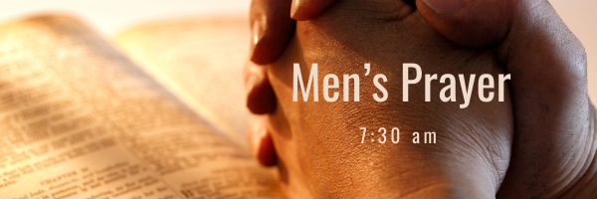
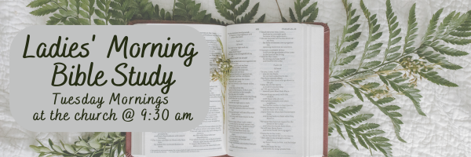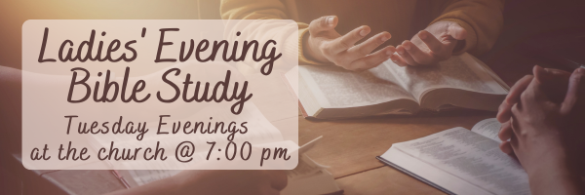

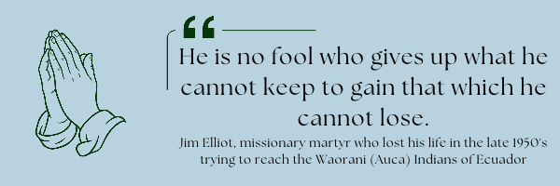A Prayer Request from Maria Diaz: Pray for 3 new Spanish believers that I Disciple weekly. Jorge, Isabel & Angela from Colombia. Pray for healing for my right leg which has been bothering me from a fall I had in my building last Summer.
November 14, 2026
November 17, 2026
Saturday has coffee time at 7:15AM, breakfast served at 7:30AM,
Tuesday will have coffee served with desert at 6:30 PM
If you have not signed up please contact Gregg by text or call him at 289-385-1625 so he knows you are joining.

Starting Wednesday, November 4th, 2026!

Operation Christmas Child
Operation Christmas Child demonstrates God’s love by sending gift-filled shoeboxes to children in need around the world. Every shoebox is an opportunity to reach a child with the Gospel.
Listed below are some shoebox packing suggestions.
• Small backpack or purse
• Soccer ball and pump
• Stuffed animal, toy car
• Jewelry making or hobby kit
• Toothbrush
• Washcloth
• Comb and brush
• Nail clipper and file
• Reusable Water bottle
• Flashlight
• Pencils, sharpener, and erasers
• Pencil container
• Pens
• Crayons
• Colored pencils
• Markers
• Notebooks
• Index cards
• Calculator
• Scissors
• Ruler
• Glue stick
• Small adhesive tape
• Drawstring bag

Sunday Ministry Schedules
Below are ministry schedules for Nursery, Jr. Church, Greeters, Ushers, and Sound & Video:
Nursery
Nov 1: Brenda Clemens, Karis Henkelman, Hannah Colwell
Nov 8: Kathryn denOuden, Amber Saunders, Rosalie McLaren
Jr. Church; ages 3 to grade 1
Nov 1: Abby Saunders, Lena Sammut
Nov 8: Christine McLaren, Samuel Sammut
Jr. Church; grades 2 to 6
Nov 1: Jeff & Karen Clemens, Graeme Anderson
Nov 8: Jenna Anderson, Tiffany Green
Greeters
Nov 1: TBA
Nov 8: Graeme & Barb Foster
Ushers
Nov 1: Graeme Foster, Leno Araujo
Nov 8: Matt Saunders, Joe Colwell
Parking Attendants
Nov 1: Nick Woytowich, Mark McLaren
Nov 8: Steve Owens
Sound & Video
Nov 1: Sound: Josh Anderson | Video: Josh Bolsonello
Nov 8: Sound: Wyatt Werner | Video: Darryl Piwek

Sunday Service
Song – Come People of the Risen King
Welcome
Song – Come Behold the Wondrous Mystery
Prayer
Scripture
Song – Jesus Paid it All
Message – Jim Clemens
Song – Before The Throne of God Above
Communion
Song- Jesus Thank You

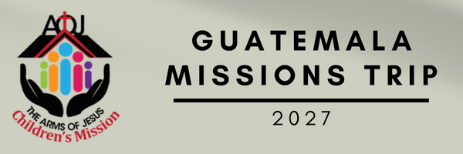
Information Meeting Sunday, Nov 1st after the morning service.

Praise & Prayer Highlights
PRAISE that the Lord provided a team for the Dugout Ministry. PRAY for the team as they prepare to start Dugout November 4th.
PRAY for Leno & Donna Araujo and their extended family as they mourn the loss of their niece's 3 week old baby. PRAY for God's comfort and peace during this time.
PRAY for our shut-ins Winnie Miller, Joan Mabley, Betty Collins, Alice White, Brian Timmins and Bev Agnew. PRAY for their spiritual encouragement.
PRAY for the McKenzie Family as they head to Harmony Road Baptist Church to start ministry there. PRAY for God's Wisdom and Guidance to them and their new Church family as they go forward in ministry.
PRAY for Dennis Tomcheski who is in Port Perry Hospital with an infection. PRAY for the doctors and nurses as they treat and care for Dennis.
PRAY for John and Joan Mank and their ongoing health concerns.
PRAY for John and Elizabeth Kulchycki as they search for a new place to rent. If you know of any possibilities please let John know.
PRAY for Betty Collins as she has some tests on November 20th at Oshawa Hospital. PRAY for God's peace and comfort.
PRAISE for the birth of Mary Deli's second grandchild, Lauren 8lbs 3oz on Thursday morning. PRAY for Marys' daughter and her family as they welcome this blessing.
Giving
Just as a reminder, there are several ways you can give:
In Person using the offering box located on the back wall of the sanctuary. Donation envelopes are available at the Welcome Centre. Please contact the church office if you would like a box of donation envelopes (office@portperrybaptist.ca)
Through your online banking, you may send electronic transfers to ppbcdonations@gmail.com.
You can also give through Canada Helps. Donation receipts will be provided by Canada Helps, and transaction fees apply.
***********************************************************************
Weekly Newsletter
The PPBC Newsletter is emailed to the church family every Friday. If you would like to be added to the weekly email list, please contact the office by phone: 905-985-8681 or by email: office@portperrybaptist.ca.
*****************************************************************
Church Information:
Location:
2210 Hwy 7A
Port Perry, ON
L9L 1B4
Office Hours:
Monday: 8:30am – 4:00pm
Tuesday: 8:30am – 4:00pm
Wednesday: Closed
Thursday: 8:30am – 4:00pm
Friday: 8:30 am - 3:00 pm
Contact:
Phone: 905.985.8681
Email: office@portperrybaptist.ca
Website: www.portperrybaptist.ca
Staff:
Sr. Pastor – Rev. Jim Clemens
Administrative Assistant – Madeline Bolsonello
Pastoral Resident – Scott McKenzie

PPBC Newsletter
Sunday, November 1st, 2026


Sunday Starting Point
Sunday, November 1st, 2026 - 9:30 am
“Beginning the day with the Word and prayer”
Adults:
Adults will meet in the sanctuary for a time of study and prayer.
Youth:
Jr & Sr High will join the Adults in the Sanctuary.
Children Aged 3 – Grade 6:
All children will meet together in Room #26 for a time of singing and Bible lesson
(Please note nursery is unavailable during Sunday School)
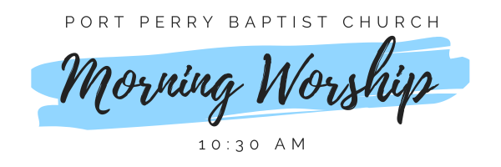Sunday Morning Worship
Sunday, November 1st, 2026 - 10:30 am
We are meeting in the sanctuary and will continue to live-stream for those who are unable to attend.
Message: First Things First Part 2
Scripture: 1 Corinthians 15:3-11
Pastor Jim Clemens

