EAST FAIRFIELD UNITED METHODIST CHURCH
Pastor: Kristen Buchs
Organist: Ruth Rowley Ministers: The Congregation
Pianist: Nancy Setinsek Choir Director: Randy Hart

Sunday, November 1, 2026
Twenty-third Sunday after Pentecost
All Saints’ Sunday

*Please stand in body or spirit as you are able.
Welcome! We invite you to take this time to prepare for worship. In these
moments, quiet your inner voice, become aware of being in community with
others, and open your heart and mind to the leading of the Holy Spirit.

GATHERING “Down at the Cross” - Stockton
“Grace Greater Than Our Sin” - Towner

CHRIST LIGHT ENTERS

MISSIONS AND MINISTRY UPDATES Grant Roberts, Liturgist

PREPARING OUR HEARTS AND MINDS FOR WORSHIP

WORDS OF PREPARATION AND CENTERING

PRELUDE “Grace Flows Down” - Bell / Giglio / Padgett

*CALL TO WORSHIP
L: Great is the grace and glory of God.
P: We give thanks with hearts of joy.

L: Great is the strength and mercy of our creator.
P: We give thanks with hearts of hope.

L: Great is the courage and hope of our Lord.
P: We give thanks with hearts of faith.

L: Great is the mercy and compassion of the Holy One.
P: We give thanks with hearts of love.

(Call to Worship, Ministry Matters-Worship Options, February 6, 2022, by Michelle Torigian.
This article is excerpted from the 2022 edition of the Abingdon Worship Annual.)

*OPENING PRAYER
Lord, we gather here this day in praise and thanksgiving for all the
wonderful things You have done for us. Help us to be faithful
disciples in all that we think, do, and say, that Your great love may
be revealed and offer healing to all people. In Jesus’ name. Amen.

*OPENING HYMN “Hymn of Promise” UMH #707

CHILDREN’S MOMENT

ALL SAINTS’ RECOGNITION
After each name is read, the congregation responds:
Thank You, Lord, for this, Your servant

THE NAMING OF THE SAINTS
Members who have joined the Church Triumphant
MaryAnne Hart 2/13/26
Phyllis Webber 4/24/26
Ronald Chamberlain 6/03/26
Robert Smith 6/08/26
Georgia Farmer 6/16/26
Jim Bable 7/11/26
Walter DeRhodes 8/21/26
Jeffrey Paul McLaughlin 8/30/26
Dorothy Featherstone 9/08/26
Family & Friends
Roberta “Bobbie” Buchs 7/28/26

PRAYER OF REMEMBRANCE

MEMORIAL HYMN “For All the Saints” (vs 1,4,6) UMH #711

OFFERING OURSELVES & OUR GIFTS
INVITATION & OFFERTORY “Send the Light” - Gabriel
*DOXOLOGY UMH #95
*DEDICATION OF GIFTS
CHOIR ANTHEM “How Firm a Foundation” - arr. / Shackley
SEEKING GOD’S WORD
SHARING OF JOYS & CONCERNS
SILENT PRAYER ~ PASTORAL PRAYER ~ THE LORD’S PRAYER

SERMON TEXT I Corinthians 15:12-22, 51-57 (NIV)
SERMON “God’s Healing Power … For Eternity” - Pastor Kristen
Prayer of Dedication

RESPONDING TO GOD’S WORD
SACRAMENT OF HOLY COMMUNION UMH pg. 12
COMMUNION PRAYER Eternal God, we give you thanks for this
holy mystery in which you have given yourself to us. Grant that
we may go into the world in the strength of your Spirit, to give
ourselves for others, in the name of Jesus Christ our Lord. Amen

*CLOSING HYMN “Sing with All the Saints in Glory” UMH #702

SENDING FORTH WITH BLESSING
*BLESSING ~ LIGHT OF CHRIST GOES INTO THE WORLD
~ Go with joy to serve the Lord ~

Altar Flowers are in honor of Ruth Rowley’s birthday.
Please join us downstairs for coffee, cake, and ice cream.
PRAYER REQUESTS NOVEMBER 1, 2026

To submit a prayer request call Denise at 330-457-2465 or 330-727-9832
If you desire a home or hospital visit call Pastor Kristen (216-559-9893)
Prayer Blankets: call Joyce Ward (330-692-3346)

Please keep in mind that the service is live-streamed and
recorded for public access. Please keep prayer requests
brief and do not use last names or identifying details.

Dolly – now back home.
Bob (Deann’s dad) – back at Whispering Pines.
Jill (Elaine’s friend) – passed away. Pray for her friends and family.
Linda B. (Kim’s mom) – was in the hospital. Now at Parkside.
Valda (Tremaine’s grandma) - in the hospital in New York.
Davion (Tremaine’s dad) - travel mercies as he comes home from N.Y.
Laura (Charlotte’s sister) - back surgery. Prayers for her and husband Joey.
Justin (Kent’s son) – vehicle accident Monday. Broke femur in two places.
David & Mary (Jeannie) – he’s had two strokes and has dementia.
Cindy W – had cataract surgery Oct. 19.
Vicki (Kay’s daughter-in-law) – pain in hips and legs.
Kara – still having stomach issues.
Sandy (Chaney’s mom) broke her sternum and vertebrae in neck & back.
Marcia M – Undergoing chemo. Still needs prayers. Back in hospital.
Grace (Alisha) – had shoulder surgery Thursday, Oct. 8.
Jon E – has been dealing with cancer. Now on hospice care.

HOMEBOUND
Dolly K. Anita M. Bob D (Whispering Pines)
Tom & Marie Linda S. Zelda C. (Whispering Pines)
Esther C. Marcia M.

IN MINISTRY
Kristen Buchs Edie Boles Jeff Pellin

Church: 330-457-2465 Pastor Kristen: 216-559-9893
Ch Email:efumc@comcast.net Email: pastorkristen0712@gmail.com
Web: www.eastfairfieldumc.com CCLI #1994841 CVLI #504 011 134


East Fairfield
United Methodist Church

November 1, 2026
9:30 AM

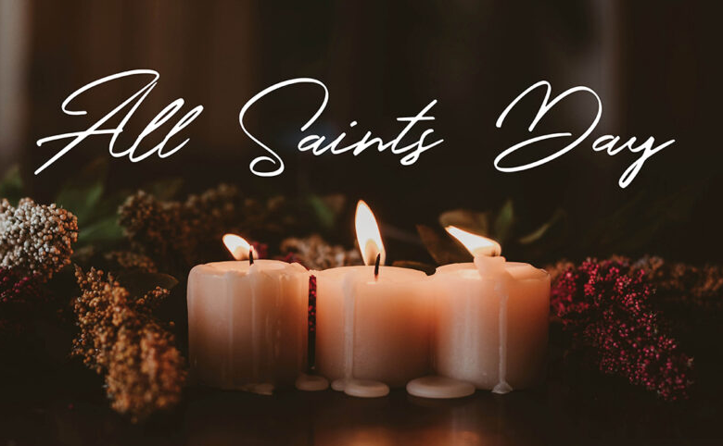

Pastor Kristen Buchs
216-559-9893
45675 State Route 558
New Waterford, OH 44445

“Working, playing, and praying together on our
faith journey, to share Jesus Christ with everyone.”

Sun | Mon | Tue | Wed | Thu | Fri | Sat
Nov. 1  All Saints’  Communion  9:30 Worship  10:30 Coffee  10:45 Sunday  School  Fellowship Hall  in use (Marriner) | Nov. 2  1:30-4:00  Prayer  Blankets  6:00 Cub  Scouts | Nov. 3  (Election  Day)  8:00 Men’s  Coffee at  the church | Nov. 4  6:00  Comforting  Cards at  Mt. Zion  7:00 Choir  Practice | Nov. 5 | Nov. 6  Pastor’s  Day Off  Office  Closed | Nov. 7  3:00 Charge Conference  at Berlin Center UM  15611 W. Akron-Canfield Road 44401
Nov. 8  Veteran’s  Recognition  9:30 Worship  10:30 Coffee  10:45 Sunday  School | Nov. 9  1:30-4:00  Prayer  Blankets  4:00-6:00  Quilting at  Elkton UM  6:00 Cub  Scouts | Nov. 10    Veteran’s  Day  8:00 Men’s  Coffee at  the church  Ladies’ Day | Nov. 11  7:00 Choir  Practice | Nov. 12  3  10:00  Congregational  Care Meeting  (New date)  7:00 Scripture  & Suds at  SunDog Cider @ Firestone Farms | Nov 13  Pastor’s  Day Off  Office  Closed | Nov. 14  8:00 – 5  Lay Servant Training at  W. Reserve UMC
Nov. 15  9:30 Worship  10:30 Coffee  10:45 Sunday  School | Nov. 16  1:30-4:00  Prayer  Blankets  6:00 Cub  Scouts  7:00  LEADERSHIP  BOARD | Nov. 17  8:00 Men’s  Coffee at  the church  Newsletter Deadline  6:30 Crafts  with Elaine | Nov. 18  6:00 Worship  Committee  7:00 Choir  Practice | Nov. 19  9:00 Mailing Com. | Nov.20  Pastor’s  Day Off  Office  Closed | Nov. 21  Cub Scouts Raingutter Regatta
Nov. 22  Hanging the Greens with Potluck Lunch  9:30 Worship  10:30 Coffee  10:45 Sunday  School | Nov. 23  6:00 Cub  Scouts | Nov. 24  8:00 Men’s  Coffee at  the church | Nov. 25  Office is Closed  7:00 Choir  Practice | Nov. 26   | Nov 27  Pastor’s  Day Off  Office  Closed | Nov. 28  8:30-10:00  Caring for  God’s Lambs  at Trinity UMC
Nov. 29  9:30 Worship  10:30 Coffee  10:45 Sunday  School  4:00 4-H | Nov. 30  (Pastor’s Day Off)  1:30-4:00  Prayer  Blankets  6:00 Cub  Scouts

Craft Night with Elaine
Tuesday, November 17, 2026
6:30 PM

Sign up on the clipboard in the foyer.
Registration deadline is Sunday, Nov. 8.
There will be a small fee for supplies.
More info later.


2026
Poinsettia Order Form
Deadline to order is November 15

 |  |  | How Many ?
6” Pot | Red |  |  | @ $ 9.75
6” Pot | White |  |  | @ $ 9.75
6” Pot | Pink |  |  | @ $ 9.75
6” Pot | Marble |  |  | @ $ 9.75
6” Pot | New: Red Glitter |  |  | @ $ 9.75
8” Pot | Red |  |  | @ $ 22.75
8” Pot | White |  |  | @ $ 22.75
8” Pot | Pink |  |  | @ $ 22.75
8” Pot | Marble |  |  | @ $ 22.75
8” Pot | New: Red Glitter |  |  | @ $ 22.75
TOTAL |  |  |  |  | $
Name:
Phone: |  |  |  |  | Env. #
In Honor of:
In Memory of:

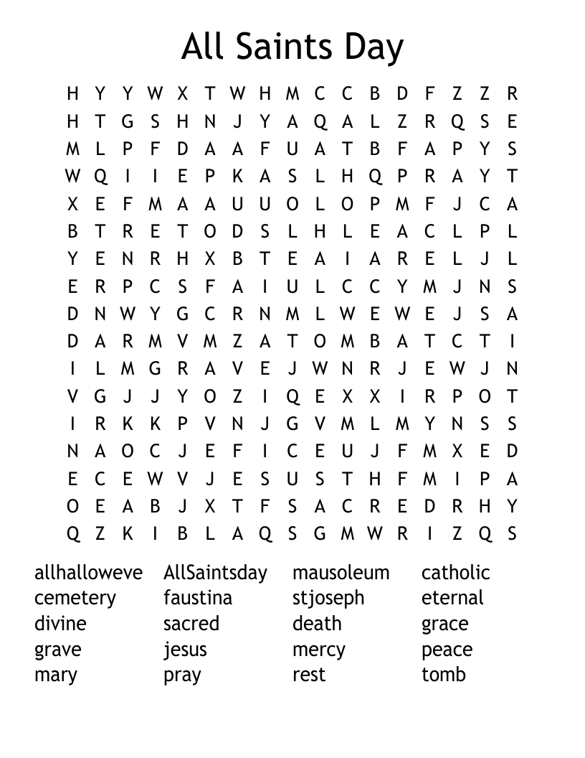

Mission of the Month

Peace With Justice – Fund # 15

With your Peace With Justice offering,
we come together to support ministries that work for
peace and fairness around the world. It’s a day when the church speaks out against violence and inequality and renews its commitment to be peacemakers - just as Jesus taught.

4C’s Food Item ~ Quick Oats

Update on Mission Giving for 2026
FUND | NAME OF FUND | NEED | RECEIVED | STILL NEED
2 | General Mission Fund | 5,099 | 6,834 | 0
33 | 4C’s | 125 | 1,175 | 0
32 | Cub Scouts | 150 | 695 | 0
37 | Way Station | 150 | 160 | 0
22 | Flat Rock | 175 | 265 | 0
64 | Farmer to Farmer – Liberia | 300 | 360 | 0
13 | UMCOR Sunday | Any Donation | 75
21 | UMCOR – U.S. Disasters | Any Donation | 110
14 | Blanket Sunday | Any Donation | 65
15 | Peace With Justice | Any Donation | 10
16 | World Communion | Any Donation | 25
17 | Student Day | Any Donation | 75
46 | Heroes & Halos | Any Donation | 200
63 | InStep Program | Any Donation | 50
38 | Operation Christmas Child Shoeboxes |  | 118 plus 90

Fund Balances as of end of SEPTEMBER
Fund # 1 Ministry Operating - 18,324
Fund # 2 Mission Fund 4,761
Fund # 3 Building Fund 39,528
Fund # 28 Elevator Fund 7,331

Last Week’s Attendance (Oct. 25)
In-Person: 64 Online: 37

