Announcements

Monday, November 2
Men’s social Banquet hall 10:00a.m.
Beaver Valley band Banquet hall 5:30p.m.
Choral works Sanctury 7:00p.m.

Tuesday, November 3
Bell practice Banquet hall 7:00p.m.
Affirming group meeting Board room / Zoom 4:00p.m.

Wednesday, November 4
Junior Choir Banquet hall 5:30p.m.
Senior Choir Banquet hall 7:00p.m.

Thursday, November 5
Thursday night group Banquet hall 7:00p.m.

Affirming group Meeting
Will take place on Tuesday November 3rd at 4:00p.m. in the boardroom and by zoom

Friendly Visitors
If anyone has a need or knows of someone who does need a home visit, please contact the church office

Prayer Chain
Prayer is a form of spiritual exercise that supports those prayed for and promotes spiritual growth in those who do the praying. Here at Trinity, we encourage the practice of prayer.
Our prayer chain is a group of people who are willing to pray for others.

Family Connexions Christmas basket
"ATTN Crafters: Have you been using your leftover yarns for mitts, hats, scarves, or socks for Family Connexions? A basket will be in the Narthex to receive your projects or gifts on November 1st. All new items whether hand crafted or purchased are gratefully received by families in crisis. If you have any questions please contact Barbara Downie, 705-444-1519.

The Outreach Committee is looking for clean and gently used warm outerwear such as boots, hatts, coats, snow pants in all sizes and especially for men. There is also a need for clean blankets, comforters and pillows during the winter. These items are given out at the community dinners as well as by request through the office.

Hope Chapel - Christmas Craft & Bake Sale
Saturday November 21 @ 9:30 – 2:00pm
In support of the community cupboard

Choral Works Songs of the Season
Featuring John Rutter’s Magnificat
Saturday November 28 @ 4:00p.m.
First Presbyterian Church, Collingwood
Tickets: General $50 / Youth $25
or at Choralworks.ca or 705-888-4454 or
posters to scan the QR code



Rev. Beth Kerr (she/her)
Diaconal Minister
Trinity United Church
140 Maple Street,
Collingwood, ON L9Y 2P8
www.collingwoodunitedchurch.ca
705-445-3901 (church)
204-872-2370 (cell)
Please note: Friday and Saturday are my sabbath days. I will reply to emails received on those days on the following Monday. For emergencies, please contact my cell phone

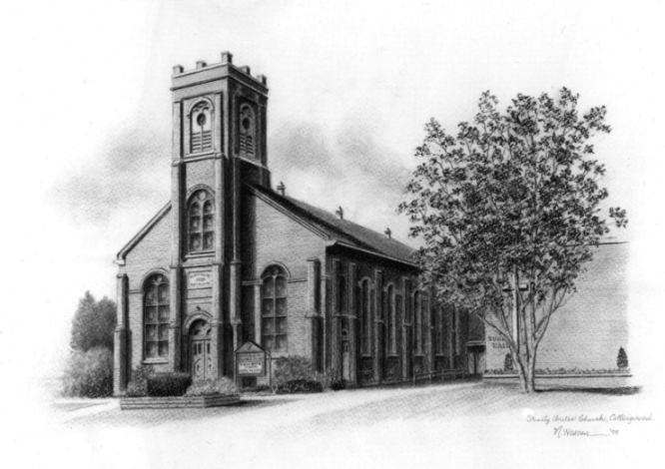

Trinity United .Church: Collingwood
Minister: Rev. Beth Kerr, 204.872.2370 (cell)
Minister’s Email minister@collingwoodunitedchurch.ca
Ministry of Music: Paul Sloan, 705.730.3121 (cell)
Choir Director: Lesley Joosten, 705.984.3243
Handbell Director: Maryellen Burgess, 705.443.1422 (cell)
UCW President: Joy Barr 705.445.0726
Office Assistant: Lori Forsythe
Church Office: office@collingwoodunitedchurch.ca
Office Hours: Tuesday to Friday, 8:30 am-12:00 pm
140 Maple Street, Collingwood, ON L9Y 2P8
Telephone: 705.445.3901
Website: www.collingwoodunitedchurch.ca

