2) In vs. 7-11, Peter not only adds urgency to the moment but he also simplifies the game plan. What does Peter mean by “be self-controlled and sober-minded for the sake of your prayers” (v.7)? What are some of the things that distract you from praying? What has helped you pray more effectively?

3) What does it mean to “keep loving one another earnestly” (v.8)? How does “love cover a multitude of sins” (v.8)? Describe a time when you extended forgiving love to another person. What was the result? Describe a time when someone else extended forgiving love toward you. What was the result?

4) When it comes to sharing your “stuff”, how is hospitality such a powerful expression of service in our day and culture? In what practical ways can you apply v.9 this week?... this month?

5) All believers have at least one spiritual gift and are expected to use these gifts in service of others and to the glory of God (vs.10-11). What is one spiritual gift that God has given you? How are you currently using it to serve others? What has helped you discover, develop and deploy your spiritual gifts?

6) In everything, God gets the glory (v.11). How much extremism would be avoided in the church and Christian community today if we did all for the greater glory of God? Why is it so important to keep His glory uppermost in our attitudes and actions in all we say and do?

What is the main thing that God has impressed upon you today?

What are you going to do about it?

Remember: The smallest obedient act is better than the greatest intention.

Primary message sources and recommended resources: Hope Again (1 Peter) by Charles R. Swindoll; Exposition of the New Testament (1 Peter) by Warren Wiersbe; NIV Application Commentary (1 Peter); Word Biblical Commentary (1 Peter); The Communicator’s Commentary (1 Peter) by Paul Cedar.

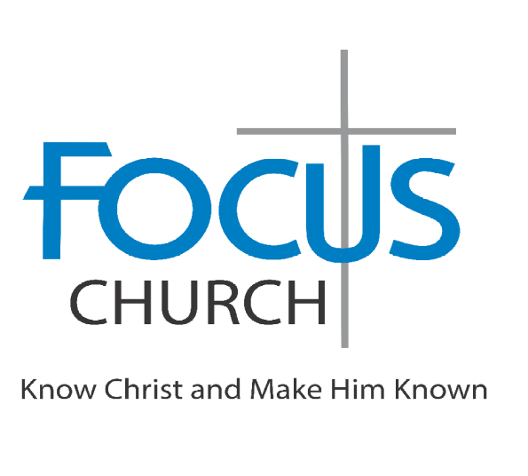
Welcome to Focus Church—a Christ-centered community learning to follow Jesus with purpose and passion. Our mission is to know Christ and make Him known – to follow Jesus fully through biblical teaching, authentic relationships, joyful worship, and compassionate service. Wherever you are on your journey, you are welcome here.

Guests: Please complete a “Connect Card” and pick up a blue gift bag as our “thank you” for being with us today.

Sunday, October 25
9am – Adult Sunday School Class
10am – Worship Celebration

Church Office & Mailing Address
10475 Crosspoint Blvd Ste 250
Indianapolis, IN 46256-3387
317-813-5996 https://www.myfocuschurch.com/

Would you like to experience and enjoy peace with God and share His peace with others? Go to peacewithgod.net to learn more.

TODAY’S MESSAGE, OCTOBER 25, 2026
SERIES: A Living Hope
“Experiencing Hope Beyond Today”
Brian Boone, Lead Pastor

He who thinks most of heaven will do most for earth.

In the church where there is lack of love and common purpose and where the spiritual lifeline of communication to God is broken, the forces of opposition will weaken and eventually destroy the church. In these verses Peter emphasizes how crucial it is that local churches be strong in fellowship with firm links of life and loyalty between the members and also between the members and God. (I. Howard Marshall)

1.______________________________________________________

The end of all things is at hand; therefore be self-controlled and sober-minded for the sake of your prayers. (1 Peter 4:7, ESV)

2.______________________________________________________

Above all, keep loving one another earnestly, since love covers a multitude of sins. (1 Peter 4:8, ESV)

3.______________________________________________________

Show hospitality to one another without grumbling. (1 Peter 4:9, ESV)

4.______________________________________________________

10 As each has received a gift, use it to serve one another, as good stewards of God’s varied grace: 11 whoever speaks, as one who speaks oracles of God; whoever serves, as one who serves by the strength that God supplies—in order that in everything God may be glorified through Jesus Christ. To him be glory and dominion forever and ever. Amen. (1 Peter 4:10-11, ESV)

My response to today’s message

Information without application falls short of God’s best for us. He wants us to apply what we learn so that we will change and grow, becoming more like Christ. The following questions are for personal and group study.

1) When have you seen “extremism” when it comes to living in light of Christ’s return? How should 1 Peter 4:7a help bring balance to our perspective and positively affect our attitudes and actions as fully devoted followers of Jesus?

