Mortification of Sin: Practical Insights
Pastor Dan Phillips August 23, 2026 Copperfield Bible Church

Introduction:

- “Experience may be the best teacher—but the tuition is mighty high.”

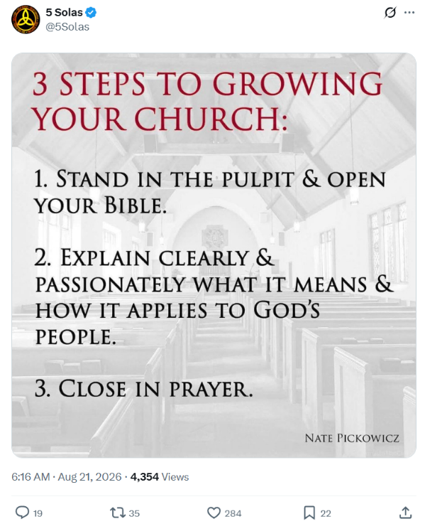
- The ___________________ between _____________ knowledge and _____________ knowledge lies in _____________ born of __________.

- ______ only makes _________ to itself, and to other ____________.

- Sin makes you _____________________.

- People locked into a sin are impervious to __________, __________ and ______________.

