Prelude – Seek the Lord Jan Knewtson
Words of Welcome

╬ Call to Worship
We gather to worship Jesus, our Lord and Teacher, who showed us how to live.
Our Lord humbled himself to serve his disciples and showed us the true meaning of love.
Christ calls us to love and serve one another, just as he loved and served.
Teach us, Lord, to follow your example of love and humility.
Let us worship the Servant Lord, who came not to be served but to serve.
Shape our hearts, O God, to love as you love and serve as you serve. Amen.

╬ Passing the Peace
All may greet one another in the name of the Lord.
╬ Lead On, O King Eternal № 580
Joys & Concerns
Pastoral Prayer

The Lord’s Prayer

Children’s Time

╬ Prayer for Illumination

Loving God, open our hearts to your Word, and open our ears to hear You speaking to us.
Help us to see the humility of Jesus, our Servant Lord,
and teach us to love and serve one another as he has shown us.
In Christ’s name, Amen.

╬ Scripture: John 13:1 - 5

╬ Gloria Patri № 70

Sermon: God Revealed “The Servant Lord”

Moments of Reflection

╬ Dear Jesus, In Whose Life I See № 468

Tithes and Offerings
Offertory – Spirit of God Jan Knewtson

╬ Doxology № 95

╬ Prayer of Dedication
Gracious God, we dedicate these offerings to your service.
As Jesus humbled himself to serve others, may these gifts reflect our love, compassion, and willingness to serve.
Use them to share your love with the world. In Jesus’ name, Amen.

╬ The Gift of Love № 408

╬ Connections

╬ Benediction
Go forth in the love of Jesus, our Servant Lord, humbling yourselves to serve others with grace and compassion.
May we follow Christ’s example, loving and serving one another in all we do. Amen and Amen!

Postlude – I Am Thine, O Lord Jan Knewtson

CALENDAR OF EVENTS – WEEK OF October 25 – October 31
Today 9:30 am Sunday Worship| Potluck Luncheon
11:30am Administrative Council Meeting
5:00 pm Family Life: Pumpkin Carving
October 26th 4:45 pm Boot Camp at Calvary Life Center
6:00 pm Cub Scouts at Calvary Life Canter
October 27th 7:00 am Men’s Breakfast at Calvary Life Center
8 am & 4:45 pm Boot Camp at Calvary Life Center
6:00pm Boy Scouts at Calvary Life Center
October 28th 8 am & 4:45 pm Boot Camp at Calvary Life Center
5:30pm Mid – Week Manna at Wesley UMC
October 29th 8 am & 4:45 pm Boot Camp at Calvary Life Center
1:00 pm Prayer Shawls at Wesley UMC
4:30 pm TOPS at Calvary Life Center
October 30th 8:00am Boot Camp at Calvary Life Center
All Day Offices Closed
October 31st

OUR PRAYERS AND THOUGHTS
Please be in prayer for: Welda UMC. Pastor Bill Nelson.
Continuing Prayers: Spencer & Helen Ambler, Debbie Spait, Chris Callier, Beverly Franklin, Terry & Sandy Rodgers, Jerry Smith, David Wichman, Vernon Miller, Sandy Wolf - Buche, Maria (infant great-granddaughter of Larry & Pam Hart), Vic Edwards (Son-in-Law of Marvin & Donna Valentine), Craig Sargeant (Brenda Sargeant’s Son), Jack Stanley, Jeff Jackson (Norma Jackson’s Son), Matt Schwenk (Karen Lee’s Son-in-law), Penny Miller (Joann Miller’s Daughter), Becky Rourk, Donna Beebe, Brenda Sargeant, Larry Robertson, Vera Shafer – Sheehan, Richard Knewtson.
Care Home Residents: Baldwin Rehab: Cheryl Moyer. Greystone: Barbara Letsinger, Kathleen Sinclair, Dianna Cuppy, Eleanor Ross, Yvonne Dunlap. Oswego Health & Rehab: Lois Kerns. Pittsburg Health & Rehabilitation: Jan Powell. Medical Lodges: Deanna Buche- Wright. Dignity Care Home: Joann Maxwell. Heartland: Jean Roberts. Hometouch: Debbi Sebbert, Don & Frances Wiles, Betty & Jerry Skidmore.

Pastor Owen is available by phone (620.228.1976), text, or email
(iolawesleypastor@gmail.com) Monday - Thursday during his office hours 9:00 - 3:30. After
hours, for emergency only. All prayer requests should be submitted to the church office by phone at 620.365.2285 or by email iolawesley@gmail.com

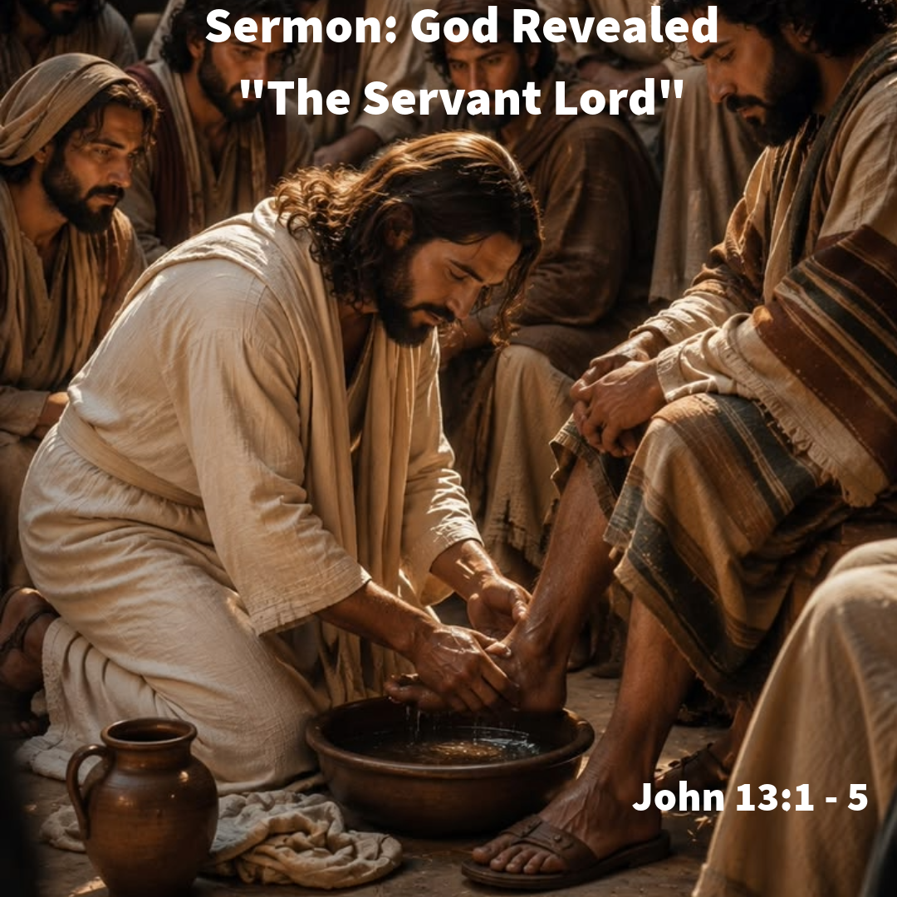

Wesley United Methodist Church
October 25, 2026
John 13: 1 - 5

13 Now before the festival of the Passover, Jesus knew that his hour had come to depart from this world and go to the Father. Having loved his own who were in the world, he loved them to the end. ² The devil had already decided^{[a]} that Judas son of Simon Iscariot would betray Jesus. And during supper ³ Jesus, knowing that the Father had given all things into his hands and that he had come from God and was going to God, ⁴ got up from supper, took off his outer robe, and tied a towel around himself. ⁵ Then he poured water into a basin and began to wash the disciples’ feet and to wipe them with the towel that was tied around him.

