Welcome to Fremont United Methodist Church!

Announcements
Ongoing: The missions comm. is accepting monetary contributions to purchase Halloween Costumes for children at FES who may not have one. If you wish to support these efforts, simply make note on the memo line, or enclose in an envelope labeled: Halloween/Costumes. Contributions accepted thru 10/25.

Oct. 29 – Charge Conference – 6pm, Westwood UMC (Goldsboro)
Oct. 31 – Trunk-or Treat – 5:30 - 7pm
Nov. 21 – Annual Dinner and Auction – 5:30 (Meal) ~ 7pm (Auction)

Weekly  ✦ Judy O’Neal Sew Blessed Community Prayer Shawl Ministry  Tuesday - 10A - Fellowship Hall  ✦ Choir - Wednesday - 7PM - Choir Room  ✦ Sunday J.A.M. (Jesus & Me)  Meets weekly after the Children’s Sermon  Monthly  ✦ United Methodist Men- Fellowship Breakfast  First Sunday of the Month - 8:30A - Fellowship Hall  ✦ United Women in Faith: Benton-Hooks Circle  First Monday of the Month - 10A - Fellowship Hall  ✦ United Women in Faith: Stewart Pike Circle  First Tuesday of the Month - 6P - Location Varies  ✦ 50 Uppers - Lunch & Fellowship  Meets the second Tuesday of each month. | Next Week’s Lectionary Scriptures  Joshua 3:7-17  Psalm 107:1-7, 33-37  1 Thessalonians 2:9-13  Matthew 23:1-12  Portions of our worship service may be adapted from, Ministry Matters, Life in Liturgy, and  UMC Discipleship.
Recurring Small Groups
Fremont United Methodist Church
Sunday, October 25, 2026

“We strive to create a space for the vibrant
transformation of humble souls to serve Christ”

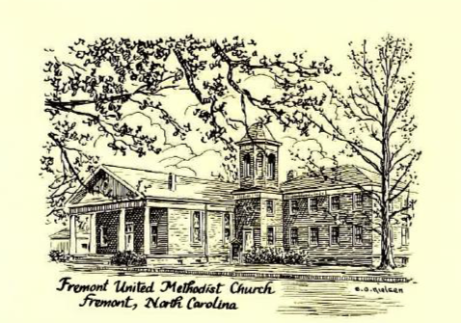

106 N. Sycamore St. Fremont, NC 27830
PO Box 147
Church Phone: (919) 242-4797
www.fremontumc-nc.org
Rev. Ben Van Staalduinen, Pastor
Choir Director: Linda Jo Sampson | Pianist: Sylvia Overman

Twenty Second Sunday after Pentecost
October 25, 2026

GATHERING
Bringing in the Light Acolyte
Welcome
*Call to Worship
PROCLAMATION
*Opening Hymns “O For a Thousand Tongues to Sing” UMH #57
*Apostles Creed UMH #881
Children’s Message Nancy Baldree
A Time to Pray
Pastoral Prayer Rev. Ben Van Staalduinen
The Lord’s Prayer UMH #895
Anthem “I’ll Fly Away” Choir
Prayer for Illumination
Old Testament Lesson Psalm 1 Rev. Ben Van Staalduinen
Gospel Lesson Matthew 22: 34-46 Joy Vinson
Sermon “Love God. Love Neighbor” Rev. Ben Van Staalduinen
Intercessory Prayer
RESPONSE
The Service of Word & Table
Confession & Pardon Congregational
The Peace
Giving Our Tithes & Offerings Larry and Susie Baker
Offertory
Offertory Prayer Rev. Ben Van Staalduinen
*Our Response “The Doxology”
The Great Thanksgiving Congregational
Breaking of the Bread
*Giving the Bread and Cup

SENDING FORTH
What’s to Come
*Hymn “Lord I Want to Be a Christian” UMH #402
*Taking the Light into the World Acolyte
*Benediction
Postlude Sylvia Overman
___________________________________________________________________________*Please stand as you are able.
STEWARDSHIP REPORT
for October 25, 2026
2026 Church Budget: $200,823.68 October 18, 2026: $14,549.00
Weekly Budget Needed: $3,862
Birthdays:
Mary Van Staalduinen (10/1), Larry Baker (10/7), Frank Davis (10/13), Bill Thering (10/18), Kim Davis (10/27), Tracy Jennings (10/29), Amy Price (10/30), Sheila McCullen (10/30)
Anniversaries:
Grant and Lauren Sasser (10/13), Kim and Freda Davis (10/15), Jordan and Robbie Webb (10/15)

Ongoing Prayer Concerns:
Chris Evans, Martha Lou Smith, Emily Gamble, Christy Straughan-Haley and Family, Roger Pittman, Dillon Wilson and Family, Julia Clarke.
If you have a name you’d like to add to our ongoing prayer concerns list, please let Pastor Ben or a member of the Worship Comm. know.

