Colington United Methodist Church
We are a Lighthouse Congregation, committed to offering safety and stability to United Methodists who have been displaced or wounded through disaffiliation.



October 25, 2026
Twenty-second Sunday after Pentecost
welcome
prelude and lighting of altar candles
Praise Ye the Lord, Ye Heavens Adore Him
call to praise and prayer
O Lord, open our lips.
And we shall declare your praise.
introit
Let the Redeemed Ellis
†opening hymn
Praise to the Lord, the Almighty ǀ UMH 139
prayers of the people
prayer for illumination
Almighty God, we thank you for the gift of your holy word. May it be a lantern to our feet, a light to our paths, and a strength to our lives. Take us and use us to love and serve all people in the power of the Holy Spirit and in the name of your
Son, Jesus Christ our Lord. Amen.
the first lesson
Deuteronomy 34:1-12
anthem
A New Name in Glory A. Miles
the second lesson
1 Thessalonians 2:1-8
sermon
†affirmation of praise
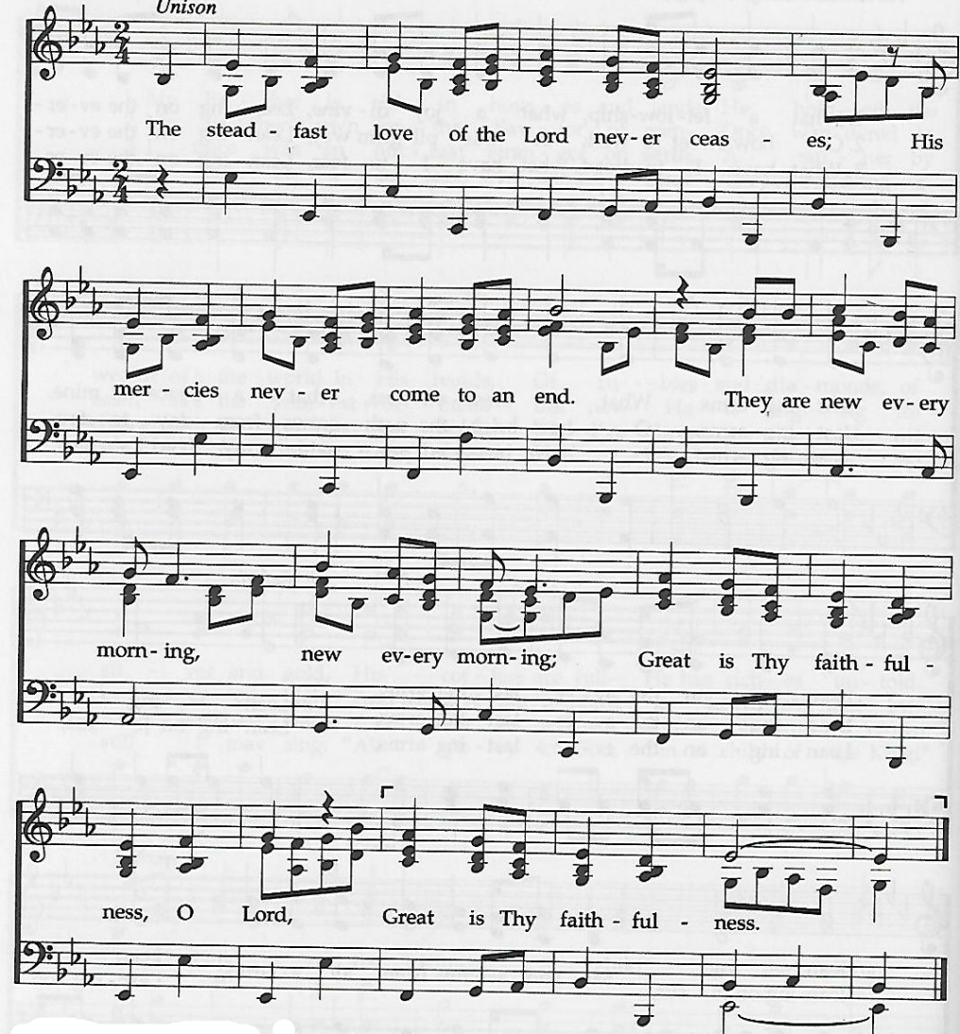
The Steadfast Love of the Lord

prayer of thanksgiving
†closing hymn
Victory In Jesus ǀ UMH 370
__________________________________________

this week at colington
These opportunities to serve as the Body of Christ are available.
Today – 3pm – Deb Kasten’s music room recital in the Sanctuary.
Monday – Student of the month at FFES.
Tuesday – 9 am – Prayer Group
Hosting Ruthie’s Kitchen. Contact Stacy Murphy to volunteer at email address- sewbusy1964@gmail.com.
Wednesday – 10am Knitters and crocheters meet.
1:45pm – Volunteers to Beach Food Pantry.

coming up
Next Sunday – Next Sunday – 8:15am – choir practice
9:30 am – Worship, in-person and Facebook Live
Mon., Nov.2 –2:15pm - MAT starts at FFES. Contact Gail Hendricks or Frances Veal to volunteer.
Wed., Nov. 4 – 12pm – Veterans lunch at Spring Arbor.
Sat., Nov.7 – UWIF annual district meeting at Sharon UMC
Wed., Nov. 11- 7:30am - FCA breakfast at FFHS.
Thurs., Nov.12 – 4pm – Mobile food pantry at FFES.
Sat., Nov.14 – 9am – UWF breakfast meeting.
Thurs., Nov.19 – 7:30am – FCA breakfast at FFMS.
Sat., Nov. 21 – 12pm - Church cookout. Hamburgers and hot dogs, drinks provided. Please sign-up for sides and desserts on sheet in fellowship room and to RSVP.

Thanks to today’s volunteers!
Ushers – Steve Knowles/Ozzie Gray
Scripture Reader – Trish Gray

The flowers on the altar are given by Jeff Albarty in memory of his beloved wife Sandy’s birthday.

Last week’s attendance – 64.

