All Saints Anglican Church
6904 Lougheed Highway, Agassiz, B.C. V0M 1A0
Bulletin October 19th, 2026 – October 25th, 2026

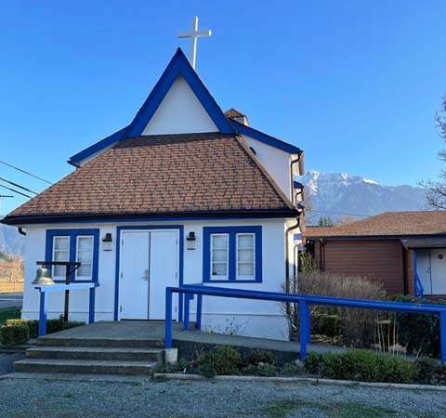

‘The ground we walk does not belong to us; for thousands of years it has been - and remains - the territory of the Stó:lō. We are grateful for their sharing.

Phone: 604-796-3553
Website: www.allsaints-agassiz.ca
https://www.facebook.com/groups/AllSaintsFamily
OUR DOOR IS OPEN AND ALL ARE WELCOME
October 25th, 2026, Twenty-Second Sunday After Pentecost
Morning Prayer
Hosts: Graham Featherstone/Jennifer Pinlac
Intercessor: Jennifer Pinlac
Lay Administrator: Dorothy Cresswell
Announcer: Virginia Jennings
Organ/Piano: Francesca Froehlich
Readers: Lynn Laughlin/Liane Loeppky
Coffee Time: Fran/Ginny

Vicar’s Warden: Ginny Jennings. 604-796-2206
People’s Warden: Lynn Laughlin. 604-799-5131
Please contact either warden if you have an issue that needs attention.

All Saint’s Calendar/Announcements:

- Book Club – On October 14th Book Club will be starting "Barefoot" by Sharon Garlough Brown, an experienced leader of spiritual formation retreats in the UK and US. The 4 women from Sensible Shoes and “Two Steps Forward” are taking their next steps in the spiritual formation journey.
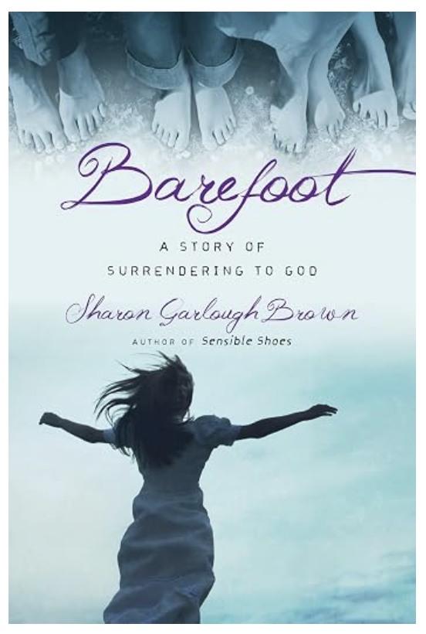

Please contact Valerie at Valeriejhamilton@yahoo.com
if you would like an invitation to the Zoom meetings
at 5.00 pm on Wednesdays.

- Bible Study is every Saturday morning 0830-0900 on Zoom. All are welcome to preview and discuss the readings for the Sunday service. Please ask Valerie to add your email address to the invitation list.

- Prayer Requests can be given on a piece of paper to either of the Wardens or entered in the Prayer Request Book on the lectern. Alternatively, you can contact Anthea Lewis at antheamlewis@shaw.ca for Pray First Prayer Circle, which is a confidential online prayer circle.

- Pastoral Care – we are not alone. Pastoral care is still available so if anyone needs emotional, physical or spiritual care, please contact one of the following people and they will put you in touch with the someone for that support.

Ginny: 604-793-3754
Lynn: 604-799-5131
Dorothy: 604-712-4710
Graham: 604-491-1288

- Music Requests may be given to the Wardens.

- AA meets in the hall every Tuesday and Friday at noon.

- Every Thursday in the hall 1100-1200 we have a social time with coffee, games if you like or just talk.

- At 1000-1100 on Thursdays there is an Interactive Bible Study on the day’s Lectionary readings. All are welcome – discover the treasures in this amazing book!

- Men’s Shed – Meets every Thursday from
1:00pm – 3:00pm at All Saints Anglican Church
A welcoming place where men can connect with
others, share their skills, learn something new
and enjoy being part of their community.
For more information contact Brian at agassizharrisonmensshed@gmail.com

- 5th Sunday of each month will be a potluck lunch after the service.

A Little Chuckle



Birthdays in the October

We have no birthdays in the month of October. I am sure someone is born in this month, but they aren’t part of our All Saints family.

Diocesan Cycle of Prayer: We Pray for the Clergy and Congregation:

The Diocesan Primate’s World Relief and Development Fund Unit – The Revd Joe Dirbas, Chair; St. Alban the Martyr, Burnaby - The Revd Brian Choto

Anglican Church of Canada Cycle of Prayer – We Pray for:

The Rt. Rev. John Stephens, Bishop, and the clergy and people of the Diocese of New Westminster

Collect

Lord God our redeemer, who heard the cry of your people and sent your servant Moses to lead them out of slavery, free us from the tyranny of sin and death, and by the leading of your Spirit bring us to our promised land; through Jesus Christ our Lord, who lives and reigns with you and the Holy Spirit, one God, now and for ever.

Sirach 18:19-33 Lynn Laughlin

¹⁹ Before you speak, learn,
and before you fall ill, take care of your health.
²⁰ Before judgment, examine yourself,
and in the hour of visitation you will find forgiveness.
²¹ Before falling ill, humble yourself,
and when you are on the point of sinning, turn back.
²² Let nothing hinder you from paying a vow promptly,
and do not wait until death to be released from it.
²³ Before making a vow, prepare yourself;
and do not be like a man who tempts the Lord.
²⁴ Think of his wrath on the day of death,
and of the moment of vengeance when he turns away his face.
²⁵ In the time of plenty think of the time of hunger;
in the days of wealth think of poverty and need.
²⁶ From morning to evening conditions change,
and all things move swiftly before the Lord.

²⁷ A wise man is cautious in everything,
and in days of sin he guards against wrongdoing.
²⁸ Every intelligent man knows wisdom,
and he praises the one who finds her.
²⁹ Those who understand sayings become skilled themselves,
and pour forth apt proverbs.

³⁰ Do not follow your base desires,
but restrain your appetites.
³¹ If you allow your soul to take pleasure in base desire,
it will make you the laughingstock of your enemies.
³² Do not revel in great luxury,
lest you become impoverished by its expense.
³³ Do not become a beggar by feasting with borrowed money,
when you have nothing in your purse.

Psalm 63:1-11

¹ You, God, are my God,
earnestly I seek you;
I thirst for you,
my whole being longs for you,
in a dry and parched land
where there is no water.

² I have seen you in the sanctuary
and beheld your power and your glory.
³ Because your love is better than life,
my lips will glorify you.
⁴ I will praise you as long as I live,
and in your name I will lift up my hands.
⁵ I will be fully satisfied as with the richest of foods;
with singing lips my mouth will praise you.
⁶ On my bed I remember you;
I think of you through the watches of the night.
⁷ Because you are my help,
I sing in the shadow of your wings.
⁸ I cling to you;
your right hand upholds me.

⁹ Those who want to kill me will be destroyed;
they will go down to the depths of the earth.
¹⁰ They will be given over to the sword
and become food for jackals.

¹¹ But the king will rejoice in God;
all who swear by God will glory in him,
while the mouths of liars will be silenced.

Psalm 98

¹ Sing to the Lord a new song,
for he has done marvelous things;
his right hand and his holy arm
have worked salvation for him.
² The Lord has made his salvation known
and revealed his righteousness to the nations.
³ He has remembered his love
and his faithfulness to Israel;
all the ends of the earth have seen
the salvation of our God.

⁴ Shout for joy to the Lord, all the earth,
burst into jubilant song with music;
⁵ make music to the Lord with the harp,
with the harp and the sound of singing,
⁶ with trumpets and the blast of the ram’s horn—
shout for joy before the Lord, the King.

⁷ Let the sea resound, and everything in it,
the world, and all who live in it.
⁸ Let the rivers clap their hands,
let the mountains sing together for joy;
⁹ let them sing before the Lord,
for he comes to judge the earth.
He will judge the world in righteousness
and the peoples with equity.

1 Corinthians 10:15-24 Liane Loeppky

¹⁵ I speak to sensible people; judge for yourselves what I say. ¹⁶ Is not the cup of thanksgiving for which we give thanks a participation in the blood of Christ? And is not the bread that we break a participation in the body of Christ? ¹⁷ Because there is one loaf, we, who are many, are one body, for we all share the one loaf.

¹⁸ Consider the people of Israel: Do not those who eat the sacrifices participate in the altar? ¹⁹ Do I mean then that food sacrificed to an idol is anything, or that an idol is anything? ²⁰ No, but the sacrifices of pagans are offered to demons, not to God, and I do not want you to be participants with demons. ²¹ You cannot drink the cup of the Lord and the cup of demons too; you cannot have a part in both the Lord’s table and the table of demons. ²² Are we trying to arouse the Lord’s jealousy? Are we stronger than he?

²³ “I have the right to do anything,” you say—but not everything is beneficial. “I have the right to do anything”—but not everything is constructive. ²⁴ No one should seek their own good, but the good of others.
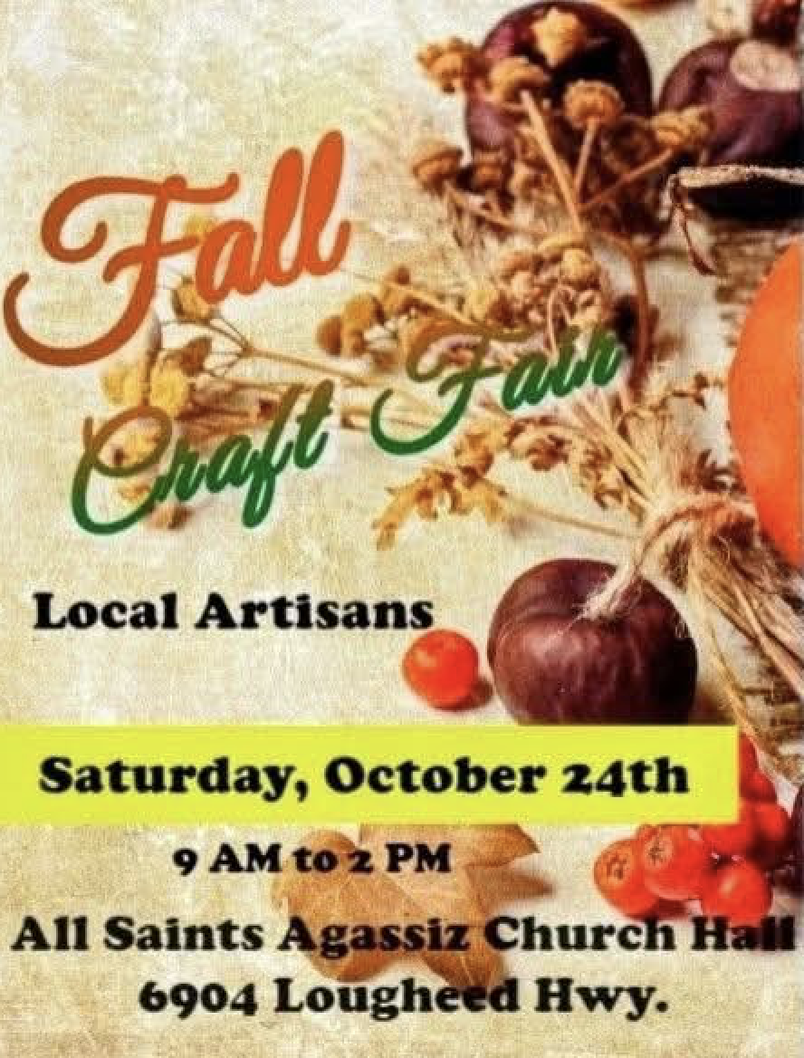

Odds and Ends
JOIN US ON SATURDAY FOR THE
FALL CRAFT FAIR
9:00am – 2:00pm

