This Week at PPBC

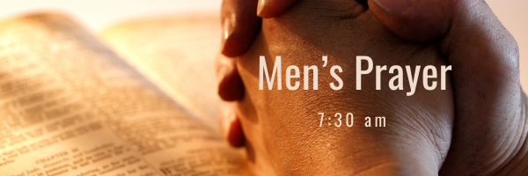


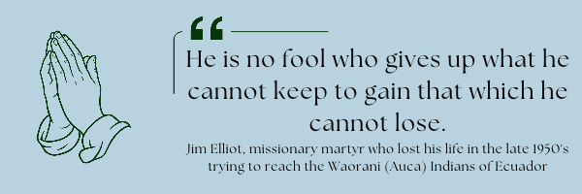A Prayer Request the Church in Anjou: Pastor-in-training, Wismy Thélus and his wife Rebca are expecting their first child. In addition, God has provided a home for them near the church. Please continue to pray for 2 elders within the church to work with Wismy. Discussion is underway for Pastor Rene and Wismy to visit us here at Port Perry Baptist in early 2027.
November 14, 2026
November 17, 2026
Saturday has coffee time at 7:15AM, breakfast served at 7:30AM,
Tuesday will have coffee served with desert at 6:30 PM
If you have not signed up please contact Gregg by text or call him at 289-385-1625 so he knows you are joining.

Starting Wednesday, November 4th, 2026!
Operation Christmas Child
Operation Christmas Child demonstrates God’s love by sending gift-filled shoeboxes to children in need around the world. Every shoebox is an opportunity to reach a child with the Gospel.
Listed below are some shoebox packing suggestions.
• Small backpack or purse
• Soccer ball and pump
• Stuffed animal, toy car
• Jewelry making or hobby kit
• Toothbrush
• Washcloth
• Comb and brush
• Nail clipper and file
• Reusable Water bottle
• Flashlight
• Pencils, sharpener, and erasers
• Pencil container
• Pens
• Crayons
• Colored pencils
• Markers
• Notebooks
• Index cards
• Calculator
• Scissors
• Ruler
• Glue stick
• Small adhesive tape
• Drawstring bag

Sunday Ministry Schedules
Below are ministry schedules for Nursery, Jr. Church, Greeters, Ushers, and Sound & Video:
Nursery
Oct 25: Lisa Dallas, Deb Brown, Alyssa Summers, Grace Brown
Nov 1: Brenda Clemens, Karis Henkelman, Hannah Colwell
Jr. Church; ages 3 to grade 1
Oct 25: Jenna Anderson, Kristine VanKessel
Nov 1: Abby Saunders, Lena Sammut
Jr. Church; grades 2 to 6
Oct 25: Gregg & Karen Anderson, Sara Davis
Nov 1: Jeff & Karen Clemens, Graeme Anderson
Greeters
Oct 25: Tracy & Karen Ballanger
Nov 1: TBA
Ushers
Oct 25: Mark McLaren, Roy Wilson
Nov 1: Graeme Foster, Leno Araujo
Parking Attendants
Oct 25: Steve Owens, Leno Araujo
Nov 1: Nick Woytowich, Mark McLaren
Sound & Video
Oct 25: Sound: Josh Anderson | Video: Gary VanKessel
Nov 1: Sound: Josh Anderson | Video: Josh Bolsonello

Sunday Service

Song – All Creatures of Our God and King
Welcome
Presentation & Prayer
Song – There is a Fountain
Song – Turn Your Eyes
Message – Jim Clemens
Song – In Christ Alone


Sunday, October 25th, 2026 @ 4:00pm

Praise & Prayer Highlights
PRAISE that the Lord provided a team for the Dugout Ministry. PRAY for the team as they prepare to start Dugout November 4th.
PRAY for Leno & Donna Araujo and their extended family as they mourn the loss of their niece's 3 week old baby. PRAY for God's comfort and peace during this time.
PRAY for the Bolsonello & Loney family as they mourn the loss of Karen Loney. PRAISE for her many ears of faith displayed. PRAY for the family as they prepare for a funeral service Saturday, October 24th.
"With grateful hearts, the Loney/Bolsonello family would like to say thank you to our extended family at Port Perry Baptist Church. Thank you for the cards, texts, calls, visits, acts of kindness, gifts of food and, most importantly, the constant prayers that surrounded and encouraged us all during these difficult months. God has blessed us through your love and care for us."
PRAY for the McKenzie Family as they head to Harmony Road Baptist Church to start ministry there. PRAY for God's Wisdom and Guidance to them and their new Church family as they go forward in ministry.
PRAY for Betty Collins and her ongoing health concerns. PRAY for her as she is now home from Hospital.
PRAY for John and Joan Mank and their ongoing health concerns.
PRAY for John and Elizabeth Kulchycki as they search for a new place to rent. If you know of any possibilities please let John know.

Giving
Just as a reminder, there are several ways you can give:
In Person using the offering box located on the back wall of the sanctuary. Donation envelopes are available at the Welcome Centre. Please contact the church office if you would like a box of donation envelopes (office@portperrybaptist.ca)
Through your online banking, you may send electronic transfers to ppbcdonations@gmail.com.
You can also give through Canada Helps. Donation receipts will be provided by Canada Helps, and transaction fees apply.
***********************************************************************
Weekly Newsletter
The PPBC Newsletter is emailed to the church family every Friday. If you would like to be added to the weekly email list, please contact the office by phone: 905-985-8681 or by email: office@portperrybaptist.ca.
*****************************************************************
Church Information:
Location:
2210 Hwy 7A
Port Perry, ON
L9L 1B4
Office Hours:
Monday: 8:30am – 4:00pm
Tuesday: 8:30am – 4:00pm
Wednesday: Closed
Thursday: 8:30am – 4:00pm
Friday: 8:30 am - 3:00 pm
Contact:
Phone: 905.985.8681
Email: office@portperrybaptist.ca
Website: www.portperrybaptist.ca
Staff:
Sr. Pastor – Rev. Jim Clemens
Administrative Assistant – Madeline Bolsonello
Pastoral Resident – Scott McKenzie

PPBC Newsletter
Sunday, October 25, 2026


Sunday Starting Point
Sunday, October 25, 2026 - 9:30 am
“Beginning the day with the Word and prayer”
Adults:
Adults will meet in the sanctuary for a time of study and prayer.
Youth:
Jr & Sr High will join the Adults in the Sanctuary.
Children Aged 3 – Grade 6:
All children will meet together in Room #26 for a time of singing and Bible lesson
(Please note nursery is unavailable during Sunday School)
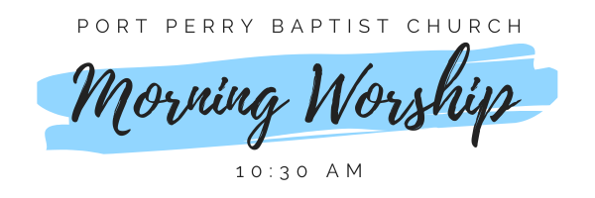Sunday Morning Worship
Sunday, October 25, 2026 - 10:30 am
We are meeting in the sanctuary and will continue to live-stream for those who are unable to attend.
Message: First Things First
Scripture: 1 Corinthians 15:1-11
Pastor Jim Clemens

