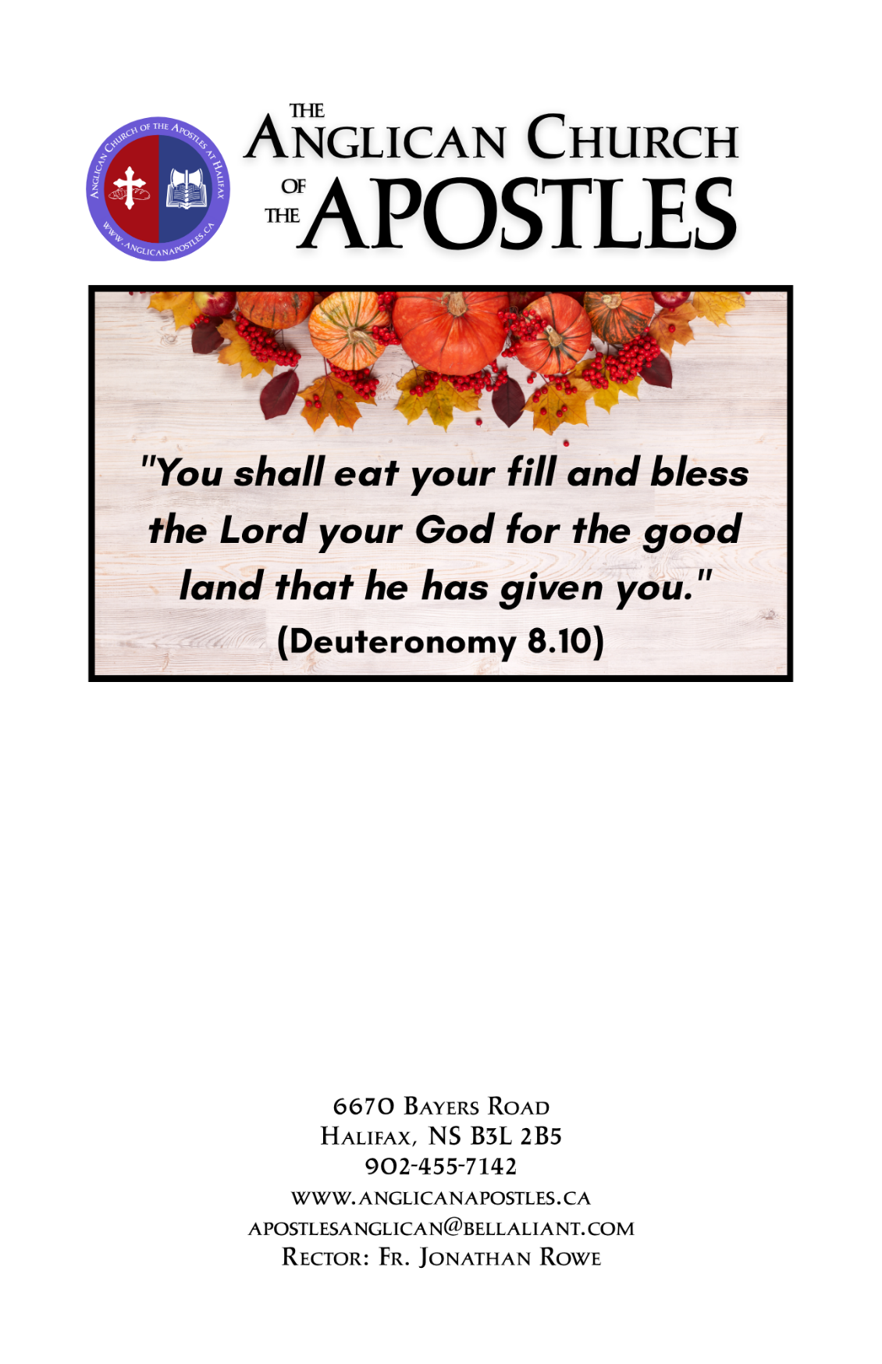

Twentieth Sunday after Pentecost
Harvest Thanksgiving
October 11, 2026
Celebration of Holy Communion

THE HOLY EUCHARIST
According to the Rite of the Book of Common Prayer
(Hymns are from the Book of Common Praise)
(Guest Organist – Wayne Rogers)
Prelude

THE ENTRANCE RITE
Opening Hymn: Come, Ye Thankful People, Come #262
Lord’s Prayer & Collect for Purity page 67
The Summary of the Law page 69
Kyrie Eleison page 70
The Collects

THE PROCLAMATION OF THE WORD
First Reading: Deuteronomy 8:7-18 (Garth Watt)
Psalm 65 (Daniel Owolabi)
Refrain: You crown the year with your goodness, O Lord.
You are to be praised, O God, in Zion; to you shall vows be performed in Jerusalem. To you that hear prayer shall all flesh come, because of their transgressions. Refrain
Our sins are stronger than we are, but you will blot them out. Happy are they whom you choose and draw to your courts to dwell there! they will be satisfied by the beauty of your house, by the holiness of your temple. Refrain
Awesome things will you show us in your righteousness, O God of our salvation, O Hope of all the ends of the earth and of the seas that are far away. You make fast the mountains by your power; they are girded about with might. Refrain
You still the roaring of the seas, the roaring of their waves, and the clamour of the peoples. Those who dwell at the ends of the earth will tremble at your marvellous signs; you make the dawn and the dusk to sing for joy. Refrain
You visit the earth and water it abundantly; you make it very plenteous; the river of God is full of water. You prepare the grain, for so you provide for the earth. Refrain
You drench the furrows and smooth out the ridges; with heavy rain you soften the ground and bless its increase. You crown the year with your goodness, and your paths overflow with plenty. Refrain
May the fields of the wilderness be rich for grazing, and the hills be clothed with joy. May the meadows cover themselves with flocks, and the valleys cloak themselves with grain; let them shout for joy and sing. Refrain
Glory be to the Father, and to the Son,
and to the Holy Spirit:
as it was in the beginning, is now,
and ever shall be, world without end. Amen.
Second Reading: 2 Corinthians 9:6-15 (Emily Rowe)
Gradual Hymn: For the Fruit of All Creation #259 (vs 1-2)
The Holy Gospel: Luke 17:11-19
Gradual Hymn: For the Fruit of All Creation #259 (vs 3)
The Nicene Creed page 71
Sermon
THE LITURGY OF THE EUCHARIST
The Offertory
Offertory Hymn: We Plough the Fields and Scatter #258
Prayer of Intercession page 75
Confession and Absolution page 76
Sursum Corda and Preface page 78
Sanctus and Benedictus page 81
Prayer of Consecration page 82
Prayer of Humble Access page 83
Agnus Dei page 84
The Communion
Communion Hymn: For the Beauty of the Earth (Tune: Dix #160) #429
Let All Things Now Living #403
The Lord’s Prayer page 85
The Gloria page 86
Blessing page 86
Closing Hymn: Now Thank We All Our God #399
Dismissal:
V. The Lord be with you; R. And with thy spirit.
V. Go in peace to love and serve the Lord.
R. Thanks be to God.
Choral Response (printed in back of hymn book)
Postlude

Please note: The Anglican Church of the Apostles provides our Sunday Services as a livestream. Find us on Facebook at:
FB.COM/APOSTLESCHURCHHALIFAX
or on YouTube at @ANGLICANAPOSTLES

NOTICES
2027 Church Calendars – 2027 Church Calendars are now available at $10 each; to purchase, please see Cora or Eileen.

Celebration of Memories – The Anglican Church of the Apostles and St. James Anglican Church are worshiping together here at Apostles next Sunday with the annual Celebration of Memories Services at 10:30 a.m.

Fall Festival of Music – The Faithful Friends Quartet, accompanied by Doug Hendsbee, will present a concert of music from a variety of traditions here at the Church of the Apostles at 2:00 PM on Sunday 25 October. We’d love to see you there!

All Saints and All Souls Day Service – will be celebrated on Sunday November 1 during our regular liturgy. Those who wish to participate are asked to submit the name or names of deceased loved ones whom they wish to have remembered in prayer and to have a candle lit in their memory. Names should be submitted to the office no later than Sunday, October 25.

Bishop’s Visitation – Clergy and parishioners from the Chebucto Region will gather for supper with Bishop Sandra Fyfe on Tuesday 3 November from 6:30-8:30 in the Cathedral’s Great Hall. Please mark your calendar, and plan to join us!
IN OUR PRAYERS
Worldwide
The Anglican Church of Burundi
Our Diocese – The Valley
Wilmot, NS Avon Valley, NS
Holy Trinity Church, Middleton St. George’s, Falmouth
All Saints’ Church, Kingston St. Michael’s, Windsor Forks
All Saints, Leminster
St. Thomas, Three Mile Plains
St. Andrew’s, Hantsport
Our Parish - Jim, Florence, Peggy, Roger, Nancy, Maverick, Connie,
Edward, Karl

