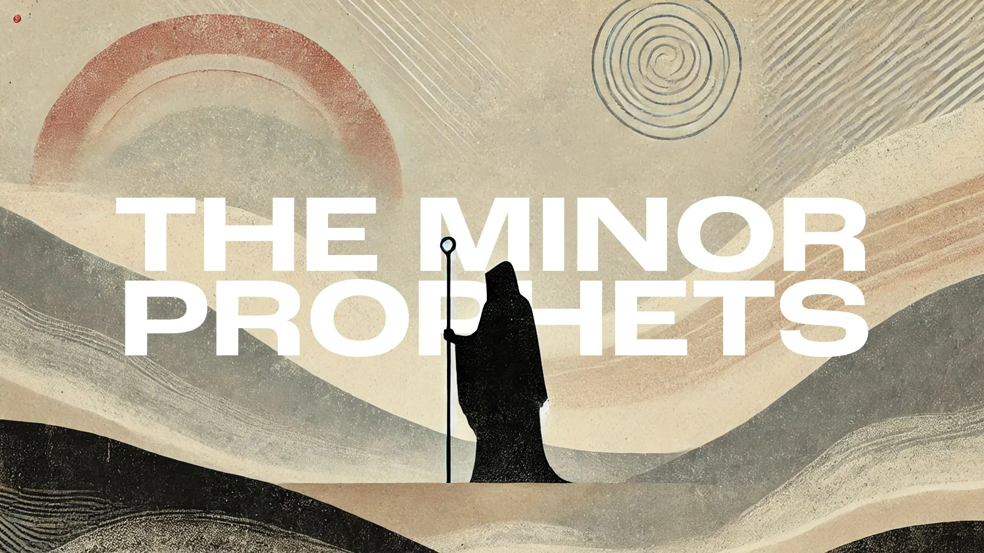
Victory Fellowship Bible Study
273 23rd St. S.W., Barberton, OH 44203
Wednesdays at 7pm
Rev. Roderick D. Grabski (330) 858-0223
arod4God@neo.rr.com FACEBOOK: Roderick Grabski

CLASS Five: The Divine Desire
- ANNOUNCEMENTS and PRAYER CONCERNS

- READ / LISTEN to Hosea 6:1-11
  - What are your initial impressions? Notable translation differences?

- AI - Chapter 6 Summary

- A Call to Repentance (6:1-3)
  - This is an assurance that all God’s punishments, even death, will be reversed. After a short time in exile (70 years), Israel will be resurrected.

  - (vs. 2) Paul may very well have had this verse in mind in 1Cor 15:4.

  - (vs. 3) Israel assumes that, just as tomorrow’s sunrise or the spring rains, God’s forgiveness will come. Their repentance is not very deep.

- The Lord’s First Lament (6:4-11a)
  - (vs. 4) The Lord is to Israel like a father of a rebellious child.

  - (vv. 5-6) God justifies His judgment. Jesus quoted vs 6 in Matthew 9:13 and 12:7.

  - (vs. 7) Adam can mean the man, or the town mentioned in Joshua 3:16.

  - (vs. 8) Gilead was an example of wicked injustice and bloodshed.

  - (vs. 9) Even the priests are indicted for murder and shameful crimes.

  - (vs. 10) God has witnessed a most horrible thing (Jeremiah 18:13).

  - (vs. 11a) Judah’s judgment is a harvest because the people are growing ripe with wickedness. (Jeremiah 51:33; Joel 3:13; Rev 14:14-20)

- READ / LISTEN to Hosea 7:1-16
  - What are your initial impressions? Notable translation differences?

- AI - Chapter 7 Summary

- God Sees Their Sin (6:11b; 7:1-2)
  - (vv. 6:11b-7:1) For the first time Hosea mentions the capital city of Samaria. What sins of Ephraim and Samaria will be exposed?

  - (vs. 2) What two things do they never consider?

- Israel’s Corruption (7:3-12)
  - (vv. 3-7) The baker is an image of the king who drunken debauchery allowed evil to flourish and co-conspirators to take advantage of them. What is the sad result of this situation?

  - (vv. 8-10) What is the overwhelming indictment against Israel? Again, what is the reason for these sad consequences?

  - (vs. 11) Who does Israel call on instead of Yahweh?

  - (vs. 12) God’s discipline will be that the news will spread to their enemies about their failed alliances.

- The Lord’s Second Lament (7:13-16)
  - (vs. 13) Here is a declaration of impending judgment.

  - (vs. 14) They do not cry out to Yahweh. Instead they wail and cut themselves in religious ritual to false gods. (1Kings 18:28)

  - (vs. 15) How do they repay Yahweh for strengthening them?

  - (vs. 16) They will be mocked for their arrogance and failure.

- APPLICATION:
  - Repentance precedes revival and restoration. (2 Chronicles 7:14)

  - God desires sincere faithfulness in our worship, and loving actions toward others. (Luke 10:27)

  - False religious beliefs and practices lead to false social and political actions. (Romans 12:2)

- Final Comments, Questions. Close in Prayer

Next Week: The Lord No Longer Loves
- Read Hosea 8:1 - 10:15 to prepare.

