All Saints Anglican Church
6904 Lougheed Highway, Agassiz, B.C. V0M 1A0
Bulletin October 12th, 2026 – October 18th, 2026

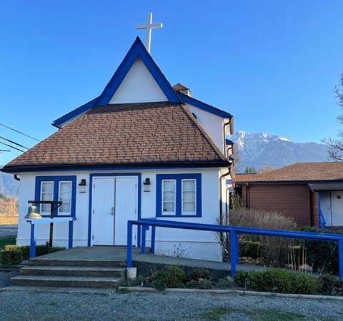

‘The ground we walk does not belong to us; for thousands of years it has been - and remains - the territory of the Stó:lō. We are grateful for their sharing.

Phone: 604-796-3553
Website: www.allsaints-agassiz.ca
https://www.facebook.com/groups/AllSaintsFamily
OUR DOOR IS OPEN AND ALL ARE WELCOME
October 18th, 2026, Twenty-First Sunday After Pentecost
Morning Prayer
Hosts: Graham Featherstone/Jennifer Pinlac
Intercessor: Keith Fossey
Lay Administrator: Dorothy Cresswell
Announcer: Virginia Jennings
Organ/Piano: Francesca Froehlich
Readers: Ginny Jennings/Bonnie Maitland
Coffee Time: Dorothy/Sherrill

Vicar’s Warden: Ginny Jennings. 604-796-2206
People’s Warden: Lynn Laughlin. 604-799-5131
Please contact either warden if you have an issue that needs attention.

All Saint’s Calendar/Announcements:

- Book Club – On October 14th Book Club will be starting "Barefoot" by Sharon Garlough Brown, an experienced leader of spiritual formation retreats in the UK and US. The 4 women from Sensible Shoes and “Two Steps Forward” are taking their next steps in the spiritual formation journey.
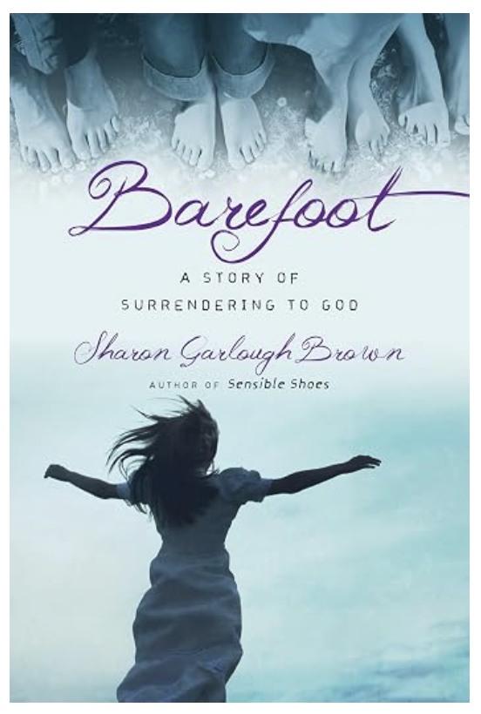

Please contact Valerie at Valeriejhamilton@yahoo.com
if you would like an invitation to the Zoom meetings
at 5.00 pm on Wednesdays.

- Bible Study is every Saturday morning 0830-0900 on Zoom. All are welcome to preview and discuss the readings for the Sunday service. Please ask Valerie to add your email address to the invitation list.

- Prayer Requests can be given on a piece of paper to either of the Wardens or entered in the Prayer Request Book on the lectern. Alternatively, you can contact Anthea Lewis at antheamlewis@shaw.ca for Pray First Prayer Circle, which is a confidential online prayer circle.

- Pastoral Care – we are not alone. Pastoral care is still available so if anyone needs emotional, physical or spiritual care, please contact one of the following people and they will put you in touch with the someone for that support.

Ginny: 604-793-3754
Lynn: 604-799-5131
Dorothy: 604-712-4710
Graham: 604-491-1288

- Music Requests may be given to the Wardens.

- AA meets in the hall every Tuesday and Friday at noon.

- Every Thursday in the hall 1100-1200 we have a social time with coffee, games if you like or just talk.

- At 1000-1100 on Thursdays there is an Interactive Bible Study on the day’s Lectionary readings. All are welcome – discover the treasures in this amazing book!

- Men’s Shed – Meets every Thursday from
1:00pm – 3:00pm at All Saints Anglican Church
A welcoming place where men can connect with
others, share their skills, learn something new
and enjoy being part of their community.
For more information contact Brian at agassizharrisonmensshed@gmail.com

- 5th Sunday of each month will be a potluck lunch after the service.

A Little Chuckle

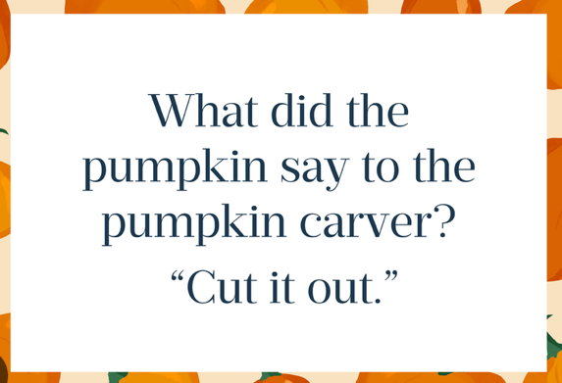

Birthdays in the October

We have no birthdays in the month of October. I am sure someone is born in this month, but they aren’t part of our All Saints family.

Diocesan Cycle of Prayer: We Pray for the Clergy and Congregation:

The Anglican Church Women – Ms Kelly Bowman, President; St. Thomas, Vancouver - The Revd Steve Black

Anglican Church of Canada Cycle of Prayer – We Pray for:

The Rt. Rev. Lynne McNaughton, Archbishop, and the clergy and people of the
Diocese of Kootenay

Collect

Almighty and everliving God, increase in us your gift of faith, that forsaking what lies behind and reaching out to what is before, we may run the way of your commandments and win the crown of everlasting joy; through Jesus Christ our Lord, who lives and reigns with you and the Holy Spirit, one God, now and for ever.

Sirach 4:1-10 Ginny Jennings

¹ My son, deprive not the poor of his living,
and do not keep needy eyes waiting.
² Do not grieve the one who is hungry,
nor anger a man in want.
³ Do not add to the troubles of an angry mind,
nor delay your gift to a beggar.
⁴ Do not reject an afflicted suppliant,
nor turn your face away from the poor.
⁵ Do not avert your eye from the needy,
nor give a man occasion to curse you;
⁶ for if in bitterness of soul he calls down a curse upon you,
his Creator will hear his prayer.

⁷ Make yourself beloved in the congregation;
bow your head low to a great man.
⁸ Incline your ear to the poor,
and answer him peaceably and gently.
⁹ Deliver him who is wronged from the hand of the wrongdoer;
and do not be fainthearted in judging a case.
¹⁰ Be like a father to orphans,
and instead of a husband to their mother;
you will then be like a son of the Most High,
and he will love you more than does your mother.

Psalm 148

¹ Praise the Lord.

Praise the Lord from the heavens;
praise him in the heights above.
² Praise him, all his angels;
praise him, all his heavenly hosts.
³ Praise him, sun and moon;
praise him, all you shining stars.
⁴ Praise him, you highest heavens
and you waters above the skies.

⁵ Let them praise the name of the Lord,
for at his command they were created,
⁶ and he established them for ever and ever—
he issued a decree that will never pass away.

⁷ Praise the Lord from the earth,
you great sea creatures and all ocean depths,
⁸ lightning and hail, snow and clouds,
stormy winds that do his bidding,
⁹ you mountains and all hills,
fruit trees and all cedars,
¹⁰ wild animals and all cattle,
small creatures and flying birds,
¹¹ kings of the earth and all nations,
you princes and all rulers on earth,
¹² young men and women,
old men and children.

¹³ Let them praise the name of the Lord,
for his name alone is exalted;
his splendor is above the earth and the heavens.
¹⁴ And he has raised up for his people a horn,
the praise of all his faithful servants,
of Israel, the people close to his heart.

Praise the Lord.

Psalm 149

¹ Praise the Lord.

Sing to the Lord a new song,
his praise in the assembly of his faithful people.

² Let Israel rejoice in their Maker;
let the people of Zion be glad in their King.
³ Let them praise his name with dancing
and make music to him with timbrel and harp.
⁴ For the Lord takes delight in his people;
he crowns the humble with victory.
⁵ Let his faithful people rejoice in this honor
and sing for joy on their beds.

⁶ May the praise of God be in their mouths
and a double-edged sword in their hands,
⁷ to inflict vengeance on the nations
and punishment on the peoples,
⁸ to bind their kings with fetters,
their nobles with shackles of iron,
⁹ to carry out the sentence written against them—
this is the glory of all his faithful people.

Praise the Lord.

Psalm 150

¹ Praise the Lord.
Praise God in his sanctuary;
praise him in his mighty heavens.
² Praise him for his acts of power;
praise him for his surpassing greatness.
³ Praise him with the sounding of the trumpet,
praise him with the harp and lyre,
⁴ praise him with timbrel and dancing,
praise him with the strings and pipe,
⁵ praise him with the clash of cymbals,
praise him with resounding cymbals.
⁶ Let everything that has breath praise the Lord.
Praise the Lord.
1 Corinthians 10:1-13 Bonnie Maitland

¹ For I do not want you to be ignorant of the fact, brothers and sisters, that our ancestors were all under the cloud and that they all passed through the sea. ² They were all baptized into Moses in the cloud and in the sea. ³ They all ate the same spiritual food ⁴ and drank the same spiritual drink; for they drank from the spiritual rock that accompanied them, and that rock was Christ. ⁵ Nevertheless, God was not pleased with most of them; their bodies were scattered in the wilderness.

⁶ Now these things occurred as examples to keep us from setting our hearts on evil things as they did. ⁷ Do not be idolaters, as some of them were; as it is written: “The people sat down to eat and drink and got up to indulge in revelry.” ⁸ We should not commit sexual immorality, as some of them did—and in one day twenty-three thousand of them died. ⁹ We should not test Christ, as some of them did—and were killed by snakes. ¹⁰ And do not grumble, as some of them did—and were killed by the destroying angel.

¹¹ These things happened to them as examples and were written down as warnings for us, on whom the culmination of the ages has come. ¹² So, if you think you are standing firm, be careful that you don’t fall! ¹³ No temptation has overtaken you except what is common to mankind. And God is faithful; he will not let you be tempted beyond what you can bear. But when you are tempted, he will also provide a way out so that you can endure it.

Odds and Ends


