THE ORDER OF WORSHIP
October 18, 2026/21st Sunday of Pentecost
Greeter: Dale Dixon and Rachel Hawk
Please fill out your Prayer & Praise Cards. Announcements are on the screens. Please come to the front pews to meet with a member of our Prayer Team before or after the service.
Gathering
Prayer of Consecration: Pastor John
One: Wake up, sleeper, rise from the dead,
All: and Christ will shine on you. Jesus, I belong to you. I lift up my heart to you. I set my mind on you. I fix my eyes on you. I offer my body to you
as a living sacrifice. Jesus, we belong to you. Praying in the name of the Father, and the Son, and the Holy Spirit, amen.

Opening Chorus: “Step by Step” No. 671 David Beaker Strasser
Prelude: “God’s Blessing Be On Thee” Ludwig van Beethoven
Bringing In the Light of Christ: Ann Via

Welcome and Announcement: Barbara Austin
*Call to Worship: Barbara Austin
One: God has set this day before us,
All: A day set apart, a day of rest and praise.
One: God has set our lives before us,
All: A span of years in which we love, and learn, and serve.
One: God has set God’s seal upon our hearts,
All: So that we might lie fully in deep love.
Let us worship God. Amen.

Greeting Our Brothers and Sisters in Christ

Proclamation and Response
*Opening Hymn: “Come, Thou Almighty King” No 27
(Collection of Prayer & Praise Cards)

Joys and Concerns: Pastor John
Prayer Chorus: “Breathe on Me, Breath of God” No. 304- V. 1
Silent Prayer & Pastoral Prayer /Lord’s Prayer: Pastor John

Anthem: “My Savior” James Koerts
Collection of Tithes and Offerings: Kirby Miller & Dale Dixon
*The Doxology: “My Tribute” On the Screen
*The Apostles’ Creed: No. 691

Scripture Reading: 1 John 3:16-18 Pastor John
One: The word of God for the people of God.
All: Thanks be to God and I believe it.

Sermon: “The Love of Christ for You” Pastor John

Sending Forth
*Closing Hymn: “Take Time to Be Holy” No. 316
Postlude: “Prayer” John M. Rasley

Please be seated. You are invited to close your eyes and use the few moments of music at the end of our service to practice Listening Prayer. This is a time to expect God to speak to you before you leave the sanctuary. In John 10:17, Jesus tells us; “My sheep hear my voice, and I know them, and they follow me.” Let’s try listening as we are silent and still. Members of the prayer team will remain on the front pews after the service. Feel free to come forward.
Benediction: Pastor John
ANNOUNCEMENTS

TO OUR VISITORS: We welcome you to Laurel Hill and hope that you feel at home. We invite you to join Laurel Hill if you do not have a church home. Please call our church office at 804-795-2772. You will find our Laurel Hill family both warm and eager to welcome you into our fellowship. Please fill out a visitor’s card and place it in
the offering plate. The password for our public WiFi is LivingHope - feel free to connect with us.

OCTOBER IS PASTOR APPRECIATION MONTH. Think of how you may bless Pastor John during this time and let him know how much he is appreciated. Also, remember our other pastors who so graciously fill the pulpit and bless us in so very many ways.

SAMARITAN PURSE CHRISTMAS BOXES…As you donate to the Christmas boxes consider giving card games, scissors and small toys a child can manipulate. Thank you.

MARK YOUR CALENDAR/PLAN TO ATTEND…On November 8th immediately following worship, we will have a “big” celebration for Agnes Stevenson’s 100th birthday. We will have a covered dish luncheon and birthday cake, of course. Don’t miss this opportunity to honor Agnes on such a very special day! This will also be a very wonderful blessing for Raymond. If you are able, bring Agnes a birthday card to remember this special day in her life. She will enjoy reading them over and over!

DEAR LAUREL HILL FRIENDS…Thank you so much for your kindness and support during Carl’s illness and recent passing. Your prayers and messages have meant so much to us. We appreciate all that you have done. Fondly, Patrice and Rebecca

SAVE THE DATE: The International Leadership Institute’s Training, “History Maker-Part 1”, is coming! We will meet at Beulah Methodist Church on Saturday, January 23, 30 and February 6. Please contact Pastor John if you want to participate.

KEEP IN OUR PRAYERS
SICK AND SHUT-INS – Kim Davis, Jean Miller, Evelyn Steele, Kathleen McKinsey, Sara Nelson, Regina Humphrey, David Torrence, Dot Gay, Sharon Loving & Family, Debra Deane, Agnes Stevenson and ML Yuhas.

- Our Weekday School – Margo Keeles (Director), our teachers, students and families.
- Our community of Varina and all the residents, our churches in our neighborhoods, schools, students, teachers, administrators and all employees.
- Our state of Virginia, our residents and leaders.
- The United States of America, our citizens and leaders, the countries of the world, their people and leaders. May God bless us all and His will be done.
- Those affected by war in Israel and Ukraine

WEEKLY CALENDAR
Monday 10:00 AM New Life House Church today. (804) 303-4828
7:00 Bible Study on Isaiah in person and on Zoom

Wednesday 9:00 AM Prayer Time with Communion
10:30 AM Bible Study
6:30 Handbell Choir-New Time

7:15 PM Chancel Choir Rehearsal-New Time

Thursday 7:00 PM PTL House Church at the Wilson’s home.

Friday 10:00 Thankful Hearts House Church (804) 737-7450

Saturday 9:00 AM Prayer Station at Dorey Park.

Sunday 10:00 AM Sunday School
11:00 AM Sunday Worship Service (also online)

Biblical Principles of Stewardship Explained https://bibleconclusions.com/biblical-principles-of-stewardship/

Do you feel tension when you think about money, time, or gifts God has given you? Many believers sense a spiritual tug between fear, freedom, and responsibility when they consider stewardship.

This article explains clear, biblical principles of stewardship that move faith into faithful action, anchored in Scripture and aimed at shaping our heart priorities and daily choices under God's ownership of all things.

How Are Biblical Principles Of Stewardship Explained?
Biblical stewardship teaches that God owns everything, believers manage what God entrusts to them, and faithful management shows itself in wise use, honest accountability, and generous giving. Scripture presents stewardship as a test of faithfulness that produces fruit for God's kingdom and care for the neighbor (see Matthew 25:14-30 (ESV)).

How can you give at Laurel Hill GMC?

1 – Cash and checks may be placed in the offering plate. Please contact the church office for offering envelopes.
2 - You may also give online. The QR code below will take you to our website’s giving page: https://laurelhill.tithelysetup.com/give

3 – Planned giving – including the LHGMC in your will is a wonderful way to ensure the ministries we are called to provide for Varina will continue into the future.

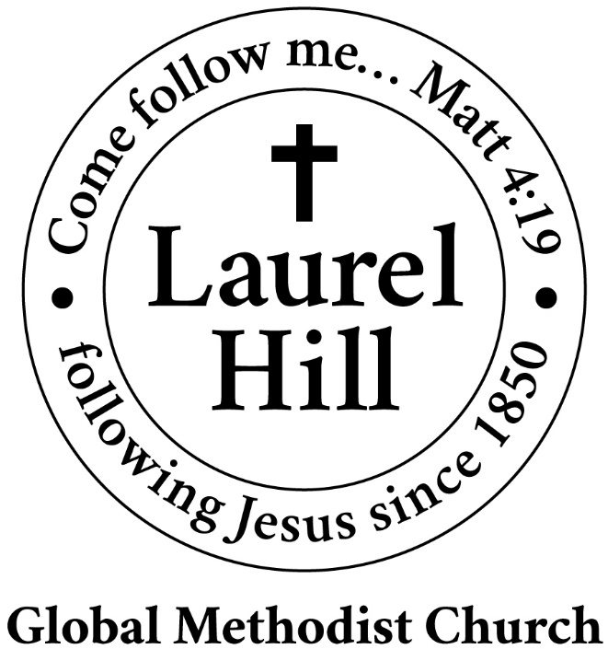
Our Mission: The Global Methodist Church exists to make disciples
of Jesus Christ and spread scriptural holiness across the globe.

1919 New Market Road, Henrico, VA 23231
On the web @ laurelhillchurch.org
Email to laurelhillchurch.varina@gmail.com
Phone: Office/804.795.2772 Pastor/804.437.0937

STAFF
Pastor: Rev. John Bright Organist/Choir Director: Pam Wilson
Secretary: Barbara Wendel School Director: Margo Keeles
Communications Assistant: Ben Wilson

that we you in thought, word, and deed.

