
Message Outline
Fall of Babylon
Revelation 17-19:10

Intro: Bible Project review of Revelation…
- Nearing the end of the apocalypse…
- Last week and wrath (cf. Rev.15-16, 1Thess.5:9, Jn.3:36)…

17:1a—Same angel for 7 bowls…
v.1-2—Bad girl symbolic of evil in variety of forms (cf. Ezek.16, 23)…
v.3—Beast is back from Rev. 12…
v.4—The clothing, crystals, and cup…
v.5—Backstory of Babylon (cf.Gen.10-11, 2Kgs.25, Daniel, Jer.51-52)…
v.6—Adulterous and murderous…
v.6b-7—Astonished by evil??? (cf. Ps.73)
v.8—Headed for destruction…
v.9-18—Decoding heads, horns, waters…
- Evil turning against itself (v.16ff.).
18:1-3—Angel brightening earth, shines light on Babylon’s dark ways…
- “Fallen, Fallen” shows certainness of doom…
v.4-8—God’s people to separate from Babylon…
v.9-20—Vanishing wealth…
v.21-24—Visual of Babylon sinking…
- “never…again” common refrain (6x)…
19:1-10—Songs of salvation…
- Wedding and clothing spotlighted in the wake of the woman in 17:4…

Lesson from Revelation 17-19:
_____________________________________
- Evil comes in looking rich and powerful (17:3ff.) but ends in a naked, bloody, mess (17:16ff.)…
- Suddenness of destruction (18:2, 8, 10, 17, 19, 21)…
- Psalm 73 and evils final outcome…

Reading Plan Next Week: Revelation 19-20
Message Outline
Fall of Babylon
Revelation 17-19:10

Intro: Bible Project review of Revelation…
- Nearing the end of the apocalypse…
- Last week and wrath (cf. Rev.15-16, 1Thess.5:9, Jn.3:36)…

17:1a—Same angel for 7 bowls…
v.1-2—Bad girl symbolic of evil in variety of forms (cf. Ezek.16, 23)…
v.3—Beast is back from Rev. 12…
v.4—The clothing, crystals, and cup…
v.5—Backstory of Babylon (cf.Gen.10-11, 2Kgs.25, Daniel, Jer.51-52)…
v.6—Adulterous and murderous…
v.6b-7—Astonished by evil??? (cf. Ps.73)
v.8—Headed for destruction…
v.9-18—Decoding heads, horns, waters…
- Evil turning against itself (v.16ff.).
18:1-3—Angel brightening earth, shines light on Babylon’s dark ways…
- “Fallen, Fallen” shows certainness of doom…
v.4-8—God’s people to separate from Babylon…
v.9-20—Vanishing wealth…
v.21-24—Visual of Babylon sinking…
- “never…again” common refrain (6x)…
19:1-10—Songs of salvation…
- Wedding and clothing spotlighted in the wake of the woman in 17:4…

Lesson from Revelation 17-19:
_____________________________________
- Evil comes in looking rich and powerful (17:3ff.) but ends in a naked, bloody, mess (17:16ff.)…
- Suddenness of destruction (18:2, 8, 10, 17, 19, 21)…
- Psalm 73 and evils final outcome…

Reading Plan Next Week: Revelation 19-20
Message Outline
Fall of Babylon
Revelation 17-19:10

Intro: Bible Project review of Revelation…
- Nearing the end of the apocalypse…
- Last week and wrath (cf. Rev.15-16, 1Thess.5:9, Jn.3:36)…

17:1a—Same angel for 7 bowls…
v.1-2—Bad girl symbolic of evil in variety of forms (cf. Ezek.16, 23)…
v.3—Beast is back from Rev. 12…
v.4—The clothing, crystals, and cup…
v.5—Backstory of Babylon (cf.Gen.10-11, 2Kgs.25, Daniel, Jer.51-52)…
v.6—Adulterous and murderous…
v.6b-7—Astonished by evil??? (cf. Ps.73)
v.8—Headed for destruction…
v.9-18—Decoding heads, horns, waters…
- Evil turning against itself (v.16ff.).
18:1-3—Angel brightening earth, shines light on Babylon’s dark ways…
- “Fallen, Fallen” shows certainness of doom…
v.4-8—God’s people to separate from Babylon…
v.9-20—Vanishing wealth…
v.21-24—Visual of Babylon sinking…
- “never…again” common refrain (6x)…
19:1-10—Songs of salvation…
- Wedding and clothing spotlighted in the wake of the woman in 17:4…

Lesson from Revelation 17-19:
_____________________________________
- Evil comes in looking rich and powerful (17:3ff.) but ends in a naked, bloody, mess (17:16ff.)…
- Suddenness of destruction (18:2, 8, 10, 17, 19, 21)…
- Psalm 73 and evils final outcome…

Reading Plan Next Week: Revelation 19-20

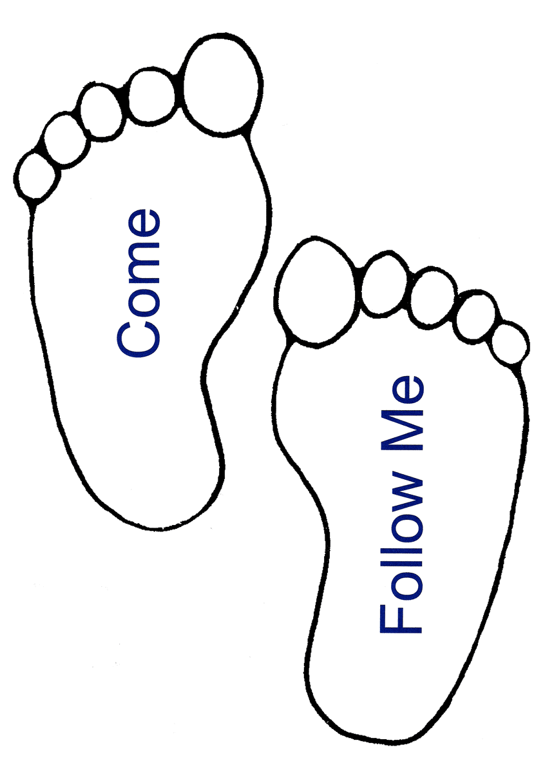
Small Group
Reflection Questions
(Please take time to ponder and pencil in
to prep for this week’s small group session.)

*Reflect on Last Week’s Practice: Sabbath
How was your practice of Sabbath (ie. what day, what did you do (or not do), what did you notice about God and yourself during that time, etc.)?

Watch: Video Session #5: Meeting God in Pain

*Can you tell one story of a painful experience you’ve been thru that has been used for good in your formation?

*How have you experienced God in times of pain and suffering?

*Which of the 3 responses to emotional pain are you most inclined toward: deny, detach, or drug? What would it look like for you to reorient yourself to pain in your life as an opportunity to be formed by God?

This Week’s Practice: Naming and Praying Emotions…
1) Notice emotions
2) Name emotions
3) Feel emotions
Small Group
Reflection Questions
(Please take time to ponder and pencil in
to prep for this week’s small group session.)

*Reflect on Last Week’s Practice: Sabbath
How was your practice of Sabbath (ie. what day, what did you do (or not do), what did you notice about God and yourself during that time, etc.)?

Watch: Video Session #5: Meeting God in Pain

*Can you tell one story of a painful experience you’ve been thru that has been used for good in your formation?

*How have you experienced God in times of pain and suffering?

*Which of the 3 responses to emotional pain are you most inclined toward: deny, detach, or drug? What would it look like for you to reorient yourself to pain in your life as an opportunity to be formed by God?

This Week’s Practice: Naming and Praying Emotions…
1) Notice emotions
2) Name emotions
3) Feel emotions
Small Group
Reflection Questions
(Please take time to ponder and pencil in
to prep for this week’s small group session.)

*Reflect on Last Week’s Practice: Sabbath
How was your practice of Sabbath (ie. what day, what did you do (or not do), what did you notice about God and yourself during that time, etc.)?

Watch: Video Session #5: Meeting God in Pain

*Can you tell one story of a painful experience you’ve been thru that has been used for good in your formation?

*How have you experienced God in times of pain and suffering?

*Which of the 3 responses to emotional pain are you most inclined toward: deny, detach, or drug? What would it look like for you to reorient yourself to pain in your life as an opportunity to be formed by God?

This Week’s Practice: Naming and Praying Emotions…
1) Notice emotions
2) Name emotions
3) Feel emotions

