
Colington United Methodist Church
October 18, 2026
Twenty-first Sunday after Pentecost

welcome
prelude and lighting of altar candles
Awesome God Mullins
opening hymn
Come and Behold Him
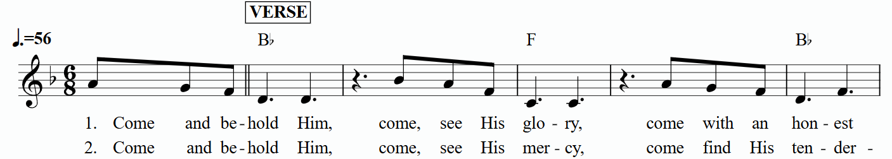
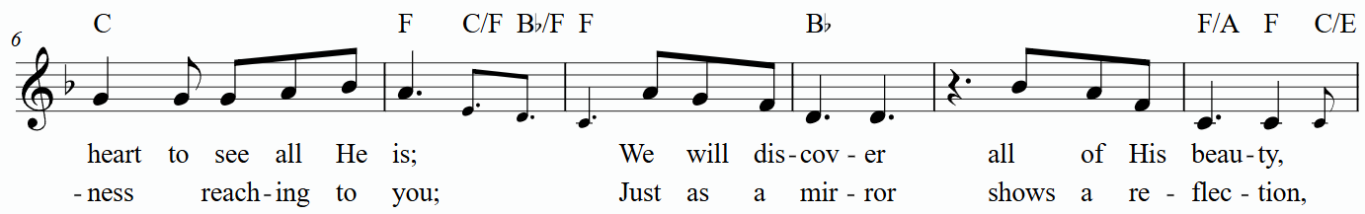
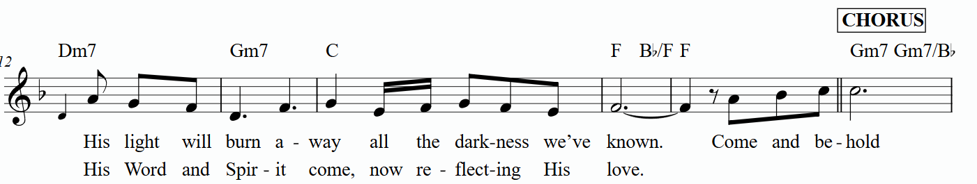
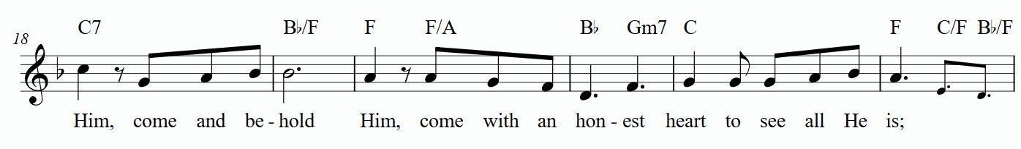

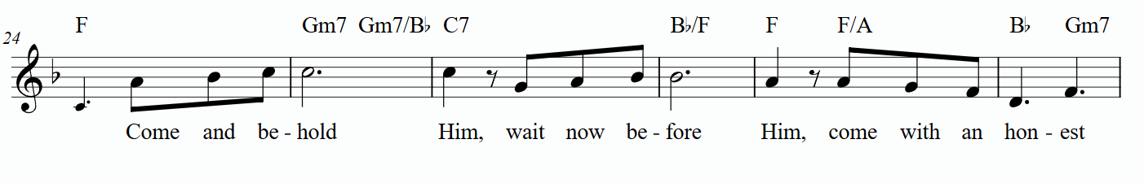



prayers of the people
the psalter
Psalm 96:1-9
special music
I’ll Fly Away ǀ Ronnie Sue Pfeiffer, Trish Gray, Pat Hansen
gospel lesson
Matthew 22:15-22
sermon
“Rendering” ǀ Rev. Jack Colenda
†affirmation of praise
As the Deer
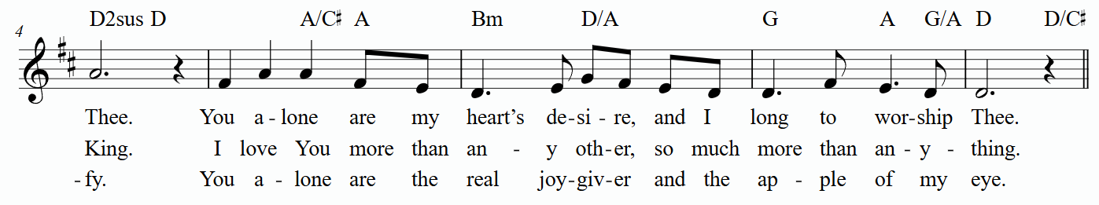
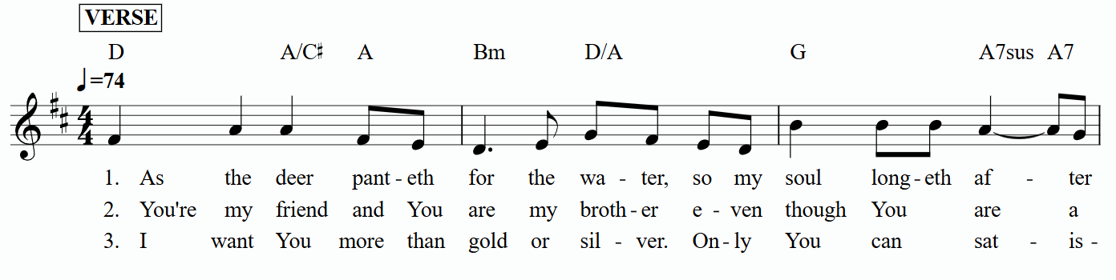

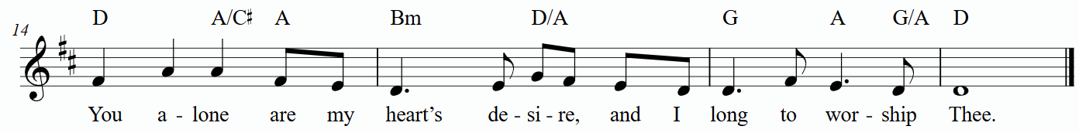
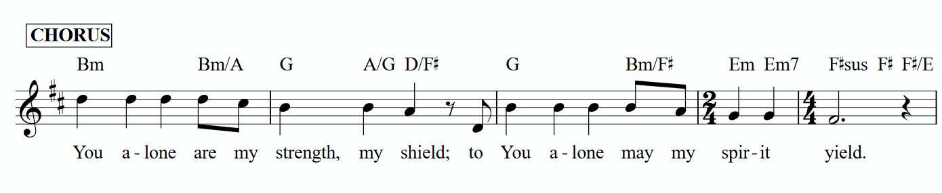

the great thanksgiving
giving the bread and the cup
†closing hymn
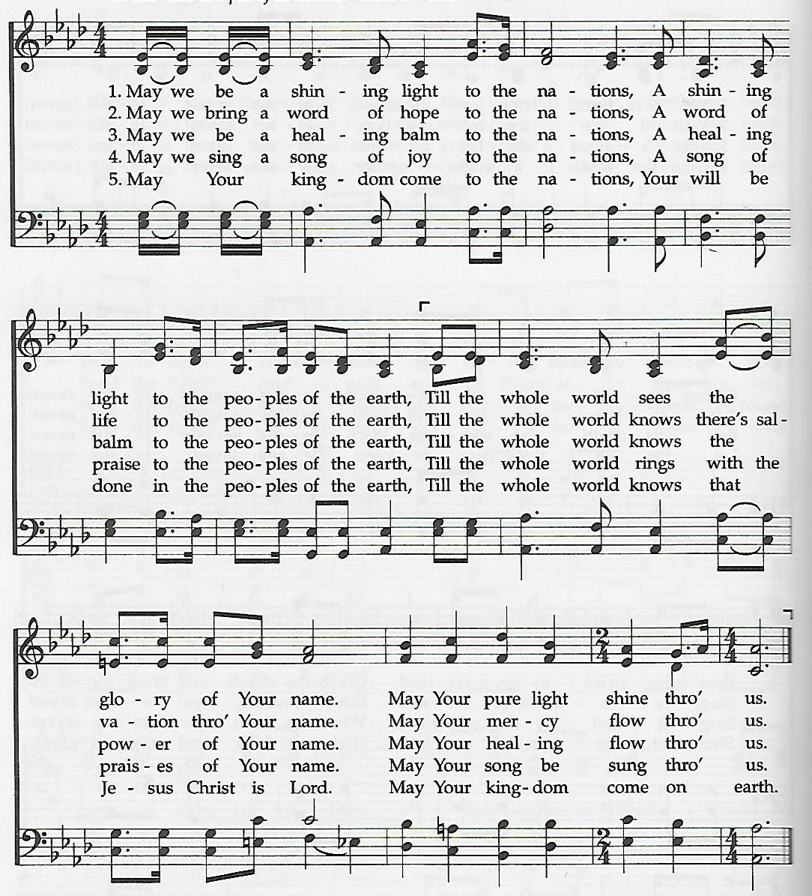
Song for the Nations

this week at colington
These opportunities to serve as the Body of Christ are available.
Tuesday – 9 am – Prayer Group
Wednesday – 10am - Admin. Council meeting.
Saturday – UWF Annual meeting at Sharon UMC.

coming up
Next Sunday – 8:15 – choir practice
9:30 am – Worship, in-person and Facebook Live
Mon., Oct. 26 – Student of the month at FFES.
Tues., Oct. 27 – Hosting Ruthie’s Kitchen. Contact Stacy Murphy to volunteer at email address- sewbusy1964@gmail.com.
Wed., Oct. 28 – 10am Knitters and crocheters meet.
1:45pm – Volunteers to Beach Food Pantry.
Mon., Nov.2 –2:15pm - MAT starts at FFES. Contact Gail Hendricks or Frances Veal to volunteer.
Wed., Nov. 4 – 12pm – Veterans lunch at Spring Arbor.

Thanks to today’s volunteers!
Ushers – Steve Knowles/ Ozzie Gray/ Wiley Beales
Scripture Reader – Sherry Rollason
Communion Assistant – Ozzie Gray

The flowers on the altar are given by Dolores Norton in memory of Ed Miller.

Last week’s attendance – 57.

