This Week at PPBC

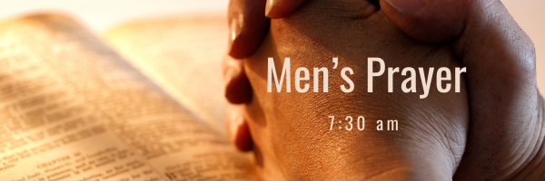


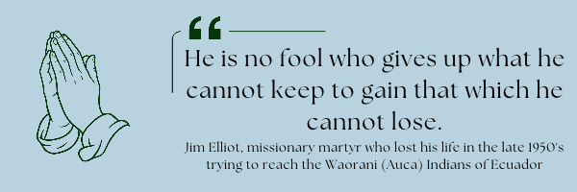A Prayer Request Merajis: Carolyn has been on maternity leave since Eli’s birth. This ends this week. Carolyn and Ebi are praying for guidance about stepping out in faith that God will provide all their needs without Carolyn having to go back to work. This would free Carolyn up to concentrate on their outreach to Iranians and their family, which is something that she has desired for a long time. She asks prayer as she decides whether or not to go back to work.
November 14, 2026
November 17, 2026
Saturday has coffee time at 7:15AM, breakfast served at 7:30AM,
Tuesday will have coffee served with desert at 6:30 PM
If you have not signed up please contact Gregg by text or call him at 289-385-1625 so he knows you are joining.

Sunday, October 25th, 2026 @ 4:00pm
Operation Christmas Child
Operation Christmas Child demonstrates God’s love by sending gift-filled shoeboxes to children in need around the world. Every shoebox is an opportunity to reach a child with the Gospel.
Listed below are some shoebox packing suggestions.
• Small backpack or purse
• Soccer ball and pump
• Stuffed animal, toy car
• Jewelry making or hobby kit
• Toothbrush
• Washcloth
• Comb and brush
• Nail clipper and file
• Reusable Water bottle
• Flashlight
• Pencils, sharpener, and erasers
• Pencil container
• Pens
• Crayons
• Colored pencils
• Markers
• Notebooks
• Index cards
• Calculator
• Scissors
• Ruler
• Glue stick
• Small adhesive tape
• Drawstring bag

Sunday Ministry Schedules
Below are ministry schedules for Nursery, Jr. Church, Greeters, Ushers, and Sound & Video:
Nursery
Oct 18: Jan Gerrow, Jen Werner, Audrianna Angrove, Brantley Colwell
Oct 25: Lisa Dallas, Laura Saunders, Alyssa Summers
Jr. Church; ages 3 to grade 1
Oct 18: Christine McLaren, Alyssa Summers
Oct 25: Jenna Anderson, Kristine VanKessel
Jr. Church; grades 2 to 6
Oct 18: Miriam Bolsonello, Tiffany Green
Oct 25: Gregg & Karen Anderson, Sara Davis
Greeters
Oct 18: TBA
Oct 25: Tracy & Karen Ballanger
Ushers
Oct 18: Nick Woytowich, Paul Sammut
Oct 25: Mark McLaren, Roy Wilson
Parking Attendants
Oct 18: Graeme Foster
Oct 25: Steve Owens, Leno Araujo
Sound & Video
Oct 18: Sound: Wyatt Werner | Video: Darryl Piwek
Oct 25: Sound: Josh Anderson | Video: Gary VanKessel

Sunday Service
Song – By Faith
Welcome
Song – There is One Gospel
Baptism
Song – Tis So Sweet to Trust in Jesus
Song – Psalm 23
Message – Jim Clemens
Song – We Will Glorify


This Sunday, October 18th, Everly Hicks will be baptized. Please be praying for Everly as she prepares to share her testimony.

Praise & Prayer Highlights
PRAY for the Lord to provide the main leader for the Dugout Ministry in the fall.
PRAY for Everly Hicks who is preparing for baptism on October 18th.
PRAY for the Bolsonello & Loney family as they mourn the loss of Karen Loney. PRAISE for her many ears of faith displayed. PRAY for the family as they prepare for a funeral service Saturday, October 24th.
"With grateful hearts, the Loney/Bolsonello family would like to say thank you to our extended family at Port Perry Baptist Church. Thank you for the cards, texts, calls, visits, acts of kindness, gifts of food and, most importantly, the constant prayers that surrounded and encouraged us all during these difficult months. God has blessed us through your love and care for us."
PRAY for the Angrove family as they mourn the loss of Steve's mom. PRAY for God's comfort to them during this time.
PRAY for Betty Collins and her ongoing health concerns. PRAY for her comfort and healing as she recovers in Whitby Hospital.
PRAY for Ray Collins who is sick, PRAY for his healing and recovery.
PRAY for Martin McCurley as he recovers from bumps and bruises from a recent fall.
PRAY for John and Joan Mank and their ongoing health concerns.
PRAY for John and Elizabeth Kulchycki as they search for a new place to rent. If you know of any possibilities please let John know.

Giving
Just as a reminder, there are several ways you can give:
In Person using the offering box located on the back wall of the sanctuary. Donation envelopes are available at the Welcome Centre. Please contact the church office if you would like a box of donation envelopes (office@portperrybaptist.ca)
Through your online banking, you may send electronic transfers to ppbcdonations@gmail.com.
You can also give through Canada Helps. Donation receipts will be provided by Canada Helps, and transaction fees apply.
***********************************************************************
Weekly Newsletter
The PPBC Newsletter is emailed to the church family every Friday. If you would like to be added to the weekly email list, please contact the office by phone: 905-985-8681 or by email: office@portperrybaptist.ca.
*****************************************************************
Church Information:
Location:
2210 Hwy 7A
Port Perry, ON
L9L 1B4
Office Hours:
Monday: 8:30am – 4:00pm
Tuesday: 8:30am – 4:00pm
Wednesday: Closed
Thursday: 8:30am – 4:00pm
Friday: 8:30 am - 3:00 pm
Contact:
Phone: 905.985.8681
Email: office@portperrybaptist.ca
Website: www.portperrybaptist.ca
Staff:
Sr. Pastor – Rev. Jim Clemens
Administrative Assistant – Madeline Bolsonello
Pastoral Resident – Scott McKenzie

PPBC Newsletter
Sunday, October 18, 2026


Sunday Starting Point
Sunday, October 18, 2026 - 9:30 am
“Beginning the day with the Word and prayer”
Adults:
Adults will meet in the sanctuary for a time of study and prayer.
Youth:
Jr & Sr High will join the Adults in the Sanctuary.
Children Aged 3 – Grade 6:
All children will meet together in Room #26 for a time of singing and Bible lesson
(Please note nursery is unavailable during Sunday School)
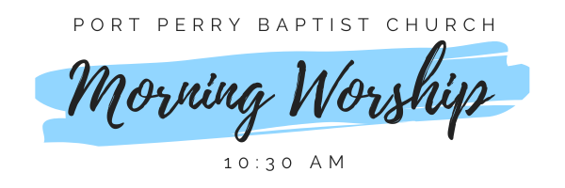Sunday Morning Worship
Sunday, October 18, 2026 - 10:30 am
We are meeting in the sanctuary and will continue to live-stream for those who are unable to attend.
Message: Prophecy, Tongues & A Healthy Church Part 3
Scripture: 1 Corinthians 14:26-40
Pastor Jim Clemens

