My response to today’s message

Information without application falls short of God’s best for us. He wants us to apply what we learn so that we will change and grow, becoming more like Christ. The following questions are for personal and group study.

1) Have you ever had the experience of feeling like a “foreigner”? Describe a time when you experienced a clash with the culture.

2) In what ways is 1 Peter 4:1-6 based upon the previous passage (1 Peter 3:18-22)? According to 1 Peter 4:1-6, how is a Christian different from the pagan culture?

3) In vs. 1-3, what is the change that occurs in the believer’s life? How has your life changed since you came to know Christ as your Savior and Lord?

4) In vs. 4-5, what is the challenge that comes to the believer? Describe a time when you experienced conflict with the culture. Peter warns us that some unbelievers will seek to draw us back into ungodly activities. What have you done to resist those pressures?

5) Christians are faced with choices regarding the culture. What does it mean to live an authentic Christian life today?

6) Discuss and apply what it means to: continue living for Christ, consider the consequences, and concentrate on Christ. How can others in your family or small group help you have hope beyond the culture?

7) As you pray, prepare and plan to share the hope of Christ, who is one person you can invite and bring with you to Focus Church?

What is the main thing that God has impressed upon you today?

What are you going to do about it?

Remember: The smallest obedient act is better than the greatest intention.

Primary message sources and recommended resources: Hope Again (1 Peter) by Charles R. Swindoll; Exposition of the New Testament (1 Peter) by Warren Wiersbe; NIV Application Commentary (1 Peter); Word Biblical Commentary (1 Peter); The Communicator’s Commentary (1 Peter) by Paul Cedar.

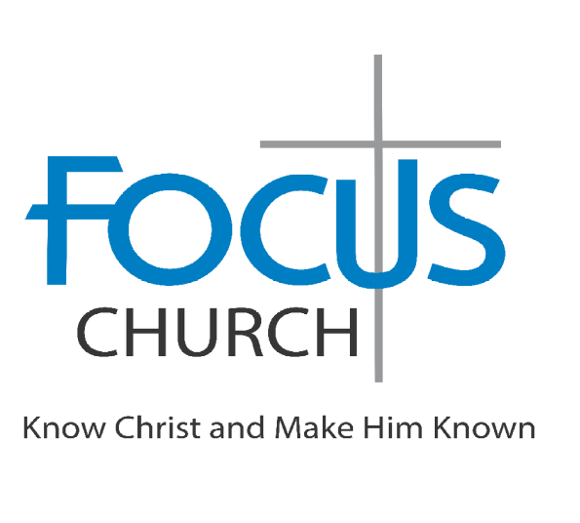
Welcome to Focus Church—a Christ-centered community learning to follow Jesus with purpose and passion. Our mission is to know Christ and make Him known – to follow Jesus fully through biblical teaching, authentic relationships, joyful worship, and compassionate service. Wherever you are on your journey, you are welcome here.

Guests: Please complete a “Connect Card” and pick up a blue gift bag as our “thank you” for being with us today.

Sunday, October 11
9am – Adult Sunday School Class
10am – Worship Celebration

Church Office & Mailing Address
10475 Crosspoint Blvd Ste 250
Indianapolis, IN 46256-3387
317-813-5996 https://www.myfocuschurch.com/

Would you like to experience and enjoy peace with God and share His peace with others? Go to peacewithgod.net to learn more.

TODAY’S MESSAGE, OCTOBER 11, 2026
SERIES: A Living Hope
“Experiencing Hope Beyond the Culture”
Brian Boone, Lead Pastor

America is not at a crossroads. America is a long way down the wrong road. It needs to come back to the crossroads and take the right road.
(Billy Graham)

We are not going to move this world by criticism of it nor conformity to it, but by the combustion within it of lives ignited by the Spirit of God.
(Vance Havner)

Therefore, since Christ suffered in his body, arm yourselves also with the same attitude… (1 Peter 4:1a, NIV)

Christ suffered for our sins once for all time. He never sinned, but he died for sinners to bring you safely home to God. He suffered physical death, but he was raised to life in the Spirit… Now Christ has gone to heaven. He is seated in the place of honor next to God, and all the angels and authorities and powers accept his authority. (1 Peter 3:18, 22, NLT)

1._____________________________________________________

¹ So then, since Christ suffered physical pain, you must arm yourselves with the same attitude he had, and be ready to suffer, too. For if you have suffered physically for Christ, you have finished with sin. ² You won’t spend the rest of your lives chasing your own desires, but you will be anxious to do the will of God. ³ You have had enough in the past of the evil things that godless people enjoy—their immorality and lust, their feasting and drunkenness and wild parties, and their terrible worship of idols. (1 Peter 4:1-3, NLT)

2._____________________________________________________

⁴ Of course, your former friends are surprised when you no longer plunge into the flood of wild and destructive things they do. So they slander you. ⁵ But remember that they will have to face God, who stands ready to judge everyone, both the living and the dead. (1 Peter 4:4-5, NLT)

3._____________________________________________________

⁶ That is why the Good News was preached to those who are now dead—so although they were destined to die like all people, they now live forever with God in the Spirit. (1 Peter 4:6, NLT)

1)_____________________________________________________

2)_____________________________________________________

3)_____________________________________________________

Let us not be so taken up with beholding the sin of the world that we do not behold Him who came to take it away. (Vance Havner)

