
THE ANGLICAN PARISH OF ST. MARK
138 Hoylake Road, Qualicum Beach, BC V9K 1K3
The Reverend Diana Boland
Twenty-first Sunday after Pentecost, 10:00 am, October 18, 2026
HOLY EUCHARIST — Book of Alternative Services
In a state of openness, and with a desire to learn the truth of our shared history, we acknowledge that we worship on the unceded territory of the Qualicum First Nation. We give thanks for their careful stewardship of the forests, rivers, oceans, lands and air, so that we might walk with them and celebrate the gift of the Creator. We commit to a lifelong journey of respectful understanding.

Welcome & Announcements
Opening Sentence: Shine as lights in the world, holding fast the word of life.
Opening Hymn: CP #312 “Sing a New Song unto the Lord”
The Gathering of the Community page 185
Gloria, Gloria, in Excelsis Deo (sung Latin, English, Latin — music CP #376)
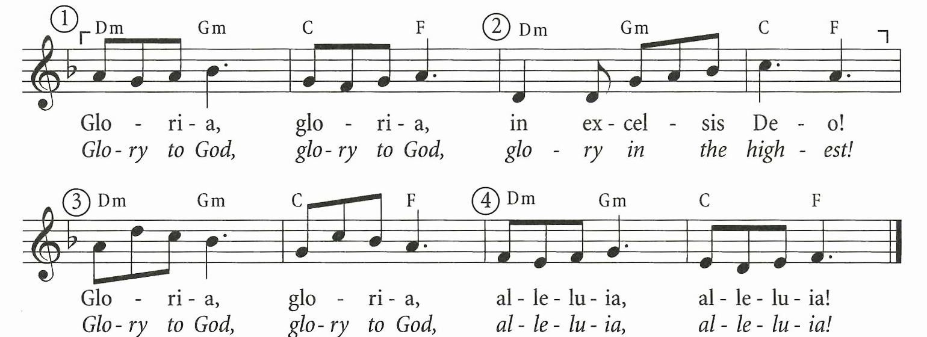
Collect of the Day (together): page 387
Almighty and everliving God,
increase in us your gift of faith,
that forsaking what lies behind
and reaching out to what is before,
we may run the way of your commandments
and win the crown of everlasting joy;
through Jesus Christ our Lord,
who lives and reigns with you and the Holy Spirit,
one God, now and for ever.
The Proclamation of the Word
First Reading: EXODUS 33:12-23
Psalm 99 page 837
Second Reading: 1 THESSALONIANS 1:1-10
Gradual Hymn: CP #402 “Come Fill Our Hearts” (vv. 1-2)
Reader: The Lord be with you
People: And also with you
Reader: The Holy Gospel of our Lord, Jesus Christ, according to Matthew
People: Glory to you Lord Jesus Christ
The Gospel: MATTHEW 22:15-22
Reader: This is the Gospel of Christ;
People: Praise to you Lord Jesus Christ
Gradual Hymn: CP #402 “Come Fill Our Hearts” (vv. 1-2)
Sermon: The Rev. Diana Boland
The Nicene Creed page 188
The Prayers of the People
Confession and Absolution page 191
The Peace
Offertory Hymn: CP #60 “I Come With Joy”
Prayer over the Gifts:
Eternal God, your word inspires our faith. May we who offer you our praise trust you in all things. We ask this in the name of Jesus Christ the Lord.
The Celebration of the Eucharist

Our Prayer Ministry
Our healing prayer team invites you to join them to pray or give thanks to God in the narthex (entrance) during or after communion, or in the alcove under the Exit sign after the service. Confidentiality is assured.

Eucharistic Prayer #2 page 196
Sanctus (Holy, Holy) — (sung - music CP #719)
The Lord’s Prayer — (sung)
The Breaking of the Bread sentence #2 page 212
Post Communion Hymn: CP #385 “Worship the Lord in the Beauty of Holiness”
Celebrant: Let us pray.
God of peace,
you have nourished us in this sacrament
with the body and blood of Christ.
May we who have taken holy things
keep faith in our hearts and lives,
in the name of Jesus Christ the Lord.
Doxology: Glory to God, whose power… page 214
Final Blessing
Recessional Hymn: CP #505 “Be Thou My Vision”
Leader: Go in peace to love and serve the Lord.
People: Thanks be to God.

EMERGENCY CONTACTS FOR PASTORAL CARE
Morag Atherstone: 250-240-6731
Cynthia Preyser: 250-954-9122

CALENDAR: OCTOBER 19 – OCTOber 25

Tuesday, October 20
9:15 – 11:00 am — Men’s Study Group
9:00 am – 3:00 pm — Off Kilter Quilters
4:00 – 5:00 pm — Handbells

Wednesday, October 21
10:00 – 11:00 am — Sermon Circle
10:00 am — Christmas Bazaar Meeting
11:30 am – 12:00 pm — BAS Holy Eucharist
12:30 – 2:30 pm — The Chosen
5:30 pm — NAC (downstairs)

Thursday, October 22
9:30 am – 10:30 am — Men’s Club
11:15 am — Choir Practice
1:00 pm — Parish Council
3:30 – 4:30 pm — 52 Ways Discussion Group

Friday, October 23
1:30 – 3:00 pm — Safe Church Video Viewing

Saturday, October 24
10:00 am — Pre-Synod Regional Gathering at St Peter's, Campbell River
2:00 pm — Memorial Service for William Atwood

Sunday, October 25
8:30 am — BCP — Holy Eucharist
10:00 am — BAS — Holy Eucharist

