THE ORDER OF WORSHIP
October 11, 2026/20th Sunday of Pentecost
Greeter: Dale Dixon and Rachel Hawk
Please fill out your Prayer & Praise Cards. Announcements are on the screens. Please come to the front pews to meet with a member of our Prayer Team before or after the service.
Gathering
Prayer of Consecration: Rev. Ed Johnson
One: Wake up, sleeper, rise from the dead,
All: and Christ will shine on you. Jesus, I belong to you. I lift up my heart to you. I set my mind on you. I fix my eyes on you. I offer my body to you
as a living sacrifice. Jesus, we belong to you. Praying in the name of the Father, and the Son, and the Holy Spirit, amen.

Opening Chorus: “Step by Step” No. 671 David Beaker Strasser
Prelude: “Morning Mood” Stanley P. Trusselle
Bringing In the Light of Christ: Rachel Hawk

Welcome and Announcement: Ann Ragland

*Call to Worship: Ann Ragland Romans 8:15-16 (NIV)
One: “For you did not receive a spirit that makes you a slave again to fear,
All: but you received the Spirit of sonship.
One: And by him we cry, ‘Abba, Father.’
All: The Spirit himself testifies with our spirit that we are God’s children.”
Amen!

Greeting Our Brothers and Sisters in Christ

Proclamation and Response
*Opening Hymn: “Blessed Assurance, Jesus Is Mine” No. 570
(Collection of Prayer & Praise Cards)

Joys and Concerns: Rev. Ed Johnson
Prayer Chorus: “Breathe on Me, Breath of God” No. 304- V. 1
Silent Prayer & Pastoral Prayer /Lord’s Prayer: Rev. Ed Johnson

Hymn: “The Love of God” No. 96
Collection of Tithes and Offerings: Stuart Walton & Bonnie Leffingwell
*The Doxology: “My Tribute” On the Screen
*The Apostles’ Creed: No. 691

Scripture Reading: Romans 8:15-16 NIV
One: The word of God for the people of God.
All: Thanks be to God and I believe it.

Sermon: “Making Sure, Part 2” Rev. Ed Johnson

Sending Forth
*Closing Hymn: “Love Divine, All Loves Excelling” No. 88
Postlude: “Morning Mood” Louise Stairs

Please be seated. You are invited to close your eyes and use the few moments of music at the end of our service to practice Listening Prayer. This is a time to expect God to speak to you before you leave the sanctuary. In John 10:17, Jesus tells us; “My sheep hear my voice, and I know them, and they follow me.” Let’s try listening as we are silent and still. Members of the prayer team will remain on the front pews after the service. Feel free to come forward.
Benediction: Rev. Ed Johnson

ANNOUNCEMENTS

TO OUR VISITORS: We welcome you to Laurel Hill and hope that you feel at home. We invite you to join Laurel Hill if you do not have a church home. Please call our church office at 804-795-2772. You will find our Laurel Hill family both warm and eager to welcome you into our fellowship. Please fill out a visitor’s card and place it in
the offering plate. The password for our public WiFi is LivingHope - feel free to connect with us.

WE WELCOME Rev. Ed Johnson to our pulpit this morning. Thank you, as always, for blessing us with your gifts. It is always a very special Sunday when you lead our worship.

IN THE FRONT ENTRYWAY on the table under the mirror, you will find information on the three ballot measures that will be on the November 3, 2026 ballots. Early voting begins on September 18th. Please contact Pastor John: johnlynnbight@gmail.com, if you would like to receive electronic copies to share.

OCTOBER IS PASTOR APPRECIATION MONTH. Think of how you may bless Pastor John during this time and let him know how much he is appreciated. Also, remember our other pastors who so graciously fill the pulpit and bless us in so very many ways.

MARK YOUR CALENDAR/PLAN TO ATTEND…On November 8th immediately following worship, we will have a “big” celebration for Agnes Stevenson’s 100th birthday. We will have a covered dish luncheon and birthday cake, of course. Don’t miss this opportunity to honor Agnes on such a very special day! This will also be a very wonderful blessing for Raymond.

KEEP IN OUR PRAYERS
SICK AND SHUT-INS – Kim Davis, Jean Miller, Evelyn Steele, Kathleen McKinsey, Sara Nelson, Regina Humphrey, David Torrence, Dot Gay, Sharon Loving & Family, Debra Deane, Agnes Stevenson and ML Yuhas.

- Our Weekday School – Margo Keeles (Director), our teachers, students and families.
- Our community of Varina and all the residents, our churches in our neighborhoods, schools, students, teachers, administrators and all employees.
- Our state of Virginia, our residents and leaders.
- The United States of America, our citizens and leaders, the countries of the world, their people and leaders. May God bless us all and His will be done.
- Those affected by war in Israel and Ukraine

WEEKLY CALENDAR
Monday 10:00 AM New Life House Church today. (804) 303-4828
Bible Study/New Study on Isaiah in person and on Zoom
Come join us in person or on Zoom.

Wednesday 9:00 AM Prayer Time with Communion
10:30 AM Bible Study today.
6:30 Handbell Choir-New Time

7:15 PM Chancel Choir Rehearsal-New Time

Thursday 7:00 PM PTL House Church at the Wilson’s home.

Friday 10:00 Thankful Hearts House Church (804) 737-7450

Saturday 9:00 AM Prayer Station at Dorey Park.

Sunday 10:00 AM Sunday School
11:00 AM Sunday Worship Service (also online)

Stewardship in the Bible
By Joshua Gordon, https://theleadpastor.com/ (adapted)

Ten Fundamentals of Biblical Stewardship
10. Use Resources to Fulfill God's Purposes (Purpose)
As God’s kids, we are asked to manage what our Father has given us —time, talents, and resources—in ways that align with God's will and mission. We are called to “seek first the kingdom of God and his righteousness, and all these things will be added to you.” Matthew 6:33. It makes sense that one of our highest priorities is to recognize that everything we possess is ultimately God's and should be used to advance His kingdom and serve others:
- supporting church activities
- helping those in need
- sharing the Gospel
- using personal skills and abilities for the common good
The principle of purpose is about reflecting God's love and faithfulness in our actions, and pointing others to Him.

How can you give at Laurel Hill GMC?

1 – Cash and checks may be placed in the offering plate. Please contact the church office for offering envelopes.
2 - You may also give online. The QR code below will take you to our website’s giving page: https://laurelhill.tithelysetup.com/give

3 – Planned giving – including the LHGMC in your will is a wonderful way to ensure the ministries we are called to provide for Varina will continue into the future.

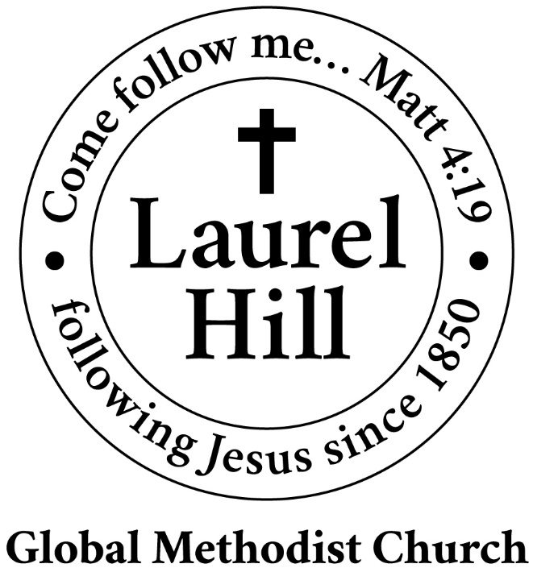
Our Mission: The Global Methodist Church exists to make disciples
of Jesus Christ and spread scriptural holiness across the globe.

1919 New Market Road, Henrico, VA 23231
On the web @ laurelhillchurch.org
Email to laurelhillchurch.varina@gmail.com
Phone: Office/804.795.2772 Pastor/804.437.0937

STAFF
Pastor: Rev. John Bright Organist/Choir Director: Pam Wilson
Secretary: Barbara Wendel School Director: Margo Keeles
Communications Assistant: Ben Wilson

that we you in thought, word, and deed.

