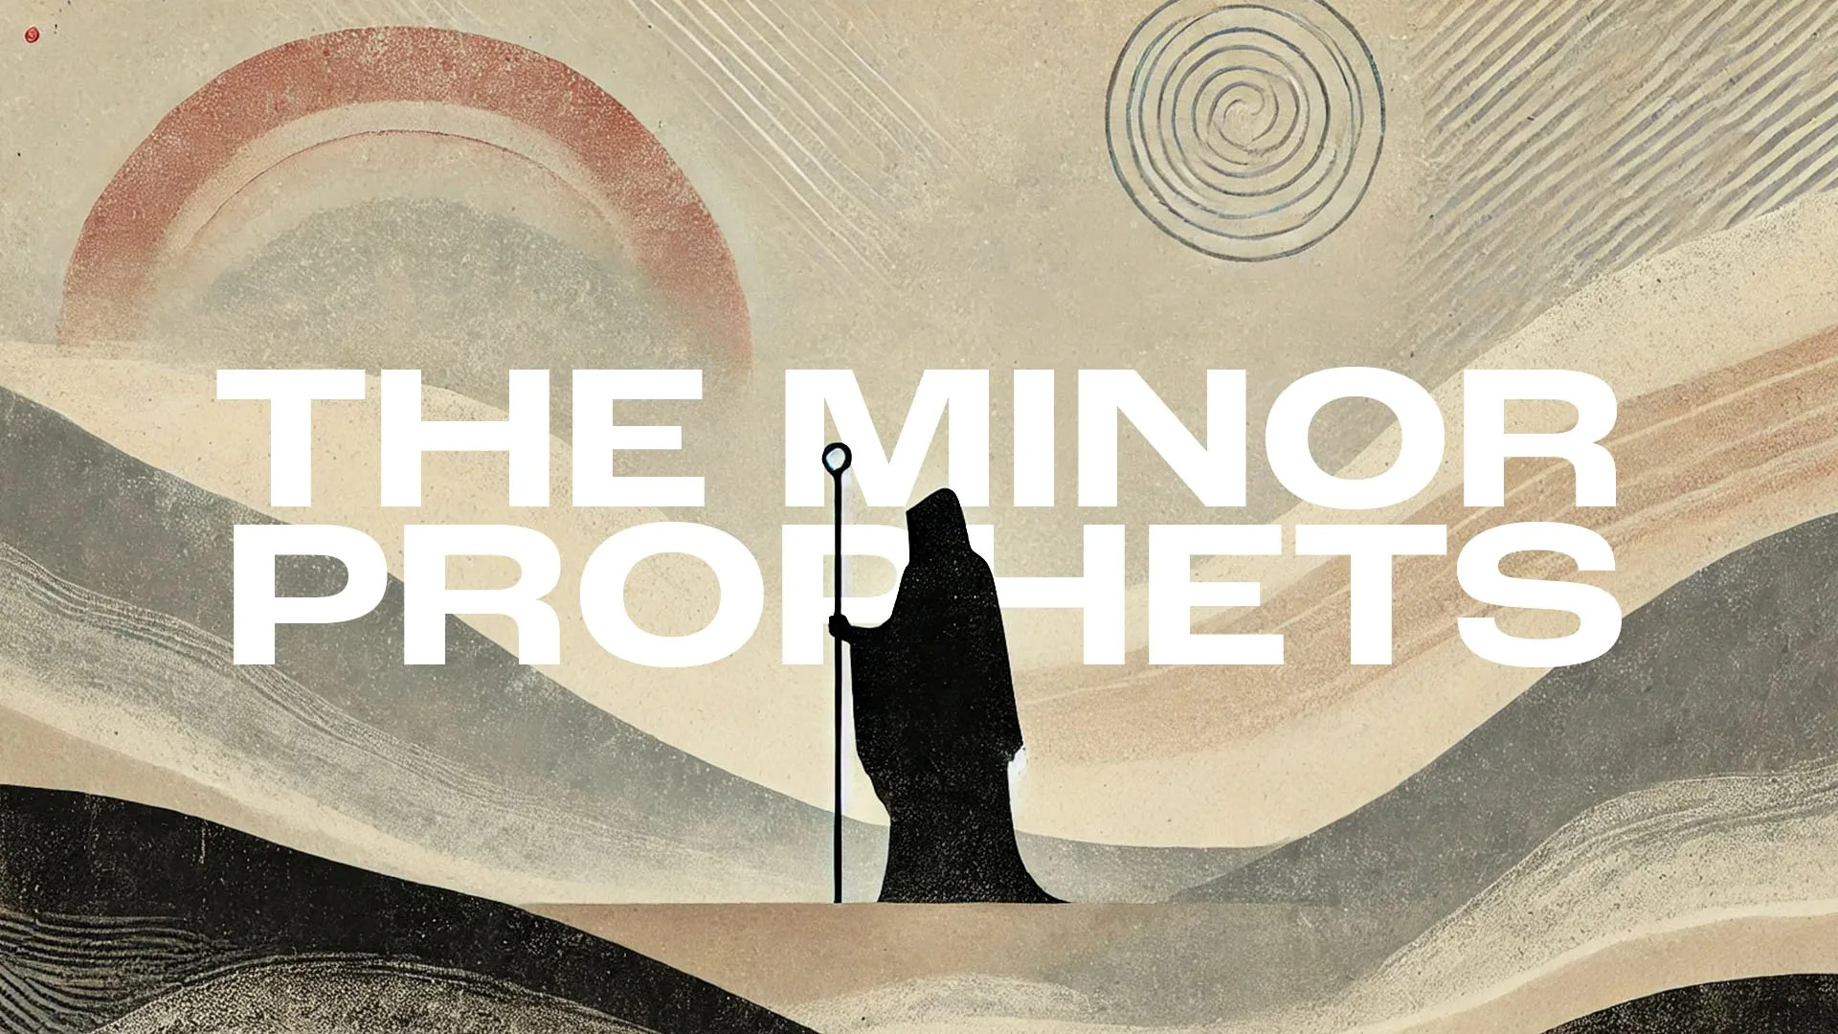
Victory Fellowship Bible Study
273 23rd St. S.W., Barberton, OH 44203
Wednesdays at 7pm
Rev. Roderick D. Grabski (330) 858-0223
arod4God@neo.rr.com FACEBOOK: Roderick Grabski

CLASS Four: Rejected Because You’re Ignorant
- ANNOUNCEMENTS and PRAYER CONCERNS

- READ / LISTEN to Hosea 4:1-19
  - What are your initial impressions? Notable translation differences?

- AI - Chapter 4 Summary

- God’s Case Against Israel (4:1-3)
  - (vs. 1) What 3 things does God charge Israel with?

  - (vs. 2) What other behaviors are present?

  - (vs. 3) How is nature affected?

- Indisputable Case Against the Priests (4:4-10)
  - (vs. 4) God’s case is not open for debate. Who bears the biggest burden of Israel’s sin?

  - (vv. 5-6) What is the reason for the destruction of God’s people and what is the result?

  - (vv. 7-10) In this section, God brings a reversal of the things they wanted and expected from their idolatrous worship.

  - What does verse 8 refer to?

- Promiscuity and Idolatry Leads to Ruin (4:11-14)
  - (vv. 11-13) What specific things do the people do in these verses?

  - (vs. 14) Interestingly, who is exempt from God’s punishment?

- Warnings for Israel and Judah (4:15-19)
  - (vs. 15) What influences does God warn Judah not to copy from Israel?

  - Hosea uses a derogatory play on words for the city Bethel. Bethel means “house of God,” but Beth-aven is “house of disaster, wickedness, idolatry, or nothingness.”

  - (vv. 16-18) In what ways and practices are Israel too far gone?

  - (vs. 19) What is the result of their folly?

- READ / LISTEN to Hosea 5:1-15
  - What are your initial impressions? Notable translation differences?

- AI - Chapter 5 Summary

- An Arrogant Nation Called to Attention (5:1-7)
  - (vv. 1-2) God is pronouncing judgment. There was an unauthorized sanctuary at Mizpah, and on Mt Tabor there was a high place where false religion was practiced.

  - (vv. 3-7) What does God know about Israel (Ephraim)? What is the result of their actions?

- Battle Cry to Destruction (5:8-15)
  - (vv. 8-9) These cities were in Benjamin between Ephraim and Judah. This was where the battle would be fought that leads to the destruction of Israel.

  - (vv. 10-12) When Israel is destroyed, Judah will enlarge their borders and bring about God’s anger on them. What will God become like to Ephraim and Judah?

  - (vv. 13-14) What happens as a result of Ephraim attempting an alliance with Syria?

  - (vs. 15) There is a glimmer of Hope.

- APPLICATION:
  - Learn God’s ways and walk in them. (Psalm 63:1-5)

  - Do not solely rely on a minister or church ritual to establish your relationship with God.(Hosea 6:6; John 17:3)

  - Turn away from anything that tempts you to disobey God, or set something as a higher priority than God. (James 4:7)

- Final Comments, Questions. Close in Prayer

Next Week: The Divine Desire
- Read Hosea 6:1 - 7:16 to prepare.

