
Message Outline
Plagues and Poured Bowls
Revelation 15-16

Intro: Dragon, beast, Lamb (Rev.12-14)…
- The Bible Project review of Revelation…

Read: Revelation 15-16
15:1—Completion of God’s wrath…
v.2—Glass, fire, harps…
v.3-4—Lyrics true of God: great, marvelous, just, true (v.3), and our proper response (v.4). (cf. Deut.32)
v.5—Keeping close eye on “temple” in Rev…
v.6—Priestly and pure clothes…
v.7-8—Bowls, wrath, and glory all held together…
16:1—Hearing the command for pouring…
v.2-7—Evil boomeranging back: sores on spots of marking (v.2) and drinking blood for shedding blood (v.3-4, 6)…
- “just” and “true” is repeated refrain…
v.8-21—Contrast of heat (cf.15:2, 16:8-9)…
- Bowl of darkness (cf. Jn.3:19)…
- Evil gathering in dry waters (cf. Ex.14:23,26)…
- Bowl into air (cf. Eph.2:2) and HUGE hail (cf. Josh.10:11)…
- Repeated refusal to repent (v.9, 11)…

Importance of Repentance in Revelation
- Calls to repent (2:5, 16, 21-22, 3:3, 19-20).
- How to repent (cf. Ps.51)…
1) _________________________v.3-4
2) _________________________v.10
3) _________________________v.13
- Living awake and clothed (Rev.16:15, cf. 1Thess.5:1-9, Rev.3:5, 17-18, 7:9, 13-14, Mt.22:11-14, Rom.12:11-14)…

Reading Plan Next Week: Revelation 17-19
Message Outline
Plagues and Poured Bowls
Revelation 15-16

Intro: Dragon, beast, Lamb (Rev.12-14)…
- The Bible Project review of Revelation…

Read: Revelation 15-16
15:1—Completion of God’s wrath…
v.2—Glass, fire, harps…
v.3-4—Lyrics true of God: great, marvelous, just, true (v.3), and our proper response (v.4). (cf. Deut.32)
v.5—Keeping close eye on “temple” in Rev…
v.6—Priestly and pure clothes…
v.7-8—Bowls, wrath, and glory all held together…
16:1—Hearing the command for pouring…
v.2-7—Evil boomeranging back: sores on spots of marking (v.2) and drinking blood for shedding blood (v.3-4, 6)…
- “just” and “true” is repeated refrain…
v.8-21—Contrast of heat (cf.15:2, 16:8-9)…
- Bowl of darkness (cf. Jn.3:19)…
- Evil gathering in dry waters (cf. Ex.14:23,26)…
- Bowl into air (cf. Eph.2:2) and HUGE hail (cf. Josh.10:11)…
- Repeated refusal to repent (v.9, 11)…

Importance of Repentance in Revelation
- Calls to repent (2:5, 16, 21-22, 3:3, 19-20).
- How to repent (cf. Ps.51)…
1) _________________________v.3-4
2) _________________________v.10
3) _________________________v.13
- Living awake and clothed (Rev.16:15, cf. 1Thess.5:1-9, Rev.3:5, 17-18, 7:9, 13-14, Mt.22:11-14, Rom.12:11-14)…

Reading Plan Next Week: Revelation 17-19
Message Outline
Plagues and Poured Bowls
Revelation 15-16

Intro: Dragon, beast, Lamb (Rev.12-14)…
- The Bible Project review of Revelation…

Read: Revelation 15-16
15:1—Completion of God’s wrath…
v.2—Glass, fire, harps…
v.3-4—Lyrics true of God: great, marvelous, just, true (v.3), and our proper response (v.4). (cf. Deut.32)
v.5—Keeping close eye on “temple” in Rev…
v.6—Priestly and pure clothes…
v.7-8—Bowls, wrath, and glory all held together…
16:1—Hearing the command for pouring…
v.2-7—Evil boomeranging back: sores on spots of marking (v.2) and drinking blood for shedding blood (v.3-4, 6)…
- “just” and “true” is repeated refrain…
v.8-21—Contrast of heat (cf.15:2, 16:8-9)…
- Bowl of darkness (cf. Jn.3:19)…
- Evil gathering in dry waters (cf. Ex.14:23,26)…
- Bowl into air (cf. Eph.2:2) and HUGE hail (cf. Josh.10:11)…
- Repeated refusal to repent (v.9, 11)…

Importance of Repentance in Revelation
- Calls to repent (2:5, 16, 21-22, 3:3, 19-20).
- How to repent (cf. Ps.51)…
1) _________________________v.3-4
2) _________________________v.10
3) _________________________v.13
- Living awake and clothed (Rev.16:15, cf. 1Thess.5:1-9, Rev.3:5, 17-18, 7:9, 13-14, Mt.22:11-14, Rom.12:11-14)…

Reading Plan Next Week: Revelation 17-19

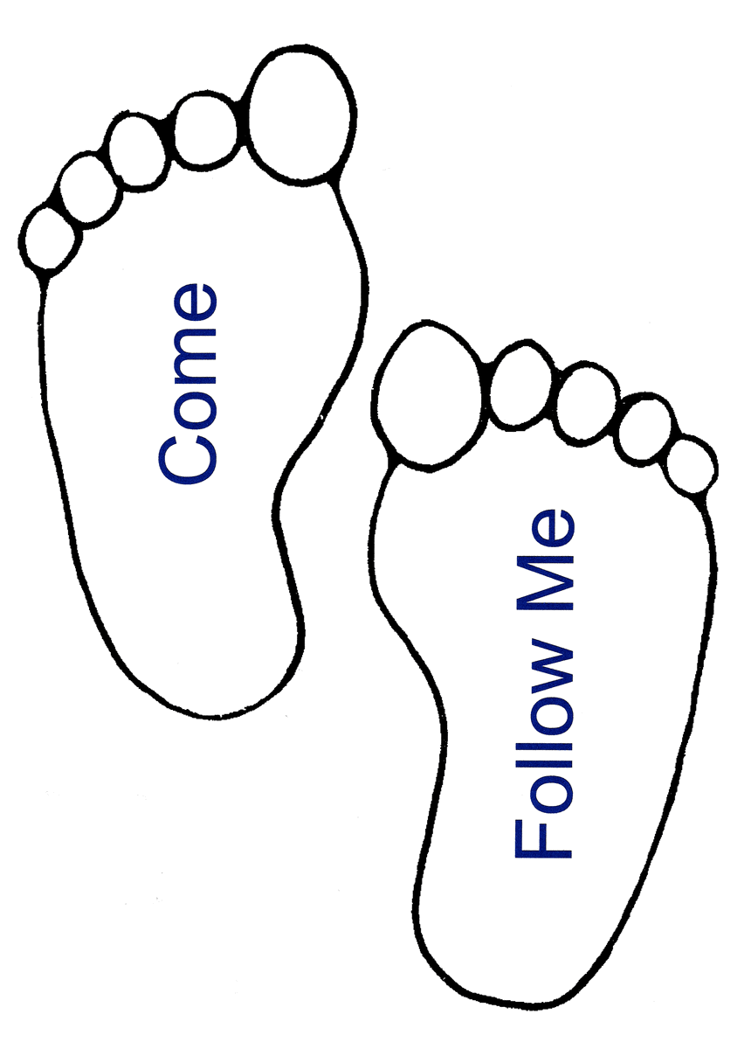
Small Group
Reflection Questions
(Please take time to ponder and pencil in
to prep for this week’s small group session.)

*Reflect on Last Week’s Practice: Read Scripture Daily
What did this practice look like for you (ie. time you spent, book of Bible, experience reading)? What was good? What was difficult? How did you sense God’s presence thru this habit?

Watch: Video Session #4: The Practices

*Of the 9 spiritual practices (ie. Sabbath, prayer, fasting, solitude, generosity, Scripture, community, service, witness), which have you practiced most and which have you practiced the least? What’s been your experience in these practices—the good or bad?

*Who most reflects God’s love to you? What do you notice about the practices that make up their life? (Bonus: if you don’t know their specific practices, try asking them their “secret of success” this week!)

*Comer says the #1 problem in our spiritual formation is time. “Hurry” is our biggest problem in formation. Have you ever tried an “unhurried day” (aka Sabbath)? What was it like?

This Week’s Practice: Practice Sabbath
Small Group
Reflection Questions
(Please take time to ponder and pencil in
to prep for this week’s small group session.)

*Reflect on Last Week’s Practice: Read Scripture Daily
What did this practice look like for you (ie. time you spent, book of Bible, experience reading)? What was good? What was difficult? How did you sense God’s presence thru this habit?

Watch: Video Session #4: The Practices

*Of the 9 spiritual practices (ie. Sabbath, prayer, fasting, solitude, generosity, Scripture, community, service, witness), which have you practiced most and which have you practiced the least? What’s been your experience in these practices—the good or bad?

*Who most reflects God’s love to you? What do you notice about the practices that make up their life? (Bonus: if you don’t know their specific practices, try asking them their “secret of success” this week!)

*Comer says the #1 problem in our spiritual formation is time. “Hurry” is our biggest problem in formation. Have you ever tried an “unhurried day” (aka Sabbath)? What was it like?

This Week’s Practice: Practice Sabbath
Small Group
Reflection Questions
(Please take time to ponder and pencil in
to prep for this week’s small group session.)

*Reflect on Last Week’s Practice: Read Scripture Daily
What did this practice look like for you (ie. time you spent, book of Bible, experience reading)? What was good? What was difficult? How did you sense God’s presence thru this habit?

Watch: Video Session #4: The Practices

*Of the 9 spiritual practices (ie. Sabbath, prayer, fasting, solitude, generosity, Scripture, community, service, witness), which have you practiced most and which have you practiced the least? What’s been your experience in these practices—the good or bad?

*Who most reflects God’s love to you? What do you notice about the practices that make up their life? (Bonus: if you don’t know their specific practices, try asking them their “secret of success” this week!)

*Comer says the #1 problem in our spiritual formation is time. “Hurry” is our biggest problem in formation. Have you ever tried an “unhurried day” (aka Sabbath)? What was it like?

This Week’s Practice: Practice Sabbath

