COLORS FOR CHUNKY BLANKET:

1 2 3 4 5 6
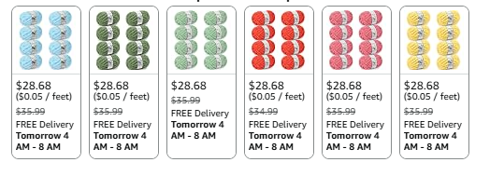
7 8 9 10 11 12
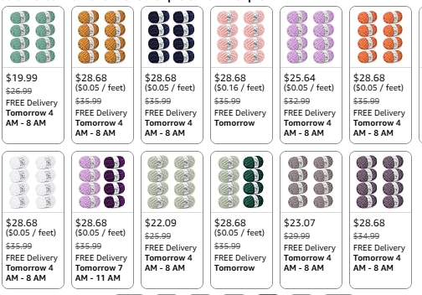
13 14 15 16 17 18

19 20 21 22 23 24
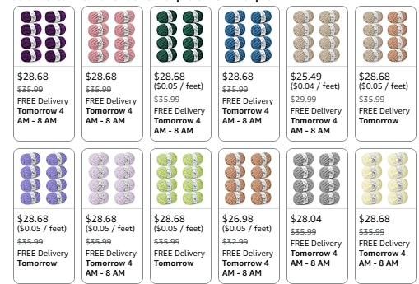
25 26 27 28 29 30

31 32 33 34 35 36
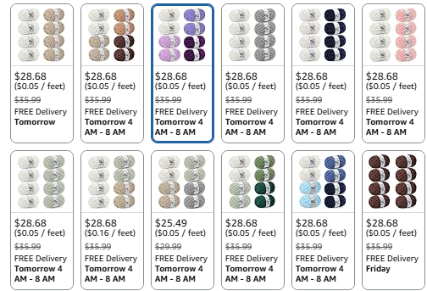
37 38 39 40 41 42

43 44 45 46 47 48
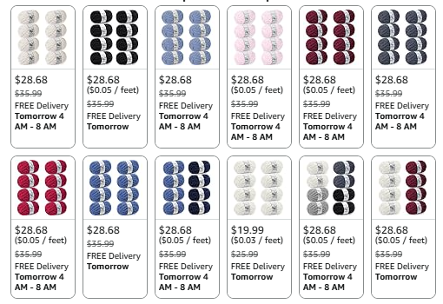
49 50 51 52 53 54

If you want to look more closely at the color options look at Amazon
Chunky Yarn for Hand Knitting - #10 Chunky Chenille Yarn

