All Saints Anglican Church
6904 Lougheed Highway, Agassiz, B.C. V0M 1A0
Bulletin October 4th, 2026 – October 11th, 2026

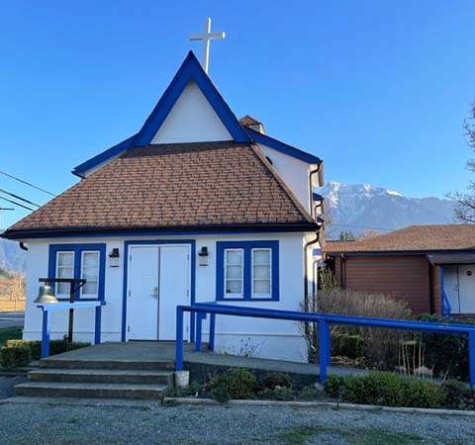


‘The ground we walk does not belong to us; for thousands of years it has been - and remains - the territory of the Stó:lō. We are grateful for their sharing.

Phone: 604-796-3553
Website: www.allsaints-agassiz.ca
https://www.facebook.com/groups/AllSaintsFamily
OUR DOOR IS OPEN AND ALL ARE WELCOME
October 11th, 2026, Thanksgiving Sunday/Holy Eucharist
Priest: Vicar Charles Balfour
Hosts: Graham Featherstone/Jennifer Pinlac
Intercessor: Graham Featherstone
Lay Administrator: Dorothy Cresswell
Announcer: Virginia Jennings
Organ/Piano: Francesca Froehlich
Readers: Greg Veltman/Andrea Hansen
Coffee Time: Sonya/Kathy

Vicar’s Warden: Ginny Jennings. 604-796-2206
People’s Warden: Lynn Laughlin. 604-799-5131
Please contact either warden if you have an issue that needs attention.

All Saint’s Calendar/Announcements:

- Book Club – On August 19th Book Club will be starting "Two Steps Forward" by Sharon Garlough Brown, an experienced leader of spiritual formation retreats in the UK and US. The 4 women from Sensible Shoes are taking their next steps in the spiritual formation journey. But each of them is finding roadblocks along the way.
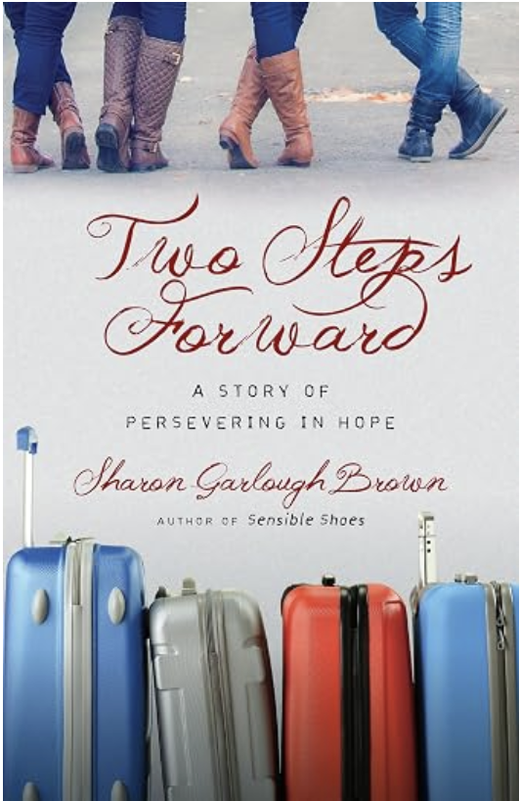

Please contact Valerie at Valeriejhamilton@yahoo.com
if you would like an invitation to the Zoom meetings
at 5.00 pm on Wednesdays.

- Bible Study is every Saturday morning 0830-0900 on Zoom. All are welcome to preview and discuss the readings for the Sunday service. Please ask Valerie to add your email address to the invitation list.

- Prayer Requests can be given on a piece of paper to either of the Wardens or entered in the Prayer Request Book on the lectern. Alternatively, you can contact Anthea Lewis at antheamlewis@shaw.ca for Pray First Prayer Circle, which is a confidential online prayer circle.

- Pastoral Care – we are not alone. Pastoral care is still available so if anyone needs emotional, physical or spiritual care, please contact one of the following people and they will put you in touch with the someone for that support.

Ginny: 604-793-3754
Lynn: 604-799-5131
Dorothy: 604-712-4710
Graham: 604-491-1288

- Music Requests may be given to the Wardens.

- AA meets in the hall every Tuesday and Friday at noon.

- Every Thursday in the hall 1100-1200 we have a social time with coffee, games if you like or just talk.

- At 1000-1100 on Thursdays there is an Interactive Bible Study on the day’s Lectionary readings. All are welcome – discover the treasures in this amazing book!

- 5th Sunday of each month will be a potluck lunch after the service.

- If you would like to book a table at the Craft Fair on October 24th, please see Fran. Cost is $35

A Little Chuckle

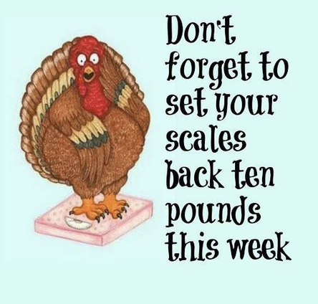

Birthdays in the October

We have no birthdays in the month of October. I am sure someone is born in this month, but they aren’t part of our All Saints family.

Diocesan Cycle of Prayer: We Pray for the Clergy and Congregation:

Dr Shakuntala Soden, Diocesan Refugee Administrator; St Thomas, Chilliwack – The Revd Lorie Martin

Anglican Church of Canada Cycle of Prayer – We Pray for:

The Rt. Rev. David Lehmann, Bishop, and the clergy and people of the Diocese of
Caledonia. For people and ministries working to address issues of poverty, homelessness, and affordable housing.

Collect

Creator of the fruitful earth, you made us stewards of all things. Give us grateful hearts for all your goodness, and steadfast wills to use your bounty well, that the whole human family, today and in generations to come, may with us give thanks for the riches of your creation. We ask this in the name of Jesus Christ the Lord.

Exodus 32:1-14 Greg Veltman

¹When the people saw that Moses was so long in coming down from the mountain, they gathered around Aaron and said, “Come, make us gods who will go before us. As for this fellow Moses who brought us up out of Egypt, we don’t know what has happened to him.”

² Aaron answered them, “Take off the gold earrings that your wives, your sons and your daughters are wearing, and bring them to me.” ³ So all the people took off their earrings and brought them to Aaron. ⁴ He took what they handed him and made it into an idol cast in the shape of a calf, fashioning it with a tool. Then they said, “These are your gods, Israel, who brought you up out of Egypt.”

⁵ When Aaron saw this, he built an altar in front of the calf and announced, “Tomorrow there will be a festival to the Lord.” ⁶ So the next day the people rose early and sacrificed burnt offerings and presented fellowship offerings. Afterward they sat down to eat and drink and got up to indulge in revelry.

⁷ Then the Lord said to Moses, “Go down, because your people, whom you brought up out of Egypt, have become corrupt. ⁸ They have been quick to turn away from what I commanded them and have made themselves an idol cast in the shape of a calf. They have bowed down to it and sacrificed to it and have said, ‘These are your gods, Israel, who brought you up out of Egypt.’

⁹ “I have seen these people,” the Lord said to Moses, “and they are a stiff-necked people. ¹⁰ Now leave me alone so that my anger may burn against them and that I may destroy them. Then I will make you into a great nation.”

¹¹ But Moses sought the favor of the Lord his God. “Lord,” he said, “why should your anger burn against your people, whom you brought out of Egypt with great power and a mighty hand? ¹² Why should the Egyptians say, ‘It was with evil intent that he brought them out, to kill them in the mountains and to wipe them off the face of the earth’? Turn from your fierce anger; relent and do not bring disaster on your people. ¹³ Remember your servants Abraham, Isaac and Israel, to whom you swore by your own self: ‘I will make your descendants as numerous as the stars in the sky and I will give your descendants all this land I promised them, and it will be their inheritance forever.’” ¹⁴ Then the Lord relented and did not bring on his people the disaster he had threatened.

Psalm 106:1-6, 19-23

¹ Praise the Lord
Give thanks to the Lord, for he is good;
his love endures forever.

² Who can proclaim the mighty acts of the Lord
or fully declare his praise?
³ Blessed are those who act justly,
who always do what is right.

⁴ Remember me, Lord, when you show favor to your people,
come to my aid when you save them,
⁵ that I may enjoy the prosperity of your chosen ones,
that I may share in the joy of your nation
and join your inheritance in giving praise.

⁶ We have sinned, even as our ancestors did;
we have done wrong and acted wickedly.

¹⁹ At Horeb they made a calf
and worshiped an idol cast from metal.
²⁰ They exchanged their glorious God
for an image of a bull, which eats grass.
²¹ They forgot the God who saved them,
who had done great things in Egypt,
²² miracles in the land of Ham
and awesome deeds by the Red Sea.
²³ So he said he would destroy them—
had not Moses, his chosen one,
stood in the breach before him
to keep his wrath from destroying them.

Philippians 4:1-9 Andrea Hansen

¹Therefore, my brothers and sisters, you whom I love and long for, my joy and crown, stand firm in the Lord in this way, dear friends!

² I plead with Euodia and I plead with Syntyche to be of the same mind in the Lord. ³ Yes, and I ask you, my true companion, help these women since they have contended at my side in the cause of the gospel, along with Clement and the rest of my co-workers, whose names are in the book of life.

⁴ Rejoice in the Lord always. I will say it again: Rejoice! ⁵ Let your gentleness be evident to all. The Lord is near. ⁶ Do not be anxious about anything, but in every situation, by prayer and petition, with thanksgiving, present your requests to God. ⁷ And the peace of God, which transcends all understanding, will guard your hearts and your minds in Christ Jesus.

⁸ Finally, brothers and sisters, whatever is true, whatever is noble, whatever is right, whatever is pure, whatever is lovely, whatever is admirable—if anything is excellent or praiseworthy—think about such things. ⁹ Whatever you have learned or received or heard from me, or seen in me—put it into practice. And the God of peace will be with you.

Matthew 22:1-14 Vicar Charles Balfour

¹Jesus spoke to them again in parables, saying: ² “The kingdom of heaven is like a king who prepared a wedding banquet for his son. ³ He sent his servants to those who had been invited to the banquet to tell them to come, but they refused to come.

⁴ “Then he sent some more servants and said, ‘Tell those who have been invited that I have prepared my dinner: My oxen and fattened cattle have been butchered, and everything is ready. Come to the wedding banquet.’

⁵ “But they paid no attention and went off—one to his field, another to his business. ⁶ The rest seized his servants, mistreated them and killed them. ⁷ The king was enraged. He sent his army and destroyed those murderers and burned their city.

⁸ “Then he said to his servants, ‘The wedding banquet is ready, but those I invited did not deserve to come. ⁹ So go to the street corners and invite to the banquet anyone you find.’ ¹⁰ So the servants went out into the streets and gathered all the people they could find, the bad as well as the good, and the wedding hall was filled with guests.

¹¹ “But when the king came in to see the guests, he noticed a man there who was not wearing wedding clothes. ¹² He asked, ‘How did you get in here without wedding clothes, friend?’ The man was speechless.

¹³ “Then the king told the attendants, ‘Tie him hand and foot, and throw him outside, into the darkness, where there will be weeping and gnashing of teeth.’

¹⁴ “For many are invited, but few are chosen.”

Odds and Ends



