Colington United Methodist Church
We are a Lighthouse Congregation, committed to offering safety and stability to United Methodists who have been displaced or wounded through disaffiliation.

October 11, 2026
Twentieth Sunday after Pentecost

welcome
prelude and lighting of altar candles
I Could Sing of Your Love Forever Smith
call to worship
Rejoice in our God always!
Again I say rejoice!
For God has gathered us together
From all the corners of the earth,
To be present now,
And to know the joyful unity
Of being one with Christ.
Rejoice in our God always!
Again I say rejoice.
introit
Rejoice in the Lord Always
†opening hymn
I Love to Tell the Story ǀ UMH 156
prayers of the people
prayer for illumination
Almighty God, we thank you for the gift of your holy word. May it be a lantern to our feet, a light to our paths, and a strength to our lives. Take us and use us to love and serve all people in the power of the Holy Spirit and in the name of your
Son, Jesus Christ our Lord. Amen.
response
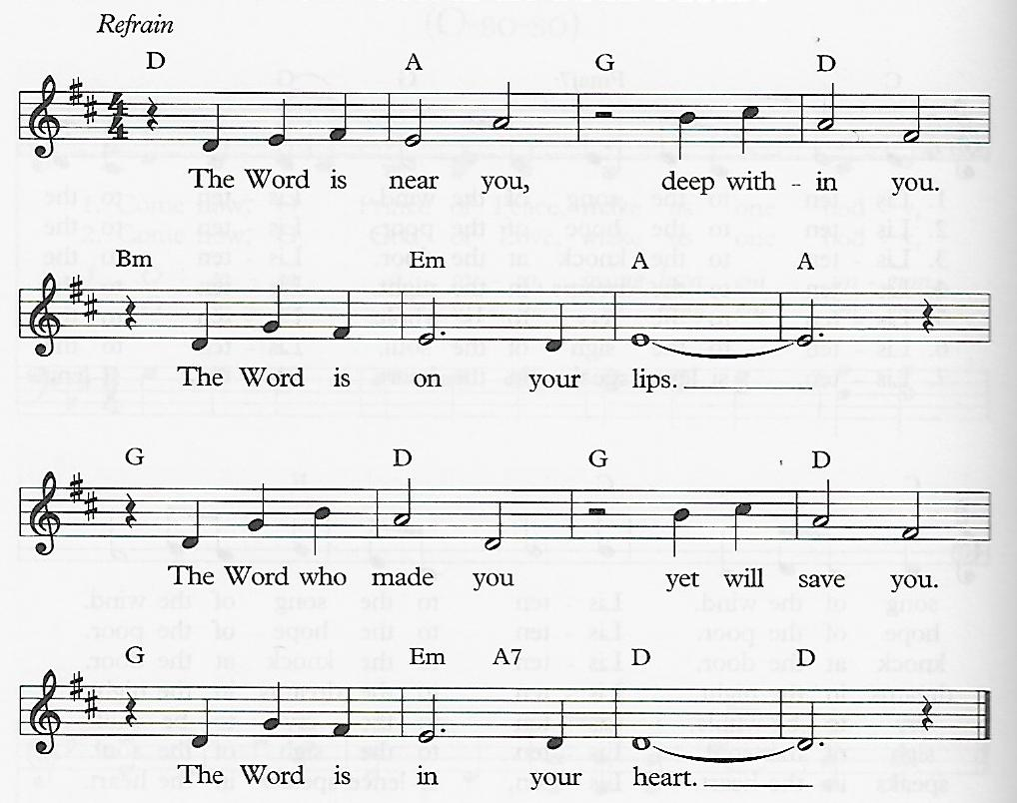
The Word Is in Your Heart

the first lesson
the first lesson
Exodus 32:1-14
hymn of preparation
O Jesus I Have Promised ǀ UMH 396
the second lesson
Philippians 4:1-9
sermon
†affirmation of praise
Find Us Faithful
O may all who come behind us find us faithful;
May the fire of our devotion light their way.
May the footprints that we leave
Lead them to believe,
And the lives we live inspire them to obey.
O may all who come behind us find us faithful.
prayer of thanksgiving
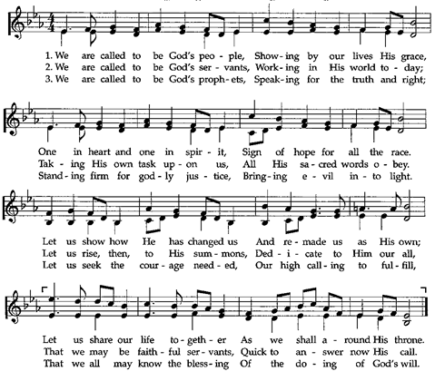
†closing hymn

this week at colington
These opportunities to serve as the Body of Christ are available.
Today – following worship – Pastor Appreciation reception.
Tuesday – 9 am – Prayer Group
Wednesday – 7:30am – FCA breakfast at FFHS.
10am – Knitters and crocheters meet.
Thursday – 7:30am – FCA breakfast at FFMS.
Saturday – 9am – Men’s ministry breakfast.
10:15am - Worship service at Spring Arbor Memory Care Unit
coming up
Next Sunday – 8:15am – choir practice
9:30 am – Worship, in-person and Facebook Live, YouTube
Wed., Oct. 21 – 10am - Admin. Council meeting.
Sat., Oct. 24 – UWF Annual meeting at Sharon UMC.
Mon., Oct. 26 – Student of the month at FFES.
Tues., Oct. 27 – Hosting Ruthie’s Kitchen. Contact Stacy Murphy to volunteer at email address- sewbusy1964@gmail.com.
Wed., Oct. 28 – 10am Knitters and crocheters meet.
1:45pm – Volunteers to Beach Food Pantry.
Thanks to today’s volunteers!
Ushers – Steve Knowles/Ozzie Gray/ Wiley Beales
Scripture Reader – Merinda DeHart
The flowers on the altar are given by JJ and Rebecca Jones in memory of JJ’s Mom, Edna Hudgin’s birthday.
Last week’s attendance – 65.

