EAST FAIRFIELD UNITED METHODIST CHURCH
Pastor: Kristen Buchs
Organist: Ruth Rowley Ministers: The Congregation
Pianist: Nancy Setinsek Choir Director: Randy Hart
Sunday, October 11, 2026
Twentieth Sunday after Pentecost / Camdyn Cusick Baptism

*Please stand in body or spirit as you are able

Welcome! We invite you to take this time to prepare for worship. In these
moments, quiet your inner voice, become aware of being in community with
others, and open your heart and mind to the leading of the Holy Spirit.

GATHERING “O the Deep, Deep Love of Jesus” - Williams
“He Leadeth Me” - Bradbury

CHRIST LIGHT ENTERS

MISSIONS AND MINISTRY UPDATES Jon Vollnogle, Liturgist

PREPARING OUR HEARTS AND MINDS FOR WORSHIP

WORDS OF PREPARATION AND CENTERING

PRELUDE “More About Jesus” - Sweney

*CALL TO WORSHIP
L: Our Loving God calls us together as His people so He may
transform us with His love.
P: He transforms our hearts so that we may love generously.
L: He transforms our eyes so that we may see His grace.
P: He transforms our hands so that we may serve others.
L: He transforms our spirits, that we may be the body of Christ,
P: gathered to worship and sent out to serve.

(Adapted from The Abingdon Worship Annual,
edited by Mary J. Scifres and B.J. Beu, Copyright © Abingdon Press.)

*OPENING PRAYER
Open our hearts and our spirits to hear your healing words of
peace and love, O God. Help us be the people of service and
justice that You have called us to be. Make us ready to heal rather
than harm; to serve rather than sever. Give us hearts of joy and
justice, for we offer this prayer in Jesus’ name. AMEN.

*HYMN “Spirit of God, Descend upon My Heart” UMH #500

READING FROM PSALMS Psalm 106:1-6 and 19-23 (NIV) Pg. 488

THE SACRAMENT OF BAPTISM: Camdyn Cusick
Congregational Response: With God’s help, we will so order
our lives after the example of Christ, that surrounded by steadfast
love, Camdyn may be established in the faith, and confirmed and
strengthened in the way that leads to life eternal.

CHILDREN’S MOMENT

CHOIR ANTHEM “Standin’ in the Need of Prayer” - Drennan

OFFERING OURSELVES & OUR GIFTS
INVITATION
OFFERTORY “Love Lifted Me” - Smith
*DOXOLOGY UMH #95
*DEDICATION OF GIFTS

SEEKING GOD’S WORD
OLD TESTAMENT READING Exodus 32:1-14 (NIV) Pg. 70

SHARING OF JOYS & CONCERNS
SILENT PRAYER
PASTORAL PRAYER
THE LORD’S PRAYER

SERMON TEXT 1 Corinthians 6:19-20 & Romans 12:1-2 (NIV)

SERMON “Living Our Faith the 4-H Way: - Pastor Kristen
I Pledge My Health to Better Living”
Prayer of Dedication

RESPONDING TO GOD’S WORD

*HYMN “Lord, I Want to Be a Christian” UMH # 402

SENDING FORTH WITH BLESSING
*BLESSING
LIGHT OF CHRIST GOES INTO THE WORLD
~ Go with joy to serve the Lord ~

As we conclude our service, please join us downstairs for a time to relax,
continue conversations and enjoy coffee and refreshments.

The rose on the altar is in celebration of the Baptism of
Camdyn Lee Cusick. Parents are Cory & Jordan Cusick.
Grandparents are Anita Cusick and Scott & Tracy Gottschling.

Flowers on the altar are from Linda Cook
in memory of Ron Cook for his birthday.

Today, Sunday, October 11
Sound: Bill Rowley
Computer: Vicki Freeman
Livestream: Hannah Roberts

Next Sunday, October 18: Jeannie Arnoto, Liturgist

PRAYER REQUESTS OCTOBER 11, 2026

To submit a prayer request call Denise at 330-457-2465 or 330-727-9832
If you desire a home or hospital visit call Pastor Kristen (216-559-9893)
Prayer Blankets: call Joyce Ward (330-692-3346)

Please keep in mind that the service is live-streamed and
recorded for public access. Please keep prayer requests
brief and do not use last names or identifying details.

Sandy W (Chaney’s sister) - fell and broke a vertebrae and her sternum.
Marcia M – now at home. Still needs prayers.
Russell (Larry Walters brother-in-law) – pancreatic cancer.
Bob (Deann’s dad) – now at Masternick Health Care in New Middletown.
Elaine – heart ablation at Cleveland went well. Now home.
Grace (Alisha) – had shoulder surgery Thursday, Oct. 8.
Dolly – short of breath. Struggling to breathe.
Jake (Mitchell Hart’s friend) – cancer confined to lung. Will remove that lobe.

Bill Harding – passed away Sept.30. Keep Barb in your prayers.
Katelin – in an induced coma at Salem ICU. In need of prayers.
Katie (Vicki Deliquadri’s niece) – surgery not healing. Complications. (21 yr old)
Jerry M – doing well. Thanks for the prayers.
Denise (Jeannie’s friend) – recovering from 3 strokes and 2 heart surgeries.
Janice (Missy’s co-worker) – now has type 1 diabetes.
Bob & Kathy M. – travel mercies for trip to Australia, New Zealand, etc.
Maralyn Porter – fell and broke wrist in two places.
Jon V – Thanks for the prayer blanket, cards, texts, and phone calls.
Jon E – has been dealing with cancer. Now under hospice care.

HOMEBOUND
Dolly K. Anita M. Bob D (Masternick)
Tom & Marie Linda S. Zelda C. (Whispering Pines)
Esther C. Marcia M.

IN MINISTRY
Kristen Buchs Edie Boles Jeff Pellin

Church: 330-457-2465 Pastor Kristen: 216-559-9893
Ch Email:efumc@comcast.net Email: pastorkristen0712@gmail.com
Web: www.eastfairfieldumc.com CCLI #1994841 CVLI #504 011 134


East Fairfield
United Methodist Church

October 11, 2026
9:30 AM

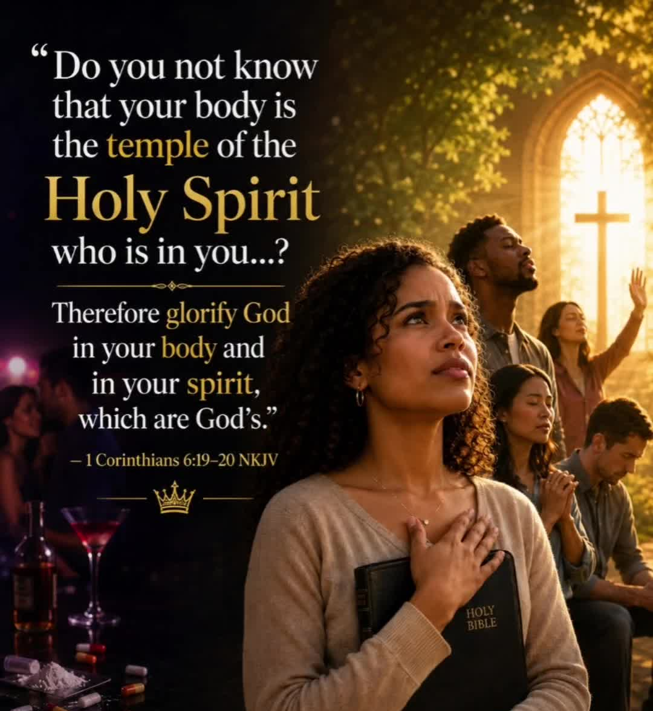

Pastor Kristen Buchs
216-559-9893
45675 State Route 558
New Waterford, OH 44445

“Working, playing, and praying together on our
faith journey, to share Jesus Christ with everyone.”

Sun | Mon | Tue | Wed | Thu | Fri | Sat
Oct. 11  9:30 Worship  - Baptism  10:30 Coffee  10:45 Sunday  School | Oct. 12  1:30-4:00  Prayer  Blankets  4:00-6:00  Quilting at  Elkton UM  6:00 Cub  Scouts | Oct. 13  8:00 Men’s  Coffee  Ladies’ Day | Oct. 14  7:00 Choir  Practice  7:00 Scripture  & Suds at  VINYARDS at  Pine lake | Oct. 15 | Oct 16  Pastor’s  Day Off  Office  Closed | Oct. 17
Oct. 18  Laity Sunday  9:30 Worship  10:30 Coffee  10:45 Sunday  School | Oct. 19  1:30-4:00  Prayer  Blankets  6:00 Cub  Scouts  7:00  Leadership  Board | Oct. 20  8:00 Men’s  Coffee | Oct. 21  7:00 Choir  Practice | Oct. 22  7:00 Scripture & Suds at Sundog Cider  House at Firestone  Farms | Oct 23  Pastor’s  Day Off  Office  Closed | Oct. 24  8:30-10:00  Caring for  God’s Lambs  at Trinity
Oct. 25  9:30 Worship  10:30 Coffee  10:45 Sunday  School  4:00 4-H Country Hands  (Hannah Farmer)  5:00 Potluck Fellowship at Emmanuel | Oct. 26  12:00  Women’s  Joy Circle  Lunch  1:30-4:00  Prayer  Blankets  6:00 Cub | Oct. 27  Newsletter  Deadline  8:00 Men’s  Coffee  7:00  Centenary  Leadership  Board | Oct. 28  7:00 Choir  Practice | Oct. 29  9:00  Mailing  Com. | Oct 30  Pastor’s  Day Off  Office  Closed | Oct. 31  Halloween
Nov. 1  All Saints’  Communion  9:30 Worship  10:30 Coffee  10:45 Sunday  School | Nov. 2  1:30-4:00  Prayer  Blankets  6:00 Cub | Nov. 3  8:00 Men’s  Coffee | Nov. 4  7:00 Choir  Practice | Nov. 5 | Nov. 6  Pastor’s  Day Off  Office  Closed | Nov. 7  Turn clocks back  3:00 PM Charge Conference at  Berlin Center UM  15611 W. Akron-Canfield Rd. 44401

Columbiana Meals on Wheels
Spaghetti Dinner Drive Thru
Saturday, October 24, 3:00 to 6:00 pm
or until dinners are sold out.
Firestone Park, Columbiana – Pavilion #1 West
Donation: $12 - For advance ordering call 330-482-0366.

Mission of the Month

World Communion Sunday – Fund # 16

Money raised for World Communion Sunday, helps provide scholarships for racial and ethnic minority students in the US, and students worldwide.

4C’s Food Item ~ Quick Oats

Update on Mission Giving for 2026
FUND | NAME OF FUND | NEED | RECEIVED | STILL NEED
2 | General Mission Fund | 5,099 | 6,709 | 0
33 | 4C’s | 125 | 1,175 | 0
32 | Cub Scouts | 150 | 665 | 0
37 | Way Station | 150 | 160 | 0
22 | Flat Rock | 175 | 265 | 0
64 | Farmer to Farmer – Liberia | 300 | 360 | 0
13 | UMCOR Sunday | Any  Donation | 75
21 | UMCOR – U.S. Disasters | Any  Donation | 105
14 | Blanket Sunday | Any  Donation | 65
15 | Peace With Justice | Any  Donation | 0
16 | World Communion | Any  Donation | 25
17 | Student Day | Any  Donation | 75
46 | Heroes & Halos | Any  Donation | 100
63 | InStep Program | Any  Donation | 40
38 | Operation Christmas Child Shoeboxes |  | 118 plus 90

Fund Balances as of end of AUGUST
Fund # 1 Ministry Operating - 9,555
Fund # 2 Mission Fund 4,670
Fund # 3 Building Fund 38,998
Fund # 28 Elevator Fund 8,249

Last Week’s Attendance (Oct. 4)
In-Person: 74 Online: 31

