YOU’RE INVITED
ENNEAGRAM LEVEL 1 COURSE
Dec. 5, 2026
9:00 am – 5:00 pm
Location: Anglican Church of the Good Shepherd
408 38 St SW Calgary, AB
BACKGROUND
The Enneagram is a personality typology based on ancient wisdom. Handed down as an oral tradition, the Enneagram was eventually recorded and researched. Companies such as Sony, Disney, and Hewlett Packard have all used this training to enhance team building and communication. It has been well researched and studied by people with doctorates in understanding human interaction and brain formation.
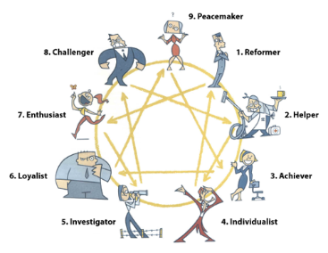
Although it is more common in the US, Canadians are beginning to embrace this teaching as they understand its dynamic nature and the depth of learnings that come from its teachings.
FEEDBACK
Deb E Berg has used this training for over 20 years in her private practice and in consulting with agencies needing supports with their staff. Here are what participants have shared about the course:
• I struggle with learning things that make me feel like I am being ‘put in a box’. I was pleasantly surprised with what I learned.
• I was struggling with relationships in my work and personal life. I learned new things that have shifted how I relate to others.
• I knew that people think differently but this training helped me learn how other people think differently.
• This was a fun and relaxed learning environment.
METHOD
Deb E Berg uses a method of training that includes lectures, group work and exercises. Everyone is welcome to participate at a level that feels safe and comfortable for them. Participation is always voluntary and guided by your comfort level. Come and join us for a day of team building and learning together.

COST
This course is offered by donation to the Church of the Good Shepherd. The regular fee is $80 per person or $150 per couple, but you are welcome to contribute an amount that feels manageable for you.
Lunch will not be provided, so please feel free to bring your own. A kitchen with a fridge and microwave is available in the Lower Hall for your convenience.
COURSE REGISTRATION FORM
Enneagram Level 1 Course
Date: December 5, 2026 Time: 9:00 a.m.–5:00 p.m.
Location: Anglican Church of the Good Shepherd, 408 38 St SW, Calgary, AB
Participant Information
Full name | Enter full name
Email address | Enter email address
Phone number | Enter phone number
Professional Designation and 6 CEU Certificate
Professional designation | ☐ Counsellor ☐ Social worker ☐ Other: Enter other designation
Registration/licence number | Enter registration/licence number
Professional association or regulatory body | Enter association or regulatory body
Current designation status | ☐ Active ☐ Other: Enter other status
CEU certificate request | ☐ Yes, I am requesting a certificate for 6 Credit Enrollment Units (CEUs).  ☐ No, I am not requesting a CEU certificate.
The 6-CEU certificate is available to participants who already hold a professional designation, such as counsellor or social worker. Please provide the information above so eligibility can be confirmed.
Registration and Payment
Registration type | ☐ Individual ☐ Couple (second participant: Enter second participant)
Donation amount | $Amount
Dietary, accessibility, or other needs | Enter dietary, accessibility, or other needs
Participant Confirmation
I confirm that the information provided is accurate. If I request a 6-CEU certificate, I confirm that I currently hold the professional designation listed above.
Signature | Type signature
Date | Select date

For more information about Debbie and the Enneagram, please see her website at debeberg.com

