Holy Trinity Evangelical Lutheran Church

20th Sunday After Pentecost

October 11 2026, at 10:30 am

Lay Speaker, Bill Pim

*Prelude

* Welcome and Announcements Worship Assistant

*Opening Hymn "Now We Join in Celebration" ELW 462
One License A-700000
1.Now we join in celebration at our Savior’s invitation, dressed
no more in spirit, somber, clothed instead in joy and wonder;
for the Lord of all existence, putting off divine transcendence,
stoops again in love to meet us, with his very life to feed us.

2.Lord, as round this feast we gather, fill out hearts with holy rapture! For this bread and cup of blessing are for us the sure
possessing of your loving deed on Calv’ry, of your living self,
our vict’ry, pledge of your unfailing presence, foretaste here of heav’nly gladness.

3.Lord, we share in this communion as one fam’ly of God’s children, reconciled through you, our brother, one in you with God our Father. Give us grace to live for others, serving all, both friends and strangers, seeking justice, love, and mercy till you come in final glory,

* Confession and Forgiveness Lay Speaker, Bill Pim
Blessed be the holy Trinity, ☩ one God, who pours love into our hearts and healing upon the earth. Amen.

Confident that God justifies us by grace through faith, let us confess our sin.

Compassionate God, we confess that we struggle to embody your goodness in the world and in our own hearts. Creation groans from overuse. Jealousy and bitterness strain our relationships. Divisions disrupt your call to show genuine love to others. Turn our hearts back to you. Restore our world and reconcile us to one another. Renew us to live as your holy people, following the way of Jesus Christ. Amen.

Hear this good news: We have peace with God through ☩ Jesus Christ, in whom there is no condemnation, but only forgiveness and the promise of eternal life. Receive freely this healing gift of grace. Amen.

* Canticle of Praise “Change My Heart, O God” ELW 801
CCLI-11222261
Change my heart, O God; make it ever true.
Change my heart, O God; may I be like you.
You are the potter, I am the clay.
Mold me and make me; this is what I pray.

*Greeting Lay Speaker, Bill Pim
The grace of our lord, Jesus Christ, the love of God and the communion of the holy spirit be with you all. and also with you.

*Prayer of the Day Worship Assistant
Lord of the feast, you have prepared a table before all peoples and poured out your life with abundance. Call us again to your banquet. Strengthen us by what is honorable, just, and pure, and transform us into a people of righteousness and peace, through Jesus Christ, our Savior and Lord. Amen.

* Passing of the Peace Worship Assistant
May the peace of christ be with you always. and also with you.

Please share the peace of christ with one another with a wave.
*Children’s Moment – pulpit prequel – Lay Speaker, Bill Pim

*First Lesson: Isaiah 25:1-9 Reader
¹ O Lord, you are my God;
I will exalt you; I will praise your name,
for you have done wonderful things,
plans formed of old, faithful and sure.
² For you have made the city a heap,
the fortified city a ruin;
the palace of foreigners is a city no more;
it will never be rebuilt.
³ Therefore strong peoples will glorify you;
cities of ruthless nations will fear you.
⁴ For you have been a refuge to the poor,
a refuge to the needy in their distress,
a shelter from the rainstorm and a shade from the heat.
When the blast of the ruthless was like a winter rainstorm,
⁵ the noise of foreigners like heat in a dry place,
you subdued the heat with the shade of clouds;
the song of the ruthless was stilled.
⁶ On this mountain the Lord of hosts will make for all peoples
a feast of rich food, a feast of well-aged wines,
of rich food filled with marrow, of well-aged wines strained clear.
⁷ And he will destroy on this mountain
the shroud that is cast over all peoples,
the covering that is spread over all nations;
⁸ he will swallow up death forever.
Then the Lord God will wipe away the tears from all faces,
and the disgrace of his people he will take away from all the earth,
for the Lord has spoken.
⁹ It will be said on that day,
“See, this is our God; we have waited for him, so that he might save us.
This is the Lord for whom we have waited;
let us be glad and rejoice in his salvation.”
The Word of the Lord. Thanks be to God.

*Psalm 23 Reader
¹ The Lord is my shepherd; I shall not want.
² He makes me lie down in green pastures;
he leads me beside still waters;
³ he restores my soul.
He leads me in right paths
for his name’s sake.
⁴ Even though I walk through the darkest valley,
I fear no evil,
for you are with me;
your rod and your staff,
they comfort me.
⁵ You prepare a table before me
in the presence of my enemies;
you anoint my head with oil;
my cup overflows.
⁶ Surely goodness and mercy shall follow me
all the days of my life,
and I shall dwell in the house of the Lord
my whole life long.

*Second Lesson: Philippians 4:1-9 Reader
¹ My brothers and sisters, whom I love and long for, my joy and crown, stand firm in the Lord in this way, my beloved.
² I urge Euodia and I urge Syntyche to be of the same mind in the Lord. ³ Yes, and I ask you also, my loyal companion, help these women, for they have struggled beside me in the work of the gospel, together with Clement and the rest of my coworkers, whose names are in the book of life.
⁴ Rejoice in the Lord always; again I will say, Rejoice. ⁵ Let your gentleness be known to everyone. The Lord is near. ⁶ Do not be anxious about anything, but in everything by prayer and supplication with thanksgiving let your requests be made known to God. ⁷ And the peace of God, which surpasses all understanding, will guard your hearts and your minds in Christ Jesus.
⁸ Finally, brothers and sisters, whatever is true, whatever is honorable, whatever is just, whatever is pure, whatever is pleasing, whatever is commendable, if there is any excellence and if there is anything worthy of praise, think about these things. ⁹ As for the things that you have learned and received and heard and noticed in me, do them, and the God of peace will be with you.
The Word of the Lord. Thanks be to God.

* Acclamation “Alleluia” ELW pg. 205
Al-le-lu-ia! Lord and Savior: open now your saving word.
Let it burn like fire within us; speak until our hearts are stirred.
Al-le-lu-ia! Lord we sing for the good news that you bring.

* Gospel: Matthew 22:1-14 Lay Speaker, Bill Pim
The Holy Gospel according to Matthew, the 22th chapter. Glory to you, O Lord.
¹ Once more Jesus spoke to them in parables, saying: ² “The kingdom of heaven may be compared to a king who gave a wedding banquet for his son. ³ He sent his slaves to call those who had been invited to the wedding banquet, but they would not come. ⁴ Again he sent other slaves, saying, ‘Tell those who have been invited: Look, I have prepared my dinner, my oxen and my fat calves have been slaughtered, and everything is ready; come to the wedding banquet.’ ⁵ But they made light of it and went away, one to his farm, another to his business, ⁶ while the rest seized his slaves, mistreated them, and killed them. ⁷ The king was enraged. He sent his troops, destroyed those murderers, and burned their city. ⁸ Then he said to his slaves, ‘The wedding is ready, but those invited were not worthy. ⁹ Go therefore into the main streets, and invite everyone you find to the wedding banquet.’ ¹⁰ Those slaves went out into the streets and gathered all whom they found, both good and bad, so the wedding hall was filled with guests.
¹¹ “But when the king came in to see the guests, he noticed a man there who was not wearing a wedding robe, ¹² and he said to him, ‘Friend, how did you get in here without a wedding robe?’ And he was speechless. ¹³ Then the king said to the attendants, ‘Bind him hand and foot, and throw him into the outer darkness, where there will be weeping and gnashing of teeth.’ ¹⁴ For many are called, but few are chosen.”
The Gospel of the Lord. Praise to you, O Christ.

Sermon “Proper Attire Required” Lay Speaker, Bill Pim

* Hymn of the Day "Amazing Grace " ELW 779
Public Domain
1.Amazing grace! – how sweet the sound – that saved a wretch like me! I once was lost, but now am found; was blind, but now I see.

2.’Twas grace that taught my heart to fear, and grace my fears relieved; how precious did that grace appear the hour I first believed.

3.Through many dangers, toils, and snares I have already come;
‘tis grace has brought me safe thus far, and grace will lead me home.

4.The Lord has promised good to me; his word my hope secures; he will my shield and portion be as long as life endures.

5.When we’ve been there ten thousand years, bright shining as the sun, we’ve no less days to sing God’s praise than when we’d first begun.

* Apostle’s Creed Worship Assistant
Let us proclaim our faith in the words of the apostle’s creed.
I believe in God, the Father almighty,
creator of heaven and earth.
I believe in Jesus Christ, God's only Son, our Lord,
who was conceived by the power of the Holy Spirit,
born of the Virgin Mary,
suffered under Pontius Pilate,
was crucified, died, and was buried;
he descended to the dead.
On the third day he rose again;
he ascended into heaven,
he is seated at the right hand of the Father,
and he will come to judge the living and the dead.
I believe in the Holy Spirit,
the holy catholic Church,
the communion of saints,
the forgiveness of sins,
the resurrection of the body,
and the life everlasting. Amen.

* Prayers of Intercession Bill Pim
Be seated
prayer requests or joys to share
Seeking the Spirit of God who makes all things new, we pray for the church and the world.

Holy God, we remember your promise of unity on your holy mountain. Empower the World Council of Churches and all those working across religious difference, that the world may know your undivided love. Hear us, O God. Your mercy is great.

We remember your promise of green pastures and quiet waters. Preserve all places of natural beauty and restore our relationship with the land. Hear us, O God. Your mercy is great.

We remember your promise to not abandon us amid storm and disaster.
Renew all communities facing disasters (regions in crisis may be named) and give your courage to those leading relief efforts. Hear us, O God. Your mercy is great.

We remember your promise to wipe away every tear. Heal and console all who are sick or suffering (especially). Hear us, O God. Your mercy is great.

We remember your promise of a banquet open to all people. Challenge this congregation to open wide our doors and welcome everyone to the table. Hear us, O God. Your mercy is great.

We remember your promise to swallow up death forever. We give thanks for those who have gone before us. Hear us, O God. Your mercy is great.

Trusting in your boundless grace, O God, we lift up these spoken prayers and those in our hearts; through Jesus Christ our Lord. Amen.

*Offering Worship Assistant
The monthly mission for october is for “outreach – holiday baskets.” let us give to god what he has first given us.

*Offering Music by Jared

*Offering Hymn "Glory to God, Whose Goodness Shines" ACS 1087 One License A-700000
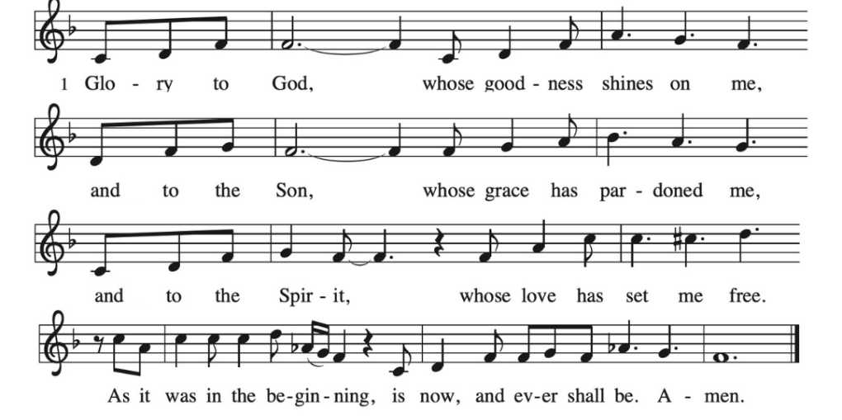
* Offering Prayer Worship Assistant
God of creation, you send rain and the earth springs forth abundantly. All blessings are from you; make us generous with what we have. Use our gifts, our abilities, and our hearts in service to you and in love to our neighbors, today and always. Amen.

* Lord’s Prayer Lay Speaker, Bill Pim
gathered into one by the holy spirit, let us pray as jesus taught us to pray.
Our Father, which art in heaven, Hallowed be Thy Name, Thy kingdom come, Thy will be done, on earth as it is in heaven. give us this day our daily bread; and forgive us our trespasses, as we forgive those who trespass against us; and lead us not into temptation, but deliver us from evil. for thine is the kingdom, and the power, and the glory, forever and ever. amen.
* Blessing
The God of love
draw you into full accord and one mind,
in the body of Christ Jesus.
Amen.
The God of hope
grant you strength and joy in all circumstances
through the interceding of the Spirit.
Amen.
The God of grace
☩ bless you now and forever.
Amen.

*Hymnology Story Be seated Lay Speaker, Bill Pim

* Closing Hymn "I Surrender All" Blue Hymnal 596
Public Domain
1.All to Jesus I surrender, All to Him I freely give; I will ever love and trust Him, In His presence daily live. I surrender all, I surrender all. All to Thee, my blessed Savior, I surrender all.
2.All to Jesus I surrender, Humbly at His feet I bow, Worldly pleasures all forsaken, Take me, Jesus, take me now. I surrender
all, I surrender all. All to Thee, my blessed Savior, I surrender all.

3.All to Jesus I surrender, Make me, Savior, wholly Thine; May Thy Holy Spirit fill me, May I know Thy pow’r divine. I surrender all, I surrender all. All to Thee, my blessed Savior, I surrender all.

4.All to Jesus I surrender, Lord, I give myself to Thee; Fill me with Thy love and power, Let Thy blessing fall on me. I surrender
all, I surrender all. All to Thee, my blessed Savior, I surrender all.

* Dismissal
Go out in joy. Be led forth in peace. Thanks be to God!

*Postlude

