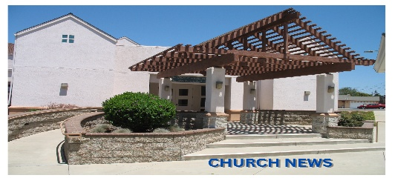
LUTHERAN CHURCH OF OUR SAVIOR
October 11, 2026

Visitors and families, welcome! We are honored to have you worship with us today! Worshiping in a new place or with children can be a challenge. But in the words of Jesus: "Let the little children come to me and do not hinder them"(Matthew 19:14). We take that attitude seriously and hope to serve you as you bring yourself and your little ones into the presence of Jesus today.

Resources for Visitors and Families:

If you have a question or concern about anything this morning, please ask the Pastor or Ushers who will be happy to assist you.
Children are invited to the front of the Sanctuary during the children’s message to participate in an age-appropriate message.
Kids’ Boxes with church-appropriate items are available in the church entryway.
A Quiet Room is also available for stretching little legs if needed.

Prayer Chain: Prayer requests may be emailed to Linda Bornhoft at lcos.prayers@gmail.com. If you are unable to email, the church office can be contacted (805-937-1116).

Praying for five families of our congregational family each week is one way that we show our care for one another. Please keep these families on your prayer list this week:
Becky Zielke, Shaena Allred, Keith Almond, Greg & Vicki Amaral, and Mark & Nanci Andersen.

The flowers on the altar are given to the glory of God and sponsored by Becky Zielke in celebration of Jim LaBelle’s birthday


Mowing Reminder: October 17 – Riddiough, Schofield

Parents Night Out is this Friday! We will be playing with the preschoolers from 6-8pm. Please sign up with Lisa DiModica via text or call 805-354-4443.


There will be a VERY SHORT congregational meeting after church on October 18. Please stay and vote!


Preschool is starting to learn the story of Joseph over the next few weeks. We will be doing a food drive in October to remember how Joseph helped Egypt during the famine. God provided for the people of Egypt through Joseph, just like He provides enough for us to help others, too!

Please keep our teachers and kids in your prayers. Each week we will list one teacher and four students to pray for. Keep these on your list for this week: Miss Emma, Jaden, John, Jules, and Julia.

It’s not too early to start thinking about Halloween, is it? We don’t think so!

We are looking for donations of candy and for anyone willing to decorate a trunk! We’d like at least 15 trunks that are decorated in fun ways to help reach our community. Sign up to bring a bag of candy or to decorate a trunk at the back of the church!
This is an event sure to be fun for all ages, with our hayride around the big field, roasting s’mores over the fire, and plenty of candy to go around!
If you have any questions, reach out to Katie at upwardbound.lcos@gmail.com. We’d love any extra help.


College Care Kits: We’re collecting gift cards to bless and support our college students! We are looking for gas gift cards ($25–$50) and DoorDash or restaurant gift cards ($15–$25). Our goal is to collect 10 of each type, so please help us reach our goal. If you know of a college student who might benefit from a College Care Kit, please contact Katie at upwardbound.lcos@gmail.com. Thank you for helping us care for and encourage our college-aged students!
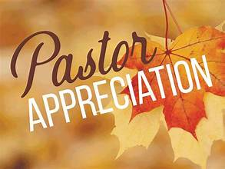

Pastor Appreciation is Today: Food, Fellowship, and… "The Wall"? Think you can handle what the Elders have been plotting, Pastor Harrell and Katie? We doubt it!
Right after service today, join us in Stahnke Hall as we celebrate Pastor Appreciation Day! Enjoy some cake, wonderful company, and a featured game called "The Wall" (disclaimer: no actual masonry skills required). Come hungry, bring your game face, and let’s show our love and gratitude to our Pastors and let them know how much we appreciate everything they do!



Honey Sunday 2026 – Purchase a bottle of honey and change the life of a child! Dakota Boys and Girls Ranch is a recognized service organization of the Lutheran Church – Missiouri Synod. It provides a place to heal for children, ages 10-18, who face psychiatric, behavioral, and trauma issues. Please see Linda Sweeney to place your honey order on either Sunday, 10/18 or 10/25. The suggested donation for each bottle is $10. For online orders, go to DakotaRanch.org/orderhoney.

Get Ready to "Stick to It" at Adult Fellowship!
Next Sunday, October 18th at 2:00 PM
Whether you’re young in years or just stubbornly refusing to act your age, Adult Fellowship is the place to be! We’re pulling out all the stops with delicious treats, prizes worth bragging about, aggressive Bingo, and the world premiere of our new game, "Stick to It" (disclaimer: no actual glue or duct tape involved... probably). Curious? Intrigued? Questioning our motives? There’s only one way to find out. Bring your appetite, your competitive spirit, and a friend!

"Ask the Expert" Estate Planning Workshop
The Lutheran Church Extension Fund (LCEF) assists LCMS congregations, members, and church workers with important tools for the future—including personal and family estate planning. Join us at LCOS for a special "Ask the Expert" workshop to get practical guidance on protecting your family and securing your legacy. Please bring your questions.

When: Friday, October 30th | 9:00 AM – 11:30 AM
Where: Lutheran Church of Our Savior

Presented by: Lutheran Church Extension Fund (LCEF)
Since a light lunch will follow, please sign up:
In Person: Add your name to the sign-up sheet in Stahnke Hall.
By Phone: Call the church office to reserve your spot. 937-1116

OPERATION CHRISTMAS CHILD

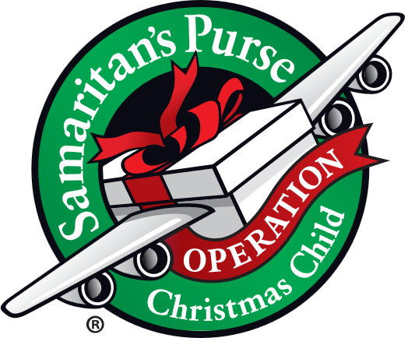
Did you miss it? Food was delicious (thank you Dawn and Estelle). 210 shoeboxes were packed. However, there are several under the Christmas tree in Stanhke Hall that need some extra special help in being full, fun -- in other words a 'WOW' gift. Please adopt one (or two), complete it and return it under the table (we'll know it has been adopted).
A huge thank you to those of you who stayed after church to assist with the packing party. Missed it and still want to help? There are several ways: adopt a box, build a box online, pack your own personal shoebox (shoeboxes available), donate to ship the shoeboxes, volunteer during National Collection Week November 16 through 23. Questions?? Ask Anita 805-680-8522.


The new picture directory is here! Each household is welcome to receive one directory. Please contact the church office to request your copy. To help protect everyone’s privacy, directories will be given out by request rather than left out for pickup. Thank you for helping us keep our church family’s information safe!


Quilting group meets 9:30-11:30 Oct. 13. All are welcome even if you don’t sew there are tasks to do, as well as enjoy the fellowship.


The Psalms have been given to us as a model for living and praying to God in good times and in bad ones. In joy and in sorrow. When things go according to plan and when the plan simply falls apart. Join us on Sunday Mornings at LCOS for a walk through the Psalms and the many powerful words and lessons they have to teach us.

Oct 11 Praying the Psalms: Confessing Our Sins. Psalm 51
Oct 18 Praying the Psalms: Praying about a World Gone Mad. Psalm 12
Oct 25 Praying the Psalms: A Way of Life. Summary

OCTOBER 11, 2026 – OCTOBER 18, 2026
Sunday  10/11 | 9:00 AM – SS/Bible Study  10:00 AM – Worship Service  11:00 AM – Pastor Appreciation  1:00 PM – New Member Instruction Class
Monday  10/12 | 4:30 PM – Elders’ Meeting  6:00 PM – Men’s Group
Tuesday  10/13 | 9:30 AM - Quilters
Wednesday  10/14 | 10:00 AM – Small Group Bible Study  6:30 PM – Handbell practice
Thursday  10/15 | Ministry Availability Due
Friday  10/16 | 6:00 PM – Parent’s Night Out
Saturday  10/17 | Mowing: Riddiough, Schofield
Sunday  10/18 | 9:00 AM – SS/Bible Study  10:00 AM – Praise/Comm. Service  11:00 AM – Council Meeting  2:00 PM – Adult Fellowship

