
Message Outline
144,000 and the Harvest
Revelation 14

Intro: Last week and the “mark of the beast”..
- Evil is real but God’s not powerless against it (cf. Rev.12, 14)…
- Rev. 14 and God’s judgment of evil…

v.1a—A sight for sore eyes:
-From dragons and beast back to the Lamb!
-Not sand (13:1) but mountain (14:1)!
v.1—Contrasting marks: mark of beast (13:16ff.) or mark of God (cf.14:1, 7:3-4, Deut.6:4- 9)…
- 144,000 as symbolic of sum total of God’s people (cf. 7:4, 9)…
v.2—God as the source of all the songs in Revelation…
v.3—“new song” and tied to redemption…
v.4-5—Odd reference to women (cf. 1Sam.21:4ff., Rev.14:8, Rev.17)…
- “redeemed” as key word (cf. Rev.7:14, 1Cor.6:9-11, 20)…
v.6a—3 angels with 3 announcements…
v.6-7—First announcement is a chance to respond to the “eternal gospel”…
v.8—Second announcement is Babylon’s fall…
v.9-12—Third announcement is judgment in reference to allegiance…
- Another call for “patient endurance” and “faithfulness” (cf. 13:10)…
v.13—Common graveside reading…
v.14-20—An image of harvest…
- A contrast or a celebration??? (cf.Heb.13:12)…
- Scriptural reminders of harvest: cf. Mt.1324-43, Gal.6:7-9, 5:16-25

Lessons from Revelation 14

1) ______________________________________

2) ______________________________________

3) ______________________________________

Reading Plan Next Week: Revelation 15-16
Message Outline
144,000 and the Harvest
Revelation 14

Intro: Last week and the “mark of the beast”..
- Evil is real but God’s not powerless against it (cf. Rev.12, 14)…
- Rev. 14 and God’s judgment of evil…

v.1a—A sight for sore eyes:
-From dragons and beast back to the Lamb!
-Not sand (13:1) but mountain (14:1)!
v.1—Contrasting marks: mark of beast (13:16ff.) or mark of God (cf.14:1, 7:3-4, Deut.6:4- 9)…
- 144,000 as symbolic of sum total of God’s people (cf. 7:4, 9)…
v.2—God as the source of all the songs in Revelation…
v.3—“new song” and tied to redemption…
v.4-5—Odd reference to women (cf. 1Sam.21:4ff., Rev.14:8, Rev.17)…
- “redeemed” as key word (cf. Rev.7:14, 1Cor.6:9-11, 20)…
v.6a—3 angels with 3 announcements…
v.6-7—First announcement is a chance to respond to the “eternal gospel”…
v.8—Second announcement is Babylon’s fall…
v.9-12—Third announcement is judgment in reference to allegiance…
- Another call for “patient endurance” and “faithfulness” (cf. 13:10)…
v.13—Common graveside reading…
v.14-20—An image of harvest…
- A contrast or a celebration??? (cf.Heb.13:12)…
- Scriptural reminders of harvest: cf. Mt.1324-43, Gal.6:7-9, 5:16-25

Lessons from Revelation 14

1) ______________________________________

2) ______________________________________

3) ______________________________________

Reading Plan Next Week: Revelation 15-16
Message Outline
144,000 and the Harvest
Revelation 14

Intro: Last week and the “mark of the beast”..
- Evil is real but God’s not powerless against it (cf. Rev.12, 14)…
- Rev. 14 and God’s judgment of evil…

v.1a—A sight for sore eyes:
-From dragons and beast back to the Lamb!
-Not sand (13:1) but mountain (14:1)!
v.1—Contrasting marks: mark of beast (13:16ff.) or mark of God (cf.14:1, 7:3-4, Deut.6:4- 9)…
- 144,000 as symbolic of sum total of God’s people (cf. 7:4, 9)…
v.2—God as the source of all the songs in Revelation…
v.3—“new song” and tied to redemption…
v.4-5—Odd reference to women (cf. 1Sam.21:4ff., Rev.14:8, Rev.17)…
- “redeemed” as key word (cf. Rev.7:14, 1Cor.6:9-11, 20)…
v.6a—3 angels with 3 announcements…
v.6-7—First announcement is a chance to respond to the “eternal gospel”…
v.8—Second announcement is Babylon’s fall…
v.9-12—Third announcement is judgment in reference to allegiance…
- Another call for “patient endurance” and “faithfulness” (cf. 13:10)…
v.13—Common graveside reading…
v.14-20—An image of harvest…
- A contrast or a celebration??? (cf.Heb.13:12)…
- Scriptural reminders of harvest: cf. Mt.1324-43, Gal.6:7-9, 5:16-25

Lessons from Revelation 14

1) ______________________________________

2) ______________________________________

3) ______________________________________

Reading Plan Next Week: Revelation 15-16

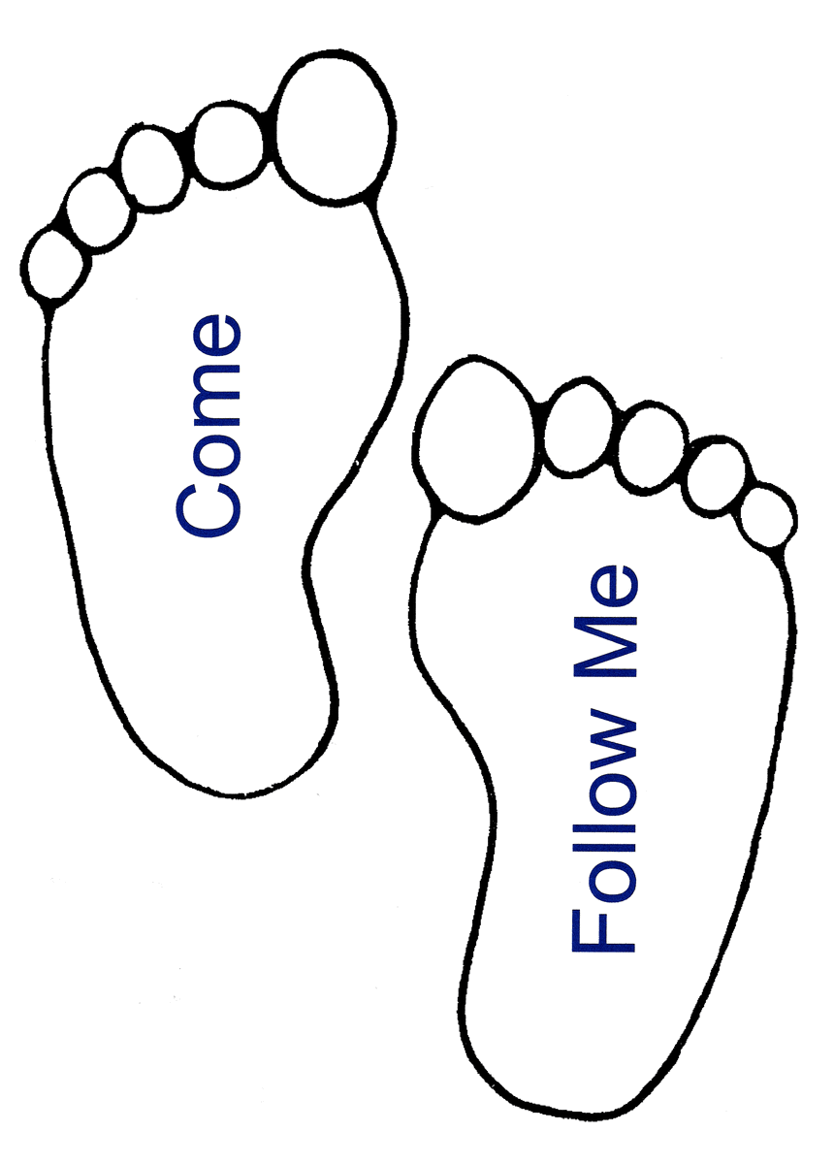
Small Group
Reflection Questions
(Please take time to ponder and pencil in
to prep for this week’s small group session.)

*Reflect on Last Week’s Practice: Formation Audit
What did you notice about your daily habits? What did you notice about family history or personal relationships that is forming you? Is there anything you’d like to change about your habits/relationships?

Watch: Video Session #2: Formation Part 2

*When has been a time in your spiritual journey when you felt “stuck”—whether in habits, unhealthy emotional patterns, or in your relationship with God? Explain.

*Was there a practice or a breakthrough moment you had that helped you get “unstuck”? Share.

*The statement was made: “Spiritual growth happens slow overtime.” Looking back, can you see some examples of growth? Give examples.

This Week’s Practice: Read Scripture Daily
Small Group
Reflection Questions
(Please take time to ponder and pencil in
to prep for this week’s small group session.)

*Reflect on Last Week’s Practice: Formation Audit
What did you notice about your daily habits? What did you notice about family history or personal relationships that is forming you? Is there anything you’d like to change about your habits/relationships?

Watch: Video Session #2: Formation Part 2

*When has been a time in your spiritual journey when you felt “stuck”—whether in habits, unhealthy emotional patterns, or in your relationship with God? Explain.

*Was there a practice or a breakthrough moment you had that helped you get “unstuck”? Share.

*The statement was made: “Spiritual growth happens slow overtime.” Looking back, can you see some examples of growth? Give examples.

This Week’s Practice: Read Scripture Daily
Small Group
Reflection Questions
(Please take time to ponder and pencil in
to prep for this week’s small group session.)

*Reflect on Last Week’s Practice: Formation Audit
What did you notice about your daily habits? What did you notice about family history or personal relationships that is forming you? Is there anything you’d like to change about your habits/relationships?

Watch: Video Session #2: Formation Part 2

*When has been a time in your spiritual journey when you felt “stuck”—whether in habits, unhealthy emotional patterns, or in your relationship with God? Explain.

*Was there a practice or a breakthrough moment you had that helped you get “unstuck”? Share.

*The statement was made: “Spiritual growth happens slow overtime.” Looking back, can you see some examples of growth? Give examples.

This Week’s Practice: Read Scripture Daily

