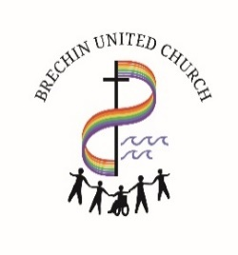
October 2, 2026
CONGREGATIONAL E-MAIL ANNOUNCEMENTS
Unit 100, 2020 Estevan Road, Nanaimo, BC, V9S 0C9
BRECHIN UNITED CHURCH OFFICE HOURS (and church entry)
9:30 a.m.–12:00 noon and 1:00–3:00 p.m., TUESDAY – FRIDAY
Phone - (250) 754-9212

WORSHIP WITH BRECHIN UNITED CHURCH
Everyone is welcome Sundays at 10:00 a.m. in person or join us on livestream at www.youtube.com/@BrechinUnitedChurch-of8yz and look for the live tab.
Link: https://us02web.zoom.us/j/89260121063?pwd=TPiL6IwyglJjfqsV1T6OxasVIqU0qb.1
Later the service will be posted to our home page
where past services can still be viewed. Parking is available across the road at
École Océane elementary school or at Zougla Restaurant

MAKE YOUR REGULAR DONATIONS TO BRECHIN BY ONE OF THESE METHODS:
- Bring your offering to regular Sunday Service
- Mail your cheque to Brechin United Church, Unit 100, 2020 Estevan Road, Nanaimo, BC, V9S 0C9
- Send an Interac E-transfer to Brechin United Church using donate@brechinunited.org (NEW)
- Use the CanadaHelps button on our website
- Apply for PAR (application forms are available at the Office)
When making your donation on-line, please include how you wish your donation to be allocated:
Local Expenses of Brechin or Mission & Service Fund. It would be helpful to also add your e-mail address. Thank you.

Link to Brechin Calendar: Calendar | Brechin United Church
For a complete list of activities at Brechin this month please open the calendar link above.
Click on any event for more information.
To print a copy of the calendar, remember to change to landscape setting.
A copy of the calendar is also posted on the bulletin board at the church.

Oct. 4th: Lay Leader: Susan Ward
Greeters: Jane & Henry Wiebe
Power Point: Kathy Torhjelm
Announcement Preparation: Jim Boggs
Audio Visual: Ian Gartshore
Coffee Servers: Lynn Burrows, Jim Boggs, Sue Dilawri
Welcome Table: Susan Ward

Oct. 11th: Lay Leader: Stan Baker
Greeters: Bruce & Linda Wilson
Power Point: Mary Boyd
Announcement Preparation: Matt Haapala
Audio Visual: Justine Etzkorn
Coffee Servers: Bonnie Haapala & Peggy Jense
Welcome Table: Gloria Le Gal

BIRTHDAYS & ANNIVERSARIES:
Happy birthday to you, Happy Anniversary to you
May God bless and keep you the coming year through.

COMMUNION NOTICE: Our worship service on October 4th will include Communion.
The congregation will be offered Communion by intinction (grape juice); however, we continue to offer grapes for those who prefer that option. We also provide a gluten free station. The Worship Team at Brechin is striving to provide a safe, meaningful worship experience for all who attend in person and from home. In whatever way you join us, know that you are welcome.

THANK YOU: The family of Catherine Angus offer their heartfelt appreciation for everyone from the Brechin family who went above and beyond to make her Celebration of Life seamless and memorable.


REACHING OUT: is Wednesday, October 7th, 7 p.m. in the Arbutus Room. We are featuring two ‘Coming Out’ stories. Xan Bell and Chris Caplette will be sharing their individual stories of their journeys to living full and authentically. These are always stories of tremendous courage!

BROADVIEW MAGAZINE DISCUSSION GROUP:
Brechin United is inviting you to a scheduled Zoom meeting.
Topic: Broadview Discussion Group
Time: October 8, 2026 04:00 PM Vancouver
Join Zoom Meeting
https://us02web.zoom.us/j/85872856711?pwd=PTAMU1Zn5AReJK1kt6KI0mhyg4w4aZ.1
Meeting chat link
https://us02web.zoom.us/launch/jc/85872856711
Meeting ID: 858 7285 6711
Passcode: 945584

FALL MEDICINE WALK WITH STZ’UMINUS ELDER DANIEL ELLIOTT: Saturday, October 10th, 10:00 a.m. Exploring Autumn medicinal plants, learning how they have been traditionally used and discovering what’s growing during the fall season. Location to be announced! Cost: $25 per adult; $15 per youth. Registration is limited! To register, please e-transfer your registration fee(s) via email to john.musgreave@gmail.com (our Circle of Friends treasurer). For questions, please contact Lynn Burrows or Colleen Crossland of Brechin 4 ACTION.
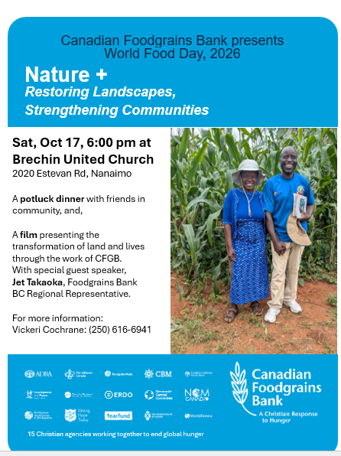
WORLD FOOD DAY: World Food Day, October 16th, will be celebrated at Brechin with a
100 mile pot luck supper on October 17th, and several other churches will be invited. Guest speaker, Jet Takaoka, of Canadian Food Grains Bank will share some thoughts and show a short film about the work of the Food Grains Bank. We are so fortunate to have Jet here on the Sunday morning also to participate in the reflection. Mark your calendars and come for the food, the inspiration and the companionship. See enclosed poster.

CELEBRATION OF LIFE: Juanita Wilkins – October 19, 2026

NANAIMO CITIZENS FOR THE REDUCTION OF HARM: Thank you for all the generous donations so far. Every Sunday, there will be a green tote by the picnic table, to collect donations. The need continues, even increases, as the weather gets colder.

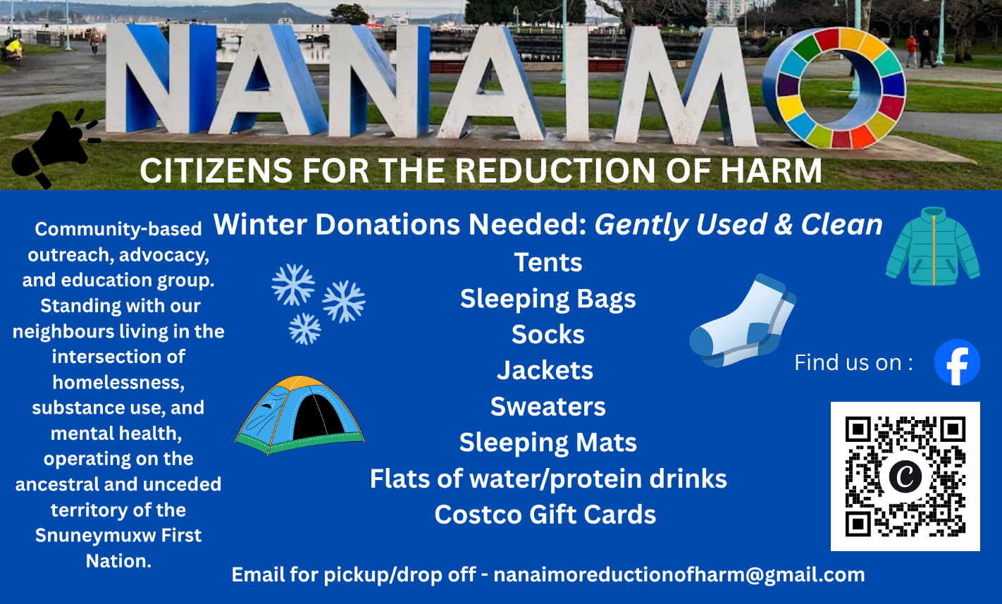

Please Wear Your Brechin Name tag
It’s a gift you give to others.
If you need one, please place your order at the
Welcome Table as you enter the Birch Room;
indicate if you would like a free paper one
or a $10.00 metal one and specify magnetic or pin attachment.
Please pay at the office or by e-transfer at: donate@brechinunited.org
Then remember to pick up the name tag.

EGG CARTONS PLEASE: Brechin’s Loaves & Fishes coordinators are looking for empty egg cartons that will be used at our Tuesday depot. We would appreciate having the cartons that hold 12 eggs. Thank you!


MEND: Friday, Oct 16th, at the Snuneymuxw Recreation & Wellness Centre. An evening with Jodi Spargur, author of the book MEND. Doors at 5:30, Elder Welcome and Prayer at 6:00 p.m. Learn about reconciliation and how we might move BEYOND land acknowledgement toward building new and genuine relationships. Tickets are $15 at MendNanaimo2026.eventbrite.ca or by emailing circle.of.friends.nanaimo.bc@gmail.com.

NARAMATA CENTRE: The United Church Retreat centre, Naramata Centre, has opened its doors and programs to people fleeing the wildfires raging through the Okanagan Valley. This meant canceling some of it’s programming - but the Centre committed to not only offering a safe place to stay, they kept their summer staff in place to offer free programming for children and youth, as well as setting up a food pantry. They embodied their commitment to radical hospitality and love for neighbour - but it comes at a cost to the Centre, in a time when they were trying to find financial stability. The canceled programs opened their doors and maintained commitment to their staff.
If you are able, donations to support this ministry can be made to Naramata Centre’s Wildfire Support, click button on Mailchimp announcements.

