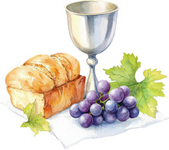
Colington United Methodist Church
October 4, 2026
United Women in Faith Sunday/World Communion Sunday

welcome
prelude and lighting of altar candles
We Are an Offering
remembrance of baptism
litany
From the beginning, God entered into covenant with the human family:
with Adam and Eve, Noah, Abraham and Sarah,
Moses, Deborah, Ruth, and Jeremiah.
Through baptism, Jesus Christ calls us into the covenant
and makes us ministers of Christ’s righteousness.
All Christian ministry is Christ’s work of outreaching love.
It demonstrates a common life of gratitude and devotion,
witness and service, celebration and discipleship.
All Christians are called to Christ’s servanthood in the world,
to the glory of God and for human fulfillment.
The Church, as community of the new covenant,
participates in Christ’s ministry of grace.
It stretches out to human needs
wherever service may convey God’s love and ours.
In our ministry of servanthood is this ultimate concern:
that all may be renewed in the image of their Creator,
and that all Christians are called to minister
in deeds and words that heal and free. Amen.

opening hymn
Let Us Break Bread Together ǀ UMH 618
introduction
Feed My Sheep ǀ Becky Eanet
scripture
James 2:15-17
reflection
The Table and the Table ǀ Rev. Jack Colenda
anthem
Everybody’s Got a Place in the Choir
prayers of the people
†affirmation of praise
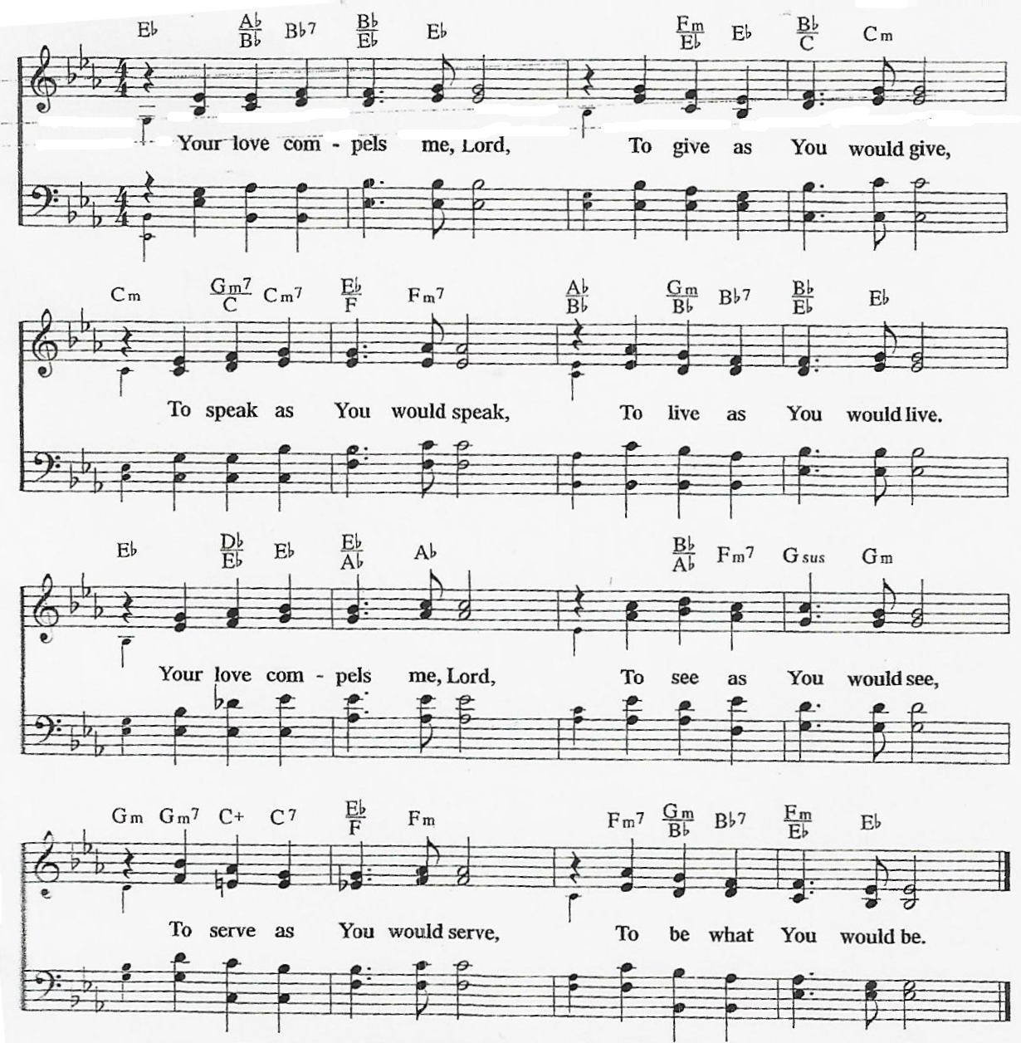
Your Love Compels Me

the great thanksgiving ǀ UMH 15
invitation to communion
I Have Called You By Name
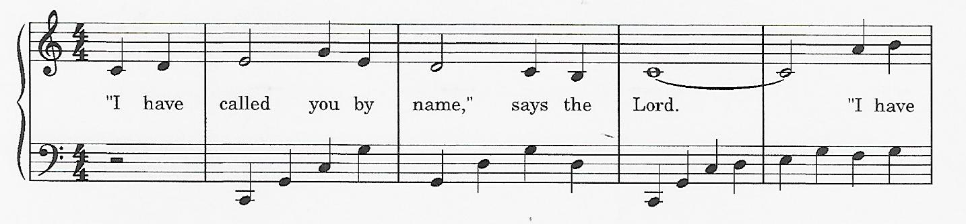

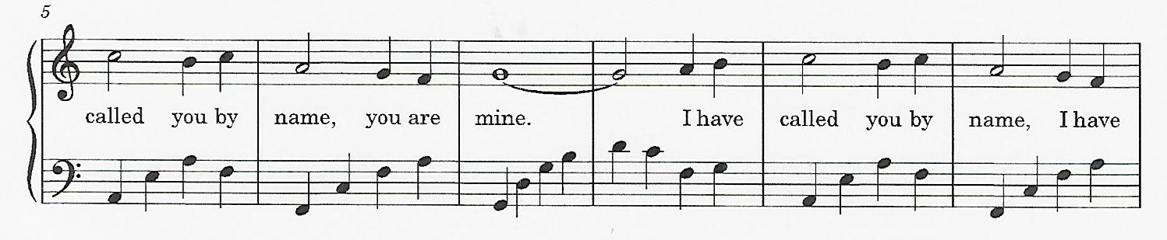

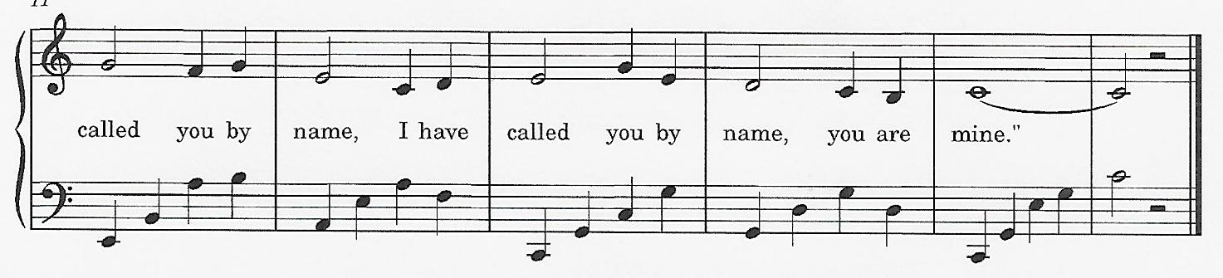

giving the bread and the cup
†closing hymn
We Are the Church ǀ UMH 558
*The large white candle which we light today is in memory of Joyce Bell and Howard Wamsley
_____________________________________________________________

this week at colington
These opportunities to serve as the Body of Christ are available.
Tuesday – 9 am – Prayer Group
Wednesday – 12pm – Veterans lunch at Spring Arbor.
Thursday – 4pm – Mobile food pantry at FFES.
6pm – Charge Conference at Kitty Hawk UMC.
Saturday – 9am – UWF breakfast meeting at church and Zoomed.

coming up
Next Sunday – 8:15 – choir practice
9:30 am – Worship, in-person and Facebook Live
Wed., Oct.14 – 7:30am – FCA breakfast at FFHS.
10am – Knitters and crocheters meet.
Thurs., Oct. 15 – 7:30am – FCA breakfast at FFMS.
Sat., Oct. 17 – 9am – Men’s ministry breakfast.
Wed., Oct. 21 – 10am - Admin. Council meeting.
Sat., Oct. 24 – UWF Annual meeting at Sharon UMC.
Mon., Oct. 26 – Student of the month at FFES.
Wed., Oct. 28 – 10am Knitters and crocheters meet.
1:45pm – Volunteers to Beach Food Pantry.

Thanks to today’s volunteers!
Ushers – Steve Knowles/ Ozzie Gray/ Wiley Beales
Communion Assistant – Debby Garber
The flowers on the altar are given by Sherry Rollason celebrating Bill Sport’s birthday.

Last week’s attendance - 80

