All Saints Anglican Church
6904 Lougheed Highway, Agassiz, B.C. V0M 1A0
Bulletin September 28th, 2026 – October 4th, 2026

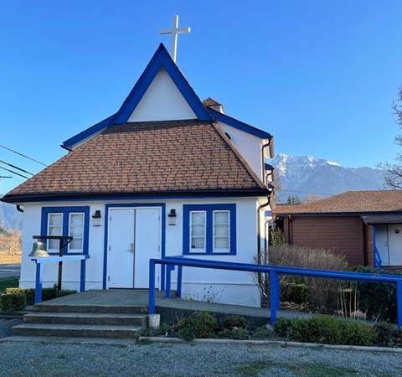

‘The ground we walk does not belong to us; for thousands of years it has been - and remains - the territory of the Stó:lō. We are grateful for their sharing.

Phone: 604-796-3553
Website: www.allsaints-agassiz.ca
https://www.facebook.com/groups/AllSaintsFamily
OUR DOOR IS OPEN AND ALL ARE WELCOME
October 4th, 2026, Nineteenth Sunday After Pentecost
Morning Prayer
Hosts: Graham Featherstone/Jennifer Pinlac
Intercessor: Valerie and David Hamilton
Lay Administrator: Dorothy Cresswell
Announcer: Virginia Jennings
Organ/Piano: Francesca Froehlich
Readers: Graham Featherstone/Dorothy Cresswell
Coffee Time: Greg & Andrea/Mathew & Mariam

Vicar’s Warden: Ginny Jennings. 604-796-2206
People’s Warden: Lynn Laughlin. 604-799-5131
Please contact either warden if you have an issue that needs attention.

All Saint’s Calendar/Announcements:

- Book Club – On August 19th Book Club will be starting "Two Steps Forward" by Sharon Garlough Brown, an experienced leader of spiritual formation retreats in the UK and US. The 4 women from Sensible Shoes are taking their next steps in the spiritual formation journey. But each of them is finding roadblocks along the way.
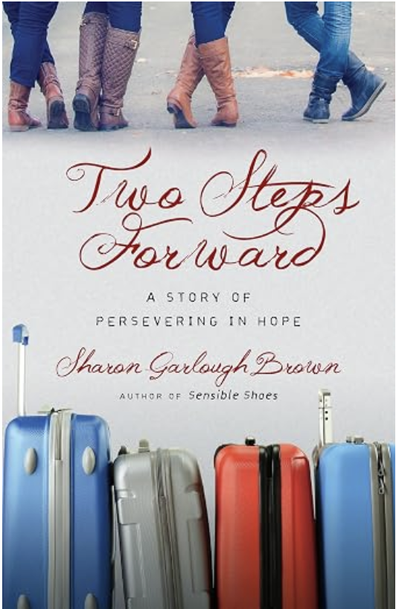

Please contact Valerie at Valeriejhamilton@yahoo.com
if you would like an invitation to the Zoom meetings
at 5.00 pm on Wednesdays.

- Bible Study is every Saturday morning 0830-0900 on Zoom. All are welcome to preview and discuss the readings for the Sunday service. Please ask Valerie to add your email address to the invitation list.

- Prayer Requests can be given on a piece of paper to either of the Wardens or entered in the Prayer Request Book on the lectern. Alternatively, you can contact Anthea Lewis at antheamlewis@shaw.ca for Pray First Prayer Circle, which is a confidential online prayer circle.

- Music Requests may be given to the Wardens.

- AA meets in the hall every Tuesday and Friday at noon.

- Every Thursday in the hall 1100-1200 we have a social time with coffee, games if you like or just talk.

- At 1000-1100 on Thursdays there is an Interactive Bible Study on the day’s Lectionary readings. All are welcome – discover the treasures in this amazing book!

- 5th Sunday of each month will be a potluck lunch after the service.

- If you would like to book a table at the Craft Fair on October 24th, please see Fran. Cost is $35

Ministerial Meandering
With thanks

You’ve spoilt me for any other parish; I don’t know how I could take another one after all you folk have given me - us - Sheila is included in all of this.
I remember reading David Price’s letter to you after he left, listing all the things he had done with you over the ten years he had been with you. I don’t intend doing that - you only have to look around you to see all that you have achieved in the last 6 years (minus 3 months).

What I really want to say begins and ends with ‘Thank you”.

You came at exactly the right time for Sheila and me. We were ‘camping’ on a farm, not knowing quite which direction to take or where to go, when the opportunity to cover your New Year services after David left came up. For reasons that can only have been directed by God, you asked me to apply for the permanent position - and, God having a really good sense of humour - I was appointed.

I have had more gifts than I can possibly say. You have trusted me with your greatest joys and deepest woes, which is humbling for anyone. You have also trusted me with your health problems - some of you more than others, and I won’t embarrass anyone by naming any of you. You all know who you are. I am only sorry that I was not in practice any more, so I could not help you any further. I would have dearly liked to do some of your surgeries, and hopefully saved several of you from the ghastly complications you have had to endure at the hands of the woefully deficient Canadian medical system.

Within the workings of the church itself, I have been blessed with a superb working group in the Parish Council. All of you have pulled your weight and contributed in so many different ways. That is what teamwork is all about.
Some of you have also had to listen to my grumblings and woes from time to time - for which I am also extremely grateful. You didn’t have to, but you did. Vicars are strangely human too - just some are more strange than others, I guess!

You welcomed Niko and Gracie, and we became known as the dog-friendly church. People enjoyed the communion rail with a sniff from Gracie - at least, I think they did. Gracie did anyway.

I will continue to write my ‘normal’ Ministerial Meandering for the foreseeable future - until I run out of steam or you ask me to stop. It might not be appropriate to continue to put the MM into the Bulletin when you have a new priest, but I would be happy to continue to send it to the distribution that I currently have of about thirty of you. If any of you want to stop receiving it, or know of another who would like to receive it - please let me know.

So for now this is not so much ‘Goodbye’ as ‘au revoir’. Keep your eyes on Jesus and keep loving one another. Welcome the stranger - remember you were one once.

As ever,

Philip+
Something to think about…

I tell you guys one thing; when I go, I want to leave behind gifts for all of you - and you can’t put any of them into your hands;

I want to leave you love, gratitude, and sense of peace in your hearts that comes from knowing Jesus Christ in every one of your neighbours.

I can live with that.
Philip Barker 2022

Birthdays in the October

We have no birthdays in the month of October. I am sure someone is born in this month, but they aren’t part of our All Saints family.

Diocesan Cycle of Prayer: We Pray for the Clergy and Congregation:

The Diocesan Refugee Unit - Ms Shannon Muir, Chair; St. David and St. Paul, Powell River - The Revd Laurel Dahill, The Rev Lucy Price, The Revd Ronald Berezan, The Revd Taras Pakholchuk

Anglican Church of Canada Cycle of Prayer – We Pray for:

The Rt. Rev. Anna Greenwood-Lee, Bishop, and the clergy and people of the Diocese of Islands and Inlets. Remember missing and murdered Indigenous women, girls, and 2SLGBTQQIA people and their families, and pray for an end to gender-based violence.

Collect

Almighty God, you have built your Church on the foundation of the apostles and prophets, Jesus Christ himself being the chief cornerstone. Join us together in unity of spirit by their teaching, that we may become a holy temple, acceptable to you; through Jesus Christ our Lord, who lives and reigns with you and the Holy Spirit, one God, now and for ever.

Hosea 13:4-14 Graham Featherstone

⁴ “But I have been the Lord your God
ever since you came out of Egypt.
You shall acknowledge no God but me,
no Savior except me.
⁵ I cared for you in the wilderness,
in the land of burning heat.
⁶ When I fed them, they were satisfied;
when they were satisfied, they became proud;
then they forgot me.
⁷ So I will be like a lion to them,
like a leopard I will lurk by the path.
⁸ Like a bear robbed of her cubs,
I will attack them and rip them open;
like a lion I will devour them—
a wild animal will tear them apart.

⁹ “You are destroyed, Israel,
because you are against me, against your helper.
¹⁰ Where is your king, that he may save you?
Where are your rulers in all your towns,
of whom you said,
‘Give me a king and princes’?
¹¹ So in my anger I gave you a king,
and in my wrath I took him away.
¹² The guilt of Ephraim is stored up,
his sins are kept on record.
¹³ Pains as of a woman in childbirth come to him,
but he is a child without wisdom;
when the time arrives,
he doesn’t have the sense to come out of the womb.

¹⁴ “I will deliver this people from the power of the grave;
I will redeem them from death.
Where, O death, are your plagues?
Where, O grave, is your destruction?

“I will have no compassion,

1 Corinthians 2:6-16 Dorothy Cresswell

⁶ We do, however, speak a message of wisdom among the mature, but not the wisdom of this age or of the rulers of this age, who are coming to nothing. ⁷ No, we declare God’s wisdom, a mystery that has been hidden and that God destined for our glory before time began. ⁸ None of the rulers of this age understood it, for if they had, they would not have crucified the Lord of glory. ⁹ However, as it is written:

“What no eye has seen,
what no ear has heard,
and what no human mind has conceived” —
the things God has prepared for those who love him—

¹⁰ these are the things God has revealed to us by his Spirit.

The Spirit searches all things, even the deep things of God. ¹¹ For who knows a person’s thoughts except their own spirit within them? In the same way no one knows the thoughts of God except the Spirit of God. ¹² What we have received is not the spirit of the world, but the Spirit who is from God, so that we may understand what God has freely given us. ¹³ This is what we speak, not in words taught us by human wisdom but in words taught by the Spirit, explaining spiritual realities with Spirit-taught words. ¹⁴ The person without the Spirit does not accept the things that come from the Spirit of God but considers them foolishness, and cannot understand them because they are discerned only through the Spirit. ¹⁵ The person with the Spirit makes judgments about all things, but such a person is not subject to merely human judgments, ¹⁶ for,

“Who has known the mind of the Lord
so as to instruct him?”

But we have the mind of Christ.

Odds and Ends



