This Week at PPBC

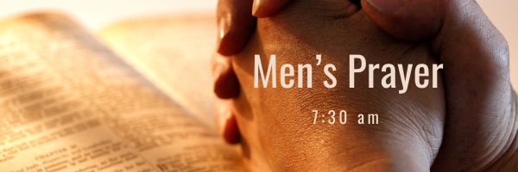


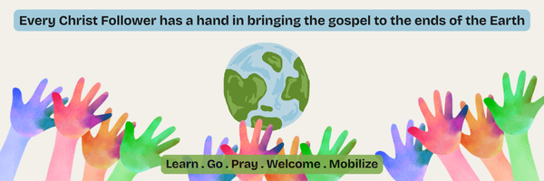A Prayer Request from the Lambs: Mission aviation is a life line for the remote work being done by Ethnos where missionaries are translating the Bible into tribal languages. We rejoice that our helicopter in Indonesia is now finally authorized and flying our missionaries and tribal workers. Our third helicopter for PNG is getting ready to be shipped. Please pray for all the logistics and safe arrival.
October 10, 2026
October 13, 2026
Wednesday Night DUGOUT
Children's Program - Wednesday, October 7, 2026
We are excited to annouce that The Dugout 2026-2027 is right around the corner! The program is for children aged 3 to grade 6 and runs Wednesdays from 6:30 pm to 8:00 pm. Program runs from October through to April
Start Date: Postponed until further notice
Time: 6:30-8pm, every Wednesday
Cost: Free!

Notes

Sunday Ministry Schedules
Below are ministry schedules for Nursery, Jr. Church, Greeters, Ushers, and Sound & Video:
Nursery
Oct 4: Brenda Clemens, Deb Brown, Grace Brown, Karis Henkelman
Oct 11: Bethany Summers, Kathryn denOuden, Amber Saunders, Hannah Colwell
Jr. Church; ages 3 to grade 1
Oct 4: Christine McLaren, Samuel Sammut
Oct 11: Kelsey Schoenrock, Lena Sammut
Jr. Church; grades 2 to 6
Oct 4: Mary Deli, Jeff & Karen Clemens
Oct 11: Jenna Anderson, Graeme Anderson
Greeters
Oct 4: Roy & Elizabeth Werner
Oct 11: Paul & Helen Jones
Ushers
Oct 4: Joe Colwell, Matt Saunders
Oct 11: Mark McLaren, TBA
Parking Attendants
Oct 4: Paul Sammut, Stephen Owens
Oct 11: Joe Colwell, Nick Woytowich
Sound & Video
Oct 4: Sound: Wyatt Werner | Video: William Conley
Oct 11: Sound: Charlie Deane | Video: Josh Bolsonello

Sunday Service
Song – Praise to The Lord the Almighty
Welcome
Scripture
Song – How Deep the Father’s Love for Us
Communion
Song – Christ Our Hope in Life and Death
Prayer
Message – Jim Clemens
Song – Holy Spirit

Praise & Prayer Highlights
PRAY for the Lord to provide the main leader for the Dugout Ministry in the fall.
PRAY for Scott & Justine and their family as they go to Harmony Rd Baptist to preach Oct. 4th.
PRAY for the Bolsonello & Loney family as they mourn the loss of Karen Loney. PRAISE for her many ears of faith displayed. PRAY for the family as they prepare for a funeral service Saturday, October 24th.
PRAY for the Angrove family as they mourn the loss of Steve's mom. PRAY for God's comfort to them during this time.
PRAY for Betty Collins and her ongoing health concerns. PRAY for her comfort and healing as she recovers in Whitby Hospital.
PRAY for Ray Collins who is sick, PRAY for his healing and recovery.
PRAY for John and Joan Mank and their ongoing health concerns.
PRAY for John and Elizabeth Kulchycki as they search for a new place to rent. If you know of any possibilities please let John know.
PRAY for Martin McCurley as he recovers from bumps and bruises from a recent fall.

Giving
Just as a reminder, there are several ways you can give:
In Person using the offering box located on the back wall of the sanctuary. Donation envelopes are available at the Welcome Centre. Please contact the church office if you would like a box of donation envelopes (office@portperrybaptist.ca)
Through your online banking, you may send electronic transfers to ppbcdonations@gmail.com.
You can also give through Canada Helps. Donation receipts will be provided by Canada Helps, and transaction fees apply.
***********************************************************************
Weekly Newsletter
The PPBC Newsletter is emailed to the church family every Friday. If you would like to be added to the weekly email list, please contact the office by phone: 905-985-8681 or by email: office@portperrybaptist.ca.
*****************************************************************
Church Information:
Location:
2210 Hwy 7A
Port Perry, ON
L9L 1B4
Office Hours:
Monday: 8:30am – 4:00pm
Tuesday: 8:30am – 4:00pm
Wednesday: Closed
Thursday: 8:30am – 4:00pm
Friday: 8:30 am - 3:00 pm
Contact:
Phone: 905.985.8681
Email: office@portperrybaptist.ca
Website: www.portperrybaptist.ca
Staff:
Sr. Pastor – Rev. Jim Clemens
Administrative Assistant – Madeline Werner
Family Ministries Director – Josh Anderson
Pastoral Resident – Scott McKenzie

PPBC Newsletter
Sunday, October 4, 2026


Sunday Starting Point
Sunday, October 4, 2026 - 9:30 am
“Beginning the day with the Word and prayer”
Adults:
Adults will meet in the sanctuary for a time of study and prayer.
Youth:
Jr & Sr High will join the Adults in the Sanctuary.
Children Aged 3 – Grade 6:
All children will meet together in Room #26 for a time of singing and Bible lesson
(Please note nursery is unavailable during Sunday School)
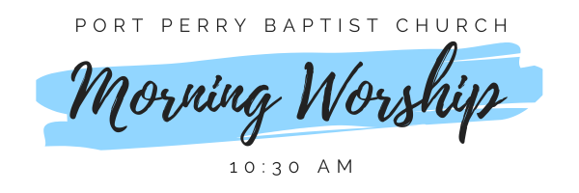Sunday Morning Worship
Sunday, October 4, 2026 - 10:30 am
We are meeting in the sanctuary and will continue to live-stream for those who are unable to attend.
Message: Prophecy, Tongues & A Healthy Church Part 2
Scripture: 1 Corinthians 14:1-25
Pastor Jim Clemens

