City Road United Methodist Church
A Lighthouse Congregation
Rev. Tim Nicholson, Pastor

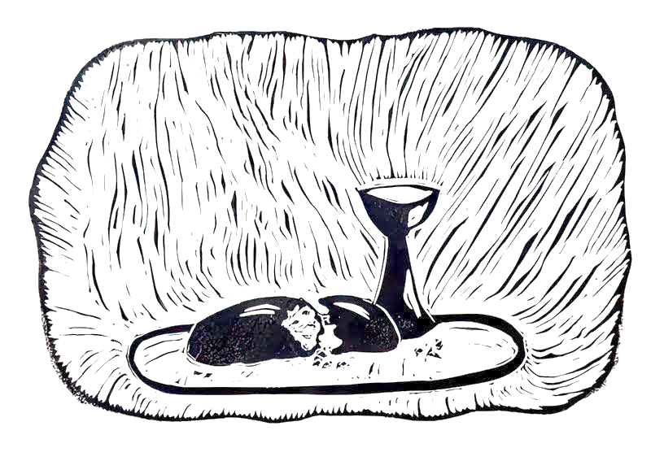

Office: (252) 335-2658
Office Hours: 12:00 pm – 3:00 pm Wednesday & Thursday
Pastor Hours: 10:00 am – 4:00 pm Wednesday & Thursday
Contact Tim for appointments

cityroadec.net crumcec@gmail.com
Facebook: https://www.facebook.com/CityRoadUMC
YouTube: https://www.youtube.com/@CityRoadUMC/streams

Sunday School: 10:00 a.m. Worship: 11:00 a.m.

Tommy Venters- Organist/Choir Director
Dawn Baker- Secretary/Technology Specialist
Jo Ann Herring- We Care
Service of Word & Table
World Communion Sunday
October 4th, 2026 11:00 am
Gathering
Prelude
Words of Welcome
*Call to Worship
Leader: On this World Communion Sunday, Jesus Christ gathers us from the north, south, east, and west. All of humanity, politically diverse, ethnically diverse, with diverse gifts, Jesus centers us, here today into one body.
People: We come to the Lord’s table because of God’s Grace, and God’s mercy toward all of us. We have sinned, but because of Jesus Christ, we know there is no greater love than your sacrifice on the cross of Calvary. Thank you Jesus!
Leader: From every nation, tribe, language, and people, God is calling the Church to unity, peace, and love in Christ.
People: We come as one body, redeemed by one Savior, Jesus Christ our Lord. HALLELUJAH!
Leader: This is not our table, but the Table of Jesus Christ, where everyone is welcomed. Everyone is welcomed from all walks of life.
People: Christ our Lord invites us all to come. HALLELUJAH!
Leader: Here we remember and may we never forget the life, death, and resurrection story, the empty grave, the encounter with Mary and his disciples, the assertion power of Jesus Christ, and the promise that Christ Jesus will come back again.
People: Today we receive grace for the journey. HALLELUJAH!
Leader: In this place we join Christians throughout the world.
People: Today we remember, we are many people, yet one body in Jesus Christ. HALLELUJAH!
Leader: Today we will worship our God who knits us together of one body in Jesus Christ.
People: With tremendous gratitude and reverence, today I worship the Lord in spirit and in truth. HALLELUJAH! HALLELUJAH! HALLELUJAH!

*Opening Hymn “Holy, Holy, Holy” UMH 64

Proclamation & Response
Psalter Reading Psalm 19

Anthem Chancel Choir

Gospel Reading Philippians 3:4b-14
Message: Pastor Tim Nicholson

Prayers of the People

Invitation to Christ’s Table UMH 7
Prayer of Confession UMH 8
In the name of Jesus Christ, you are forgiven.
In the name of Jesus Christ, you are forgiven.
Glory to God, Amen!

Sharing of Peace

Call to the Offering
Offertory
*Doxology UMH 95
*Prayer of Dedication

Holy Communion
Prayer of Great Thanksgiving UMH 13
The Lord’s Prayer
*Receiving the Bread and Cup

Communion Anthem “One Bread, One Body” UMH 620

Sending Forth
*Sending Hymn “Be Thou My Vision” UMH 451
*Benediction
*Postlude
* Stand as you are able.
Cara B. Hochhalter, Communion/Eucharist. http://diglib.library.vanderbilt.edu/act-imagelink.pl?RC=57515
CCLI License # 11639232

