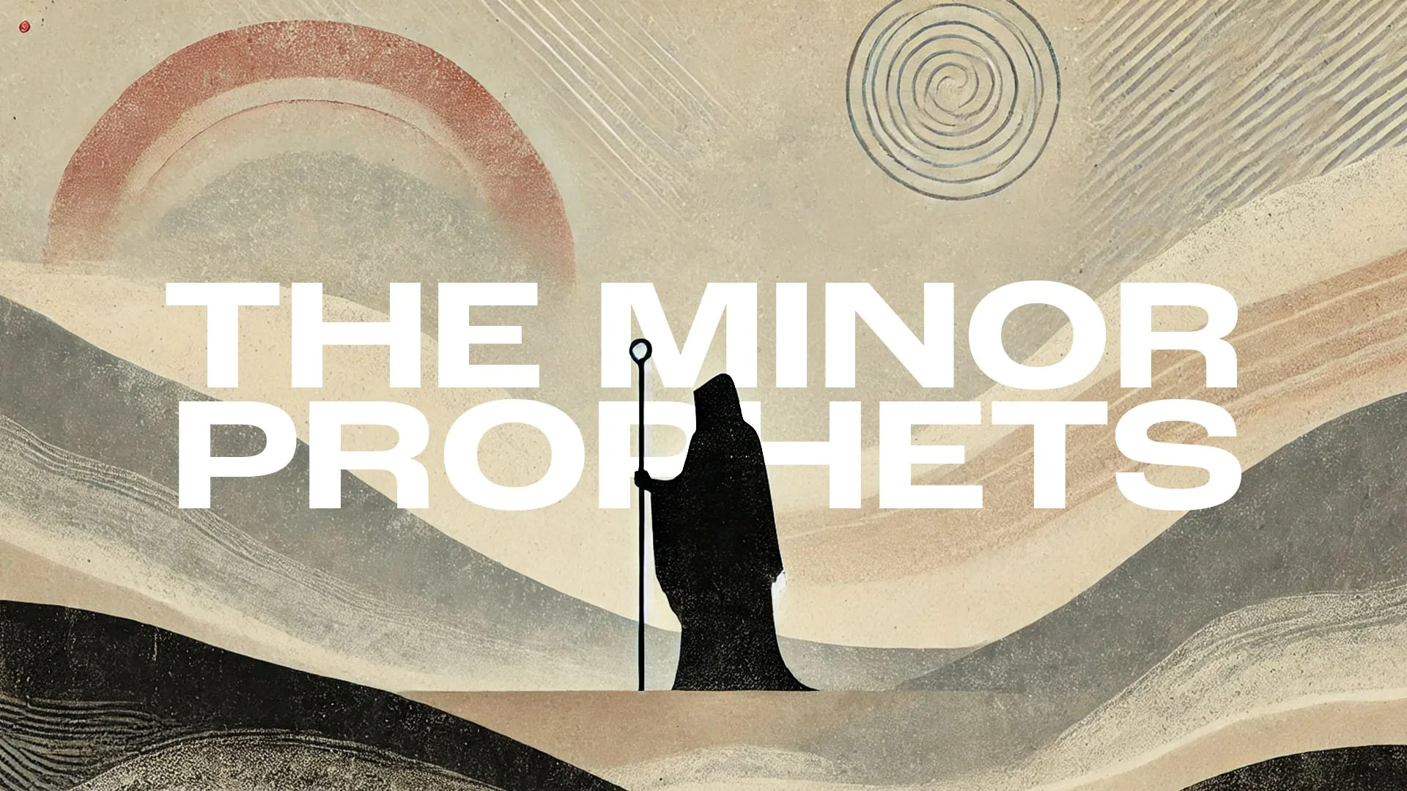
Victory Fellowship Bible Study
273 23rd St. S.W., Barberton, OH 44203
Wednesdays at 7pm
Rev. Roderick D. Grabski (330) 858-0223
arod4God@neo.rr.com FACEBOOK: Roderick Grabski

CLASS TWO: Impossible Love Affair
- ANNOUNCEMENTS and PRAYER CONCERNS

- READ / LISTEN to Hosea 1:1-11 and 2:1
  - What are your initial impressions? Notable translation differences?

- Hosea the Prophet
  - Name means “salvation.” It’s the same name in Hebrew that Joshua original had (Deut. 32:44), as well as Israel’s last king (2 Kings 17:1).

  - He is referred to by several New Testament writers:
    - Matt 2:15; 9:13; 12:7; Luke 23:30; Romans 9:25-28; 1 Cor 15:55; Rev 6:16

  - Preached in and to Israel (Ephraim) from about 755-715 B.C.

  - The book is structured around object lessons from Hosea’s marriage and family experience (chapters 1-3), and preaching (chapters 4-7).

  - It is the second largest book of the Minor Prophets, with only Zechariah being longer.

- Hosea’s Message and Purpose
  - Four-Fold Indictment Against Israel
    - Rejecting Knowledge of God and His Law, and violating the covenant requirement to show faithfulness and kindness.

    - They practiced idolatry, harlotry, and “visited” temple prostitutes.

    - Rather than God, they trusted in human inventions (kings, princes, warriors, foreign treaties).

    - They were guilty of injustice and violence (murder, lying, theft, oppression).

  - The Lord’s Instruction
    - JUST STOP IT!

    - Return to the Lord and be faithful to His covenant.

  - The Lord’s Judgement
    - The Lord has abandoned them and discipline was coming in the form of foreign domination, exile, destruction, and death.

  - The Lord is their only Hope: In response to their repentance and faith, God would love them and redeem them. God will restore and beautify Israel again.

- Revelation Received (1:1)
  - His calling runs parallel to the Southern (Judah) kings: Uzziah, Jotham, Ahaz, and Hezekiah; and one Northern (Israel) king: Jeroboam II. (See kings/prophets chart)

- Hosea’s Marriage and Children (1:2-11; 2:1)
  - The Place of Judgement (vv. 2-5)
    - Compare various translations of verse 2.

    - What are “children of promiscuity?”

    - Why did God direct Hosea to do this?

    - Compare verses 3 and 6. What is significant?

    - Jezreel is a contentious name. It means “God scatters (or sows).”

  - Historical and Biblical Importance of Jezreel:
    - Major Battles: The valley hosted many historic conflicts, including Gideon’s victory over the Midianites and King Saul’s final defeat by the Philistines at Mount Gilboa.
    - Royal City: The ancient city of Jezreel served as a winter capital and palace for northern Israelite kings like Ahab and Jezebel.
    - Naboth's Vineyard: The city is famous for the biblical story of Naboth, whose vineyard was wrongfully taken by King Ahab and Queen Jezebel.
    - Prophetic Symbolism: The prophet Hosea used the valley as a symbol of both divine judgment and future restoration for Israel. It began in 2 Kings 15:10 when King Zechariah met his death at the hand of Shallum in the Valley of Jezreel around 743 B.C. It continued in 2 Kings 15:29 when Tiglath-pilezer III of Assyria defeated Israel’s army took the territory of the Valley of Jezreel around 733–732 BC.

  - The Reason for the Judgment (1:6-7)
    - Lo-Ruhamah – No compassion. What is God’s motive for giving Gomer’s daughter this name?

    - Where does God say His compassion will go?

  - The Result of the Judgment (1:8-9)
    - Note the phrasing again in verse 8 concerning the birth of this son.
    - Lo-ammi – Not my people. This is a harsh punishment.

- A Hopeful Future (1:10 – 2:1)
  - God is a God of Hope, Unity, and Compassion!

- APPLICATION:
  - God often reveals Himself in terms of our family relationships.

  - God has a plan to restore His people in faithfulness and love.

- Final Comments, Questions. Close in Prayer

Next Week: Love as the Lord Loves - Read Hosea 2:2 - 3:5 to prepare.

