THE ORDER OF WORSHIP
September 27, 2026/18th Sunday of Pentecost
Greeter: Dale Dixon and Rachel Hawk
Please fill out your Prayer & Praise Cards. Announcements are on the screens. Please come to the front pews to meet with a member of our Prayer Team before or after the service.
Gathering
Prayer of Consecration: Pastor John
One: Wake up, sleeper, rise from the dead,
All: and Christ will shine on you. Jesus, I belong to you. I lift up my heart to you. I set my mind on you. I fix my eyes on you. I offer my body to you
as a living sacrifice. Jesus, we belong to you. Praying in the name of the Father, and the Son, and the Holy Spirit, amen.

Opening Chorus: “Step by Step” No. 671 David Beaker Strasser
Prelude: “Come Thou Almighty King” Arr. By Barbara B. Kinyon/Bells
Bringing In the Light of Christ: Kathie Whitlow

Welcome and Announcement: Jenny Nelson

*Call to Worship: Jenny Nelson
One: A love that never ceases,
All: A creativity that designed the universe,
One: A hope that cannot be quenched,
All: A pursuit of reconciliation no matter the cost:
One: These are the things that are of God,
All: Let us worship God. Amen.

Greeting Our Brothers and Sisters in Christ
Reception of New Member: Henry Hop Ragland, III (Hank)

Proclamation and Response
*Opening Hymn: “Praise to the Lord” No. 3
(Collection of Prayer & Praise Cards)

Joys and Concerns: Pastor John
Prayer Chorus: “Breathe on Me Breath of God” No. 304- V. 1
Silent Prayer & Pastoral Prayer /Lord’s Prayer: Pastor John

Anthem: “He Leadeth Me” John Purifoy
Collection of Tithes and Offerings: Barbara Austin & Dale Dixon
*The Doxology: “My Tribute” On the Screen
*The Apostles’ Creed: No. 691

Scripture Reading: Series: Letters of John
1 John 3:11-15
One: The word of God for the people of God.
All: Thanks be to God and I believe it.

Sermon: “My Brother’s Keeper” Pastor John

Sending Forth
*Closing Hymn: “Since Jesus Came into My Heart” No. 552
Postlude: “To Thee I Come” Bectha R. Frick

Please be seated. You are invited to close your eyes and use the few moments of music at the end of our service to practice Listening Prayer. This is a time to expect God to speak to you before you leave the sanctuary. In John 10:17, Jesus tells us; “My sheep hear my voice, and I know them, and they follow me.” Let’s try listening as we are silent and still. Members of the prayer team will remain on the front pews after the service. Feel free to come forward.
Benediction: Pastor John
ANNOUNCEMENTS

TO OUR VISITORS: We welcome you to Laurel Hill and hope that you feel at home. We invite you to join Laurel Hill if you do not have a church home. Please call our church office at 804-795-2772. You will find our Laurel Hill family both warm and eager to welcome you into our fellowship. Please fill out a visitor’s card and place it in
the offering plate. The password for our public WiFi is LivingHope - feel free to connect with us.

WE WELCOME Henry Hop Ragland, III (Hank) to our Laurel Hill family this morning. Take time to let him know how blessed we feel to have him join Laurel Hill.

FISH NEWS… The FISH yard sale will be on Thursday, October 1st and Friday, October 2nd. We need help setting up on Wednesday, September 30th. We especially need men at 9 AM to set up the tables early in the morning followed by the all available helpers at 10:30 AM to fill the tables with items. Thanks! Sale Hours: Thursday from 9 AM-6 PM and Friday from 9 AM-5 PM.

IN THE FRONT ENTRYWAY on the table under the mirror, you will find information on the three ballot measures that will be on the November 3, 2026 ballots. Early voting begins on September 18th. Please contact Pastor John: johnlynnbight@gmail.com, if you would like to receive electronic copies to share.

LAUREL HILL GLOBAL METHODIST CHURCH will be our new Facebook page. The old page will not be active NOW. Plan to join us on the new page and keep up with all our church’s special events and weekly calendar.

HOMELESS FEEDING…We will be gathering on September 29th at 10:00 to prepare bag lunches for the homeless. Anyone available to help is greatly appreciated. Thank you.

SATURDAY, OCTOBER 3RD, AT 4 P.M. we need help putting flags on the hill for our special Sunday. Hope you will help!

ON OCTOBER 4^{H}, we will be participating in the National Day of Prayer for Peace in Jerusalem. The wall will be up for you to write prayers that will be taken to Jerusalem. You can also write a message on a PS 91 bandana that will be given to someone in the military or a first responder. The bandanas are on the table in the extended hallway.
KEEP IN OUR PRAYERS
SICK AND SHUT-INS – Kim Davis, Jean Miller, Evelyn Steele, Kathleen McKinsey, Sara Nelson, Regina Humphrey, David Torrence, Dot Gay, Sharon Loving & Family, Debra Deane, Agnes Stevenson and ML Yuhas.

- Our Weekday School – Margo Keeles (Director), our teachers, students and families.
- Our community of Varina and all the residents, our churches in our neighborhoods, schools, students, teachers, administrators and all employees.
- Our state of Virginia, our residents and leaders.
- The United States of America, our citizens and leaders, the countries of the world, their people and leaders. May God bless us all and His will be done.
- Those affected by war in Israel and Ukraine

WEEKLY CALENDAR
Monday 10:00 AM New Life House Church today. (804) 303-4828
Bible Study/New Study on Isaiah in person and on Zoom
Come join us in person or on Zoom.

Wednesday 9:00 AM Prayer Time with Communion
10:30 AM Bible Study today.
NO Handbell Choir tonight.

7:15 PM Chancel Choir Rehearsal-New Time

Thursday 9:00 AM FISH Yard Sale
NO PTL House Church tonight.

Friday 9:00 AM FISH Yard Sale
10:00 Thankful Hearts House Church (804) 737-7450
Saturday 9:00 AM Prayer Station at Dorey Park.

Sunday 10:00 AM Sunday School
11:00 AM Sunday Worship Service (also online)

OCTOBER IS PASTOR APPRECIATION MONTH. Think of how you may bless Pastor John during this time and let him know how much he is appreciated.
Also, a birthday wish for Pastor John whose big day is tomorrow!

Stewardship in the Bible
By Joshua Godon, https://theleadpastor.com/ (adapted)

Ten Fundamentals of Biblical Stewardship

8. Demonstrating Thankfulness for God’s Provision (Gratitude)

Demonstrating thankfulness for God's provision means recognizing and expressing gratitude for the blessings we receive. 1 Thessalonians 5:12-22 provides practical instructions for living a life of faithfulness and gratitude, including the exhortation to "give thanks in all circumstances; for this is the will of God in Christ Jesus for you" (verse 18).

This ‘attitude of gratitude’ (yes, it’s corny — but it sticks in my brain... so it works) is a key aspect of stewardship. It reminds us that, in all that we do and in anything we are going through or suffering, keep a thankful outlook.

How can you give at Laurel Hill GMC?

1 – Cash and checks may be placed in the offering plate. Please contact the church office for offering envelopes.
2 - You may also give online. The QR code below will take you to our website’s giving page: https://laurelhill.tithelysetup.com/give

3 – Planned giving – including the LHGMC in your will is a wonderful way to ensure the ministries we are called to provide for Varina will continue into the future.

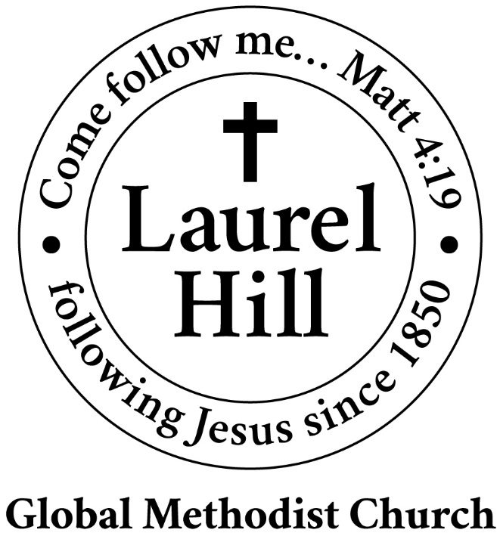
Our Mission: The Global Methodist Church exists to make disciples
of Jesus Christ and spread scriptural holiness across the globe.

1919 New Market Road, Henrico, VA 23231
On the web @ laurelhillchurch.org
Email to laurelhillchurch.varina@gmail.com
Phone: Office/804.795.2772 Pastor/804.437.0937

STAFF
Pastor: Rev. John Bright Organist/Choir Director: Pam Wilson
Secretary: Barbara Wendel School Director: Margo Keeles
Communications Assistant: Ben Wilson

that we you in thought, word, and deed.

