OUR BAPTIST IDENTITY
Binkley Baptist Church
Class 1, September 27, 2026
(Herman Greene and Mike Hawkins)

Introduction

This class concerns who Baptists are and “four fragile freedoms.” We will have four classes:

- September 27 – Origins of Baptists in England and “Bible Freedom” (Jesus Christ as revealed in scripture is our sole authority in faith and practice)
- October 4 – History of Baptists in the United States and “Soul Freedom” (right to personal faith journey without interference of creed, clergy, or government)
- October 11 – Baptists Worldwide and “Church Freedom” (autonomy of local congregations)
- October 18 – Binkley’s affiliation with the American Baptist Churches USA and Religious Freedom (freedom for, of, and from religion and separation of church) and our connection to American Baptist Churches USA

A reference for this class is Walter Shurden, The Baptist Identity: Four Fragile Freedoms

Looking ahead, on October 25 there will be a joint Sunday School class on the Palestinian situation.

After that beginning on November 1, Mike and I will teach a class drawing on Marcus Borg, Reading the Bible Again for the First Time.

Who Are Baptists Worldwide and in the United States

I will answer this in chronological steps.

What Is Religion?

Religion concerns what is difficult in life, what is beautiful, and how we are to live and the mystery behind it all and how that mystery relates to us and what the mystery expects of us.

It concerns what gives transcendent meaning to life and to our institutions and matters of ultimate concern (what is most important). Even materialism is a religion in that it has faith in the workings of cause and effect relations and logic as the ultimate realities.

Merriam Webster defines “religious” as (1) relating to or manifesting faithful devotion to an acknowledged ultimate reality or deity, and (2) of, relating to, or devoted to religious beliefs or observances.

Then it defines “religion” as (1) an organized system of religious attitudes, beliefs, and practices, (2) commitment or devotion to a god or gods, a system of beliefs, or religious observance : the service and worship of a god, of multiple gods, or of the supernatural, and (3) an interest, cause, belief, or activity that is intensely or passionately held to.

What is Christianity?

Merriam Webster says it is “the religion derived from Jesus Christ, based on the Bible as sacred scripture, and professed by Eastern, Roman Catholic, and Protestant bodies.

“Christ” it says means “Messiah,” the expected king and deliverer of the Jews. And it also says it means “an ideal type of humanity.”

We might add that Christians believe that Jesus was the revelation of the nature of God and for most Christians that Jesus was God. However, this has some problems as Jesus represents the second person in the trinity, which was present with God from the beginning. Hence, we have in the New Testament both Jesus the God-man, and Jesus the divine logos, which in John 1 was there in the beginning and through which all things came into being.

What is Protestantism?

Magisterial Protestant Reformation
- Lutheranism – Martin Luther, an Augustinian Monk, a priest, and teacher of theology at the University of Wittenburg, when he learned that the Archbishop of Mainz, Albert of Brandenberg, was going to sell indulgences to pay a debt owed for the rebuilding of St. Peter’s Basilica, wrote a letter in 1517 to the Archbishop and in his letter a copy of his “Disputation on the Power and Efficacy of Indulgences, which came to be know as the Ninety-Five Theses. They were posted on the doors of churches in Wittenburg on the eve of All Saints Day 1517 (not specifically or only on All Saints’ Church in Wittenberg. In 2018 the Theses were printed and widely distributed.
- Anglicanism – Came into being with the Act of Supremacy in 1534 which declared English monarchs the head of the church, not the Pope. Enable Henry VIII to annul his marriage to Catherine of Aragon. Later Anglicans included independent, self-governing member of the Anglican communion with its own bishops.
- Calvinism – Calvin was a French religious refugee who settled in Basel and later Geneva. wrote the first version of his Institutes of the Christian Religion in 1536
Radical Reformation (such as Anabaptists, Hutterites, Mennonites, and Amish) sought a return to the simple ways of the early church.

Lineage of the Christian Church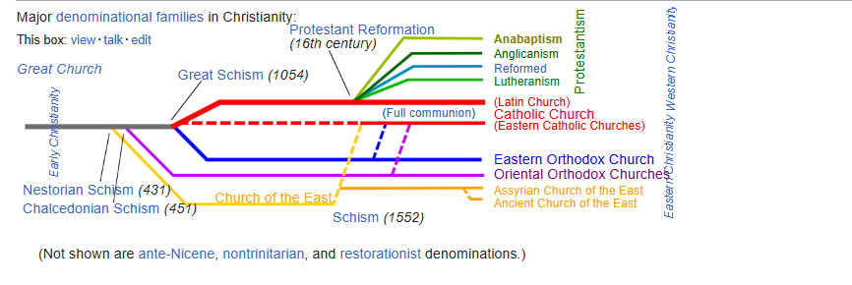
Branches of the Protestant Church
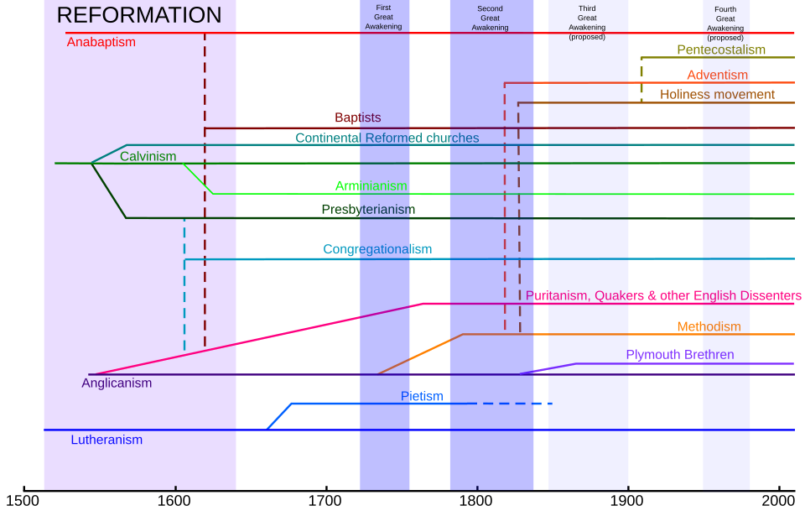
Protestantism in general holds in common these “solae” (the first three ae the basic ones)
- Sola scriptura (there is only one authority that can absolutely bind the conscience, that authority is holy scripture and that all controversies about doctrine and theology must be resolved in the final analysis by scripture)
- Sola fide (we are justified only by our faith and not by our works)
- Sola gratia (salvation comes by divine grace or "unmerited favor" only, not as something merited by the sinner)
- Sola Christo (this excludes priests as necessary for sacraments, teaching that Christ is the only mediator between God and humans—salvation is by Christ alone)
- Soli Deo gloria ("glory to God alone," which stands in opposition to the veneration of Mary, the saints, and angels)

Who are the Baptists?

Baptists arose from the dissenters of the Church of England (not from the Anabaptists)
- John Smyth was a Puritan within the Church of England. In 1607 he was excommunicated because of his nonconformism. He traveled with John Helwys to Gainsborough and joined with a Group of Puritans who were recently excommunicated from their parish churches. He and Helwys, as joint pastors, formed a congregation there. Later Smyth moved to Holland with other Puritans and discovered believers Baptism. He insisted that true worship comes from the heart and that there should be no books other than the Bible in worship. Later he became a Mennonite.
- Thomas Helwys theological beliefs were important in forming the Baptist tradition. In the early 17th century, Helwys was the principal formulator of a demand that the Church and the state be kept separate in matters of law, so that individuals might have freedom of religious conscience. This advocacy of religious liberty could be dangerous at that time. He died in prison as a consequence of the persecution of English Dissenters under King James I and is considered a martyr. Helwys embraced the theological concept of regenerate church (believers’ church) and that one becomes a member of the church by new birth and profession of faith. In January 1609, Helwys, along with Smyth, taking a logical conclusion of this doctrine, adopted a different opinion concerning the baptizand on the sacrament of Baptism, arguing that if water Baptism makes a person member of the visible Church, then only believers should be admitted to it—and not infants. Helwys formulated the earliest Baptist confession of faith, in 1611, which was addressed to fellow Puritans in England. The confession became known as the 27 Articles of Faith or the Helwys' Declaration of Faith, also the Helwys' Confession. Later Helwys returned to England and established the first Baptist church there.

Roger Williams and John Clarke are credited with bringing the Baptist tradition to America. In 1638, Williams established the First Baptist Church of Providence in the city of Providence, Rhode Island and Clarke was the local cleric at Newport, Rhode Island when he established the First Baptist Church of Newport before 1644.

Bible Freedom

Baptists are anti-creedal, which is not to say that they reject the classical creedal statements. They just do not make them binding. Baptists have had confessional statements, but they are only guides in interpretation having no authority oof conscious and are not meant to hamper freedom of thought or investigation. Each individual may judge for himself the meaning of the Bible. The Bible is authoritative but it is the right and duty of each individual to interpret it. Each individual is expected to study, interpret, and be guided by the Bible, and likewise congregations are expected to conduct themselves in accordance with their interpretations of the Bible.

