
Message Outline
Dragons and Beasts
Revelation 12-13
Intro: The Bible Project review…
- Chronology in Revelation…
- Importance of the work not the clock (cf. Acts 1:6-8)…

12:1-2—A sign that echoes to Messianic Scriptures (Gen.3:15-16, Ps.2:7-9, Rev.12:5).
v.3—Dragon as Satan (cf. Rev.20:2)…
v.4—Dragon wants the Child’s seat…
v.5-6—The Son gets the throne…
v.7-9—The Fall of Satan (cf. Is.14:12ff., Ezek.28:12ff. Lk.10:18)…
v.10-12—Song of Salvation…
- Dragon’s character: accuser (v.10)…
- Winning recipe (v.11)…
- Battle on earth and time is short (v.12)…
v.13-17—The dragon can’t win…
13:1—From the dragon to the beast…
v.2—cf. Daniel 7…
v.3-4—Fighting the beast is tough…
v.5-8—The beast or the Book…
v.9-10—“patient endurance and faithfulness”..
v.11-18—Another beast…
- Mark of the beast…
a) _____________________________
b) _____________________________
-cf. Ex.13:9, Deut.6:4-8, 11:16, 18

Lessons from Revelation 12-13

1) ___________________________________
- Tragedies that can’t be explained any other way…
- Resisting evil (cf. 1Pet.5:8-11)…
2) ___________________________________
- 12:5, 11, 13-16, 1Jn.4:1-4, Lk.10:17-20
- Contrast Rev.14 to Rev.12-13…

Reading Plan Next Week: Revelation 14
Message Outline
Dragons and Beasts
Revelation 12-13
Intro: The Bible Project review…
- Chronology in Revelation…
- Importance of the work not the clock (cf. Acts 1:6-8)…

12:1-2—A sign that echoes to Messianic Scriptures (Gen.3:15-16, Ps.2:7-9, Rev.12:5).
v.3—Dragon as Satan (cf. Rev.20:2)…
v.4—Dragon wants the Child’s seat…
v.5-6—The Son gets the throne…
v.7-9—The Fall of Satan (cf. Is.14:12ff., Ezek.28:12ff. Lk.10:18)…
v.10-12—Song of Salvation…
- Dragon’s character: accuser (v.10)…
- Winning recipe (v.11)…
- Battle on earth and time is short (v.12)…
v.13-17—The dragon can’t win…
13:1—From the dragon to the beast…
v.2—cf. Daniel 7…
v.3-4—Fighting the beast is tough…
v.5-8—The beast or the Book…
v.9-10—“patient endurance and faithfulness”..
v.11-18—Another beast…
- Mark of the beast…
a) _____________________________
b) _____________________________
-cf. Ex.13:9, Deut.6:4-8, 11:16, 18

Lessons from Revelation 12-13

1) ___________________________________
- Tragedies that can’t be explained any other way…
- Resisting evil (cf. 1Pet.5:8-11)…
2) ___________________________________
- 12:5, 11, 13-16, 1Jn.4:1-4, Lk.10:17-20
- Contrast Rev.14 to Rev.12-13…

Reading Plan Next Week: Revelation 14
Message Outline
Dragons and Beasts
Revelation 12-13
Intro: The Bible Project review…
- Chronology in Revelation…
- Importance of the work not the clock (cf. Acts 1:6-8)…

12:1-2—A sign that echoes to Messianic Scriptures (Gen.3:15-16, Ps.2:7-9, Rev.12:5).
v.3—Dragon as Satan (cf. Rev.20:2)…
v.4—Dragon wants the Child’s seat…
v.5-6—The Son gets the throne…
v.7-9—The Fall of Satan (cf. Is.14:12ff., Ezek.28:12ff. Lk.10:18)…
v.10-12—Song of Salvation…
- Dragon’s character: accuser (v.10)…
- Winning recipe (v.11)…
- Battle on earth and time is short (v.12)…
v.13-17—The dragon can’t win…
13:1—From the dragon to the beast…
v.2—cf. Daniel 7…
v.3-4—Fighting the beast is tough…
v.5-8—The beast or the Book…
v.9-10—“patient endurance and faithfulness”..
v.11-18—Another beast…
- Mark of the beast…
a) _____________________________
b) _____________________________
-cf. Ex.13:9, Deut.6:4-8, 11:16, 18

Lessons from Revelation 12-13

1) ___________________________________
- Tragedies that can’t be explained any other way…
- Resisting evil (cf. 1Pet.5:8-11)…
2) ___________________________________
- 12:5, 11, 13-16, 1Jn.4:1-4, Lk.10:17-20
- Contrast Rev.14 to Rev.12-13…

Reading Plan Next Week: Revelation 14
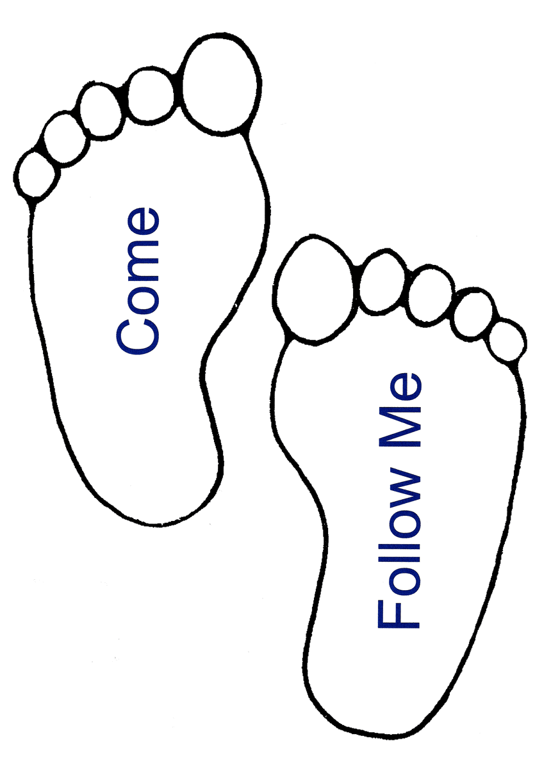
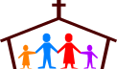
Small Group
Reflection Questions
(Please take time to ponder and pencil in
to prep for this week’s small group session.)

*Icebreaker: This week we’ll be talking about events/people/habits/environments etc. that shape us. What is one thing from childhood that shaped you to who you are today (can be deep or silly)? Explain how it shaped you.

*Reflect on Last Week’s Practice: Prayer How/when did you practice it? What went well? What was a struggle? How did you notice it shaping you?

*What habits do you keep in your daily and weekly life? How might they be shaping you?

*Who are the most important people in your life? What do those relationships look like?

*As you reflect on your own journey, what stories have shaped the way you view the world and where did these stories originate?

This Week’s Practice: Spiritual Formation Audit
-Write out daily routine/evening habits…
-Write about family history and current ppl. in life. *How are these patterns and relationships forming us?
Small Group
Reflection Questions
(Please take time to ponder and pencil in
to prep for this week’s small group session.)

*Icebreaker: This week we’ll be talking about events/people/habits/environments etc. that shape us. What is one thing from childhood that shaped you to who you are today (can be deep or silly)? Explain how it shaped you.

*Reflect on Last Week’s Practice: Prayer How/when did you practice it? What went well? What was a struggle? How did you notice it shaping you?

*What habits do you keep in your daily and weekly life? How might they be shaping you?

*Who are the most important people in your life? What do those relationships look like?

*As you reflect on your own journey, what stories have shaped the way you view the world and where did these stories originate?

This Week’s Practice: Spiritual Formation Audit
-Write out daily routine/evening habits…
-Write about family history and current ppl. in life. *How are these patterns and relationships forming us?
Small Group
Reflection Questions
(Please take time to ponder and pencil in
to prep for this week’s small group session.)

*Icebreaker: This week we’ll be talking about events/people/habits/environments etc. that shape us. What is one thing from childhood that shaped you to who you are today (can be deep or silly)? Explain how it shaped you.

*Reflect on Last Week’s Practice: Prayer How/when did you practice it? What went well? What was a struggle? How did you notice it shaping you?

*What habits do you keep in your daily and weekly life? How might they be shaping you?

*Who are the most important people in your life? What do those relationships look like?

*As you reflect on your own journey, what stories have shaped the way you view the world and where did these stories originate?

This Week’s Practice: Spiritual Formation Audit
-Write out daily routine/evening habits…
-Write about family history and current ppl. in life. *How are these patterns and relationships forming us?

