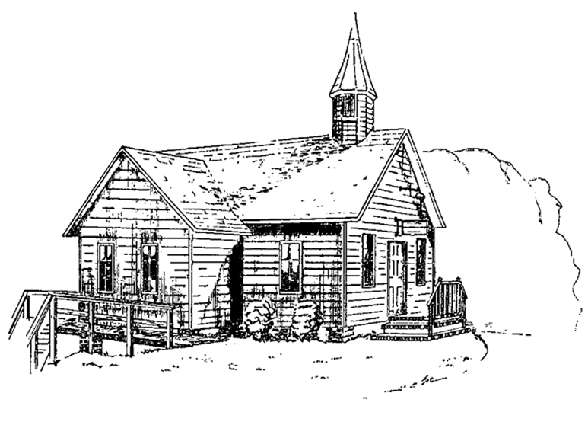
Colington United Methodist Church
September 27, 2026
Eighteenth Sunday after Pentecost

greeting
Grace and peace to you from God our Father and the Lord Jesus Christ.
Amen.
welcome
prelude and lighting of altar candles
opening hymn
How Great Thou Art ǀ UMH 77
confession and pardon ǀ UMH 8
act of praise
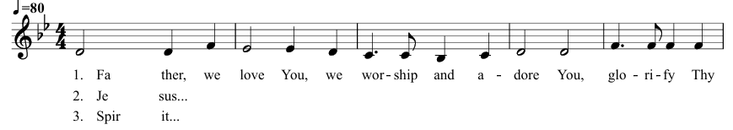
Glorify Thy Name (Green #9 if choir wants parts)

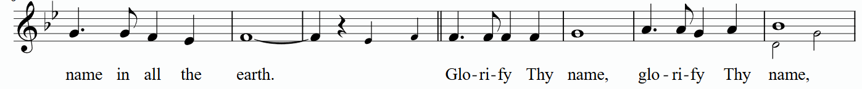

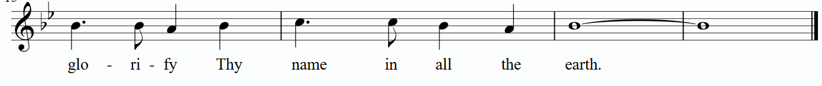

prayers of the people
the first lesson
Philippians 2:1-13
hymn of preparation
Be Still, My Soul ǀ UMH 534
the second lesson
Matthew 21:23-32
sermon
“Let This Mind”
†affirmation of praise
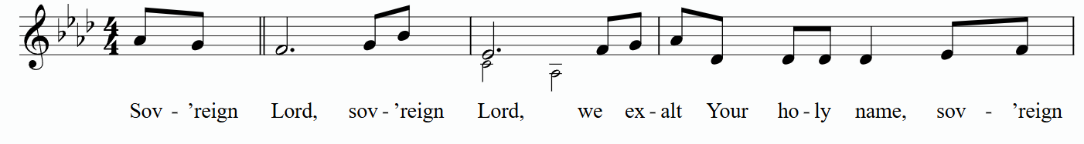
Sovereign Lord

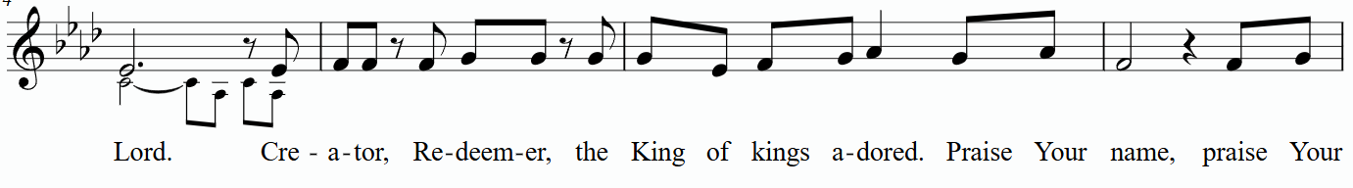

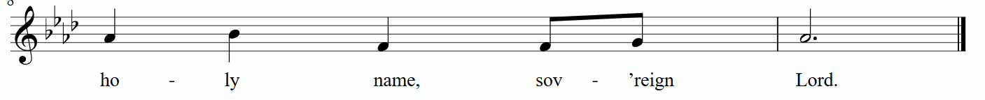

prayer of thanksgiving
All things come from you, O God, and with praise and thanksgiving we return to you what is yours. You created all that is, and with love formed us in your image. When our love failed, your love remained steadfast. You gave your only Son Jesus Christ to be our Savior, that we might have abundant and eternal life. All that we are, and all that we have, is a trust from you. And so, in gratitude for all that you have done, we offer you ourselves, and all that we have, in union with Christ’s offering for us. By your Holy Spirit make us one with Christ, one with each other, and one in
ministry to all the world; through Jesus Christ our Lord. Amen.
†closing hymn
Blessed Assurance ǀ UMH 369
_____________________________________________________________

this week at colington
These opportunities to serve as the Body of Christ are available.
Monday – 8am – Student of the Month at FFES.
Tuesday – 9 am – Prayer Group

coming up
Next Sunday – 8:15 – choir practice
9:30 am – Worship, in-person and Facebook Live -
Wed., Oct. 7 – 12pm – Veterans lunch at Spring Arbor.
Thurs., Oct. 8 – 6pm – Charge Conference at Kitty Hawk UMC.
Wed., Oct.14 – 7:30am – FCA breakfast at FFHS.
10am – Knitters and crocheters meet.
Thurs., Oct. 8 – 4pm – Mobile food pantry at FFES.
Sat., Oct. 10 – 9am – UWF breakfast meeting at church and Zoomed.
Thurs., Oct. 15 – 7:30am – FCA breakfast at FFMS.
Sat., Oct. 17 – 9am – Men’s ministry breakfast.
Wed., Oct. 21 – 10am - Admin. Council meeting.
Sat., Oct. 24 – UWF Annual meeting at Sharon UMC.
Wed., Oct. 28 – 10am Knitters and crocheters meet.
1:45pm – Volunteers to Beach Food Pantry.

Thanks to today’s volunteers!
Ushers – Steve Knowles/ Ozzie Gray/ Wiley Beales
Scripture Reader – Anne Trapani
The flowers on the altar are given by Diana Summerell in memory of Joyce Bell and by Becky Eanet in celebration of her niece Sage’s birthday.

If you would like to make an electronic donation, you may do so using the QR code below


