
THE ANGLICAN PARISH OF ST. MARK
138 Hoylake Road, Qualicum Beach, BC V9K 1K3
The Reverend Diana Boland
Eighteenth Sunday after Pentecost, 10:00 am, September 27, 2026
HOLY EUCHARIST — Liturgy of the Islands & Inlets

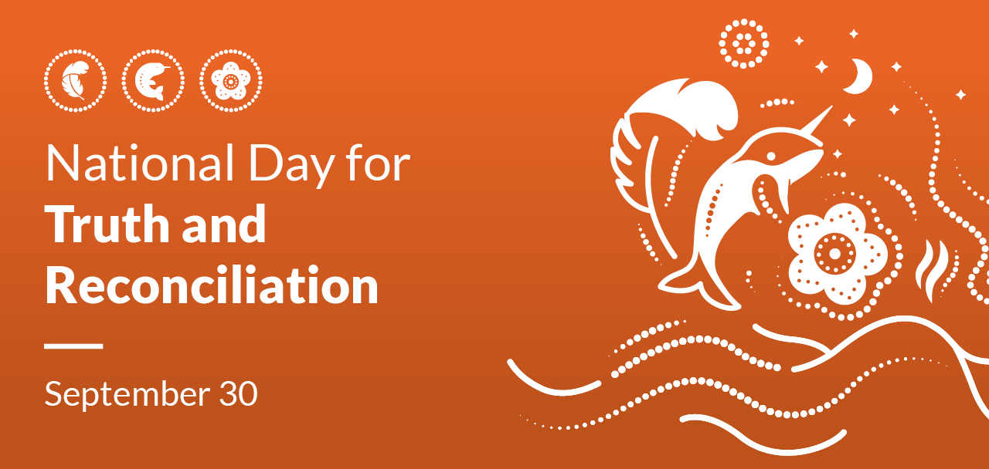
Welcome & Announcements
Acclamation: In this time and place
We gather on the ancestral territories of Kwakwaka'wakw, Nuu-chah-nulth and Coast Salish peoples.
From many places and peoples we come to this house in prayer.
In this time and place
We gather in the name of the living God.
We meet in the presence of Jesus Christ, risen and alive.
In this time and place
We gather with the community of faith around the globe and across the ages
In this time and place heaven and earth are one.
In this time and place
We are not alone, but one in Christ.
Knit together in the unity of the Spirit.
In this time and place
Hallowed, expectant, one people in God.
In the name of the Holy and Blessed One, Creator, Redeemer and Holy Spirit. Amen.
Opening Hymn: CP #465 “Here in This Place New Light”
The Gathering of the Community page 185
Glory to God (sung — music CP #702) page 186
Centering Stillness
Let us hold this moment open to the Spirit of God.
(silence)
Collect of the Day
Gracious God,
You call us to fullness of life:
Deliver us from unbelief
And banish our anxieties
Through the liberating love of Jesus Christ our Saviour. Amen.
The Proclamation of the Word
A Reading from the Hebrew Scriptures: EXODUS 17:1-7
Psalm 78:1-4, 12-16 page 845
A Reading from the New Testament Letters: PHILIPPIANS 2:1-13
Gradual Hymn: CP #418 “Draw the Circle Wide” (vv. 1)
Reader: God be with you
People: And also with you
Reader: The Good News of Jesus according to Matthew
People: Glory to you, Jesus Christ
The Gospel: MATTHEW 21:23-32
Reader: The Gospel of Christ
People: Praise to you, Jesus Christ
Gradual Hymn: CP #418 “Draw the Circle Wide” (vv. 2 & 3)
Sermon: The Rev. Diana Boland
Anthem: “Sweetgrass and Candle” Composer: R. Klusmeier. Words: John Oldham
Tirechan’s (pr. Ti-rec-han’s) Creed, 7th century (from The Patrician Texts of the Book of Armagh AD 670)
Our God is the God of all humans,
the God of heaven and earth,
the God of seas and rivers,
the God of sun and moon,
the God of all heavenly bodies,
the God of the lofty mountains,
the God of the lowly valleys.
God is above all the heavens;
and beneath the heavens.
Heaven and earth and sea,
and everything in them,
such God has as an abode.
God inspires all things
gives life to all things,
stands above all things,
and stands beneath all things.
God enlightens the light of the sun,
strengthens the light of the night and the stars,
makes wells in the arid land and dry islands in the sea,
and places the stars in the service of the greater lights.
And there is the Son who is co-eternal with God,
and similar in all respects
neither is the Son younger nor older;
and the Holy Spirit breathes in them.
And the Father and the Son and the Holy Spirit are inseparable. Amen
The Prayers of the People
Confession
Merciful Lord, your Spirit hovered over the waters where diversity sprouted and flourished. We confess our difficulty to live with legitimate differences. Forgive us those attitudes of mind, words and actions that do violence to unity in diversity.
People: Lord have mercy, Christ have mercy, Lord have mercy.
Merciful Christ, grace and joy of the multitude, listener and teacher, you give birth to new visions of hope and heal the wounds of mind and body. We confess that we have failed to listen to voices different from our own, failed to say words that bring healing and hope, and we have perpetuated exclusive attitudes to those who cry out for solidarity and fellowship.
People: Lord have mercy, Christ have mercy, Lord have mercy.
Merciful Lord, you are the source of all creation, the Eternal and life-giving Word. We confess that we do not listen to your creation that groans and cries out for liberation and renewal. Help us to walk together and to hear your voice in all living things that suffer and yearn for healing and care.
People: Lord have mercy, Christ have mercy, Lord have mercy.
O God, fountain of mercy and grace, pour over us your pardon. May your love transform us into a source of living waters to restore the strength of your people. We make our prayer through Christ our Lord.
People: Amen.
Absolutions: May the God of all healing and forgiveness draw you to himself, and cleanse you from all your sins, that you may behold the glory of his Son, the word made flesh, Jesus Christ our Lord. Amen
The Peace
Offertory Hymn: CP #73 “One Bread, One Body”
Prayer over the Gifts: O God, accept our praise and thanksgiving. Help us in all we do to offer ourselves as a true and living sacrifice, through Jesus Christ the Lord.
The Celebration of the Eucharist

Our Prayer Ministry
Our healing prayer team invites you to join them to pray or give thanks to God in the narthex (entrance) during or after communion, or in the alcove under the Exit sign after the service. Confidentiality is assured.

Eucharistic Prayer A
Priest: God is here
People: The Spirit is with us.
Priest: Lift up your hearts and minds.
People: We lift them to God.
Priest: Let us give thanks to God the Creator.
People: It is right to give our thanks and praise.
Priest: The Lord be with you
People: And also with you
Priest: Lift up your hearts.
People: We lift them to the Lord.
Presider: Let us give thanks to the Lord our God.
People: It is right to give our thanks and praise
Presider: Great Creator, with wit and wisdom you formed the universe.
In expectation, your Spirit brooded over all: the midwife of transformation.
At your Word, the skies, the seas, the lands and all life came to be.
In you, all created things shared life with one another.
In ceremony and song, dance and art, these relationships were portrayed and honoured by the first peoples of these Islands and Inlets.
The plants, the cedars, the creatures of forest, sea and air revealed your wonder and majesty.
When we turned from you, connections were broken and creation suffered.
Still, you continued to bring light from night, freedom from slavery, and life from death.
Therefore, together with our ancestors in faith and with your beloved creation we sing:
Sanctus (Holy, Holy) — (sung - music CP #719)
The Lord’s Prayer — (sung)
Breaking of the Bread
Priest: Creator of all, who summons the salmon from the depths of the seas to yearn for the place of their origin.
People: So may your Spirit stir in our hearts to return and find our home in you.
Post Communion Hymn: CP #94 “Wait For the Lord”
Prayer after Communion (said together)
O God, as we are strengthened in these holy mysteries, may our lives be a continual offering, holy and acceptable in your sight; through Jesus Christ our Lord.
Doxology: Glory to God, whose power… page 214
Final Blessing
Recessional Hymn: CP #572 “Let There Be Light”
Dismissal: Go, respecting and serving all that God has created.
People: For God created all and saw that it was good.

ALTAR FLOWERS
Flowers on the altar today are given are dedicated to Louise Kelsey’s Father, Peter Noel McCowen Welford, born Dec 25th 1914 and died Sept 29th 2013.

EMERGENCY CONTACTS FOR PASTORAL CARE
Morag Atherstone: 250-240-6731
Cynthia Preyser: 250-954-9122

ANNOUNCEMENTS
A warm welcome to all this morning, especially any who are visiting. Please join us for coffee and conversation in the hall following the service. Everyone is welcome!!
Today we are recognizing the National Day for Truth and Reconciliation.
At a Special Vestry Meeting earlier this month, parishioners approved the creation of a new stained-glass window designed by Jesse Recalma to celebrate the Centennial of St. Mark’s. We have begun raising funds to finance this exciting project. To date, approximately $5,000 has been raised through the proceeds from the Quarantones’ concert and donations from parishioners and others in the community. You will find envelopes at the back of the church for contributions toward the Window Project.
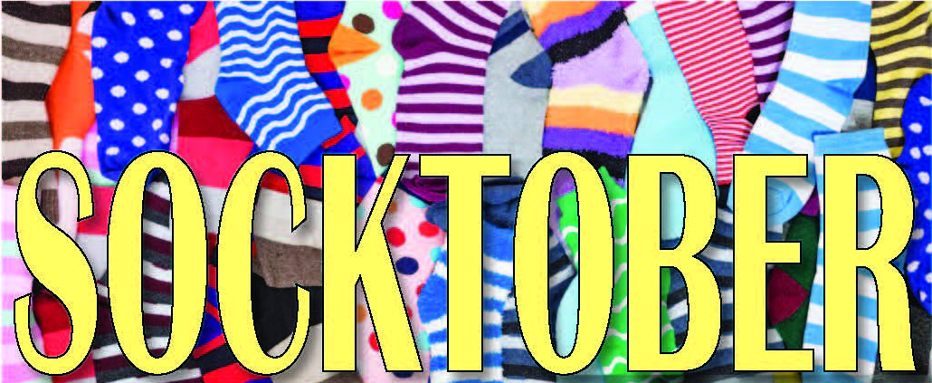
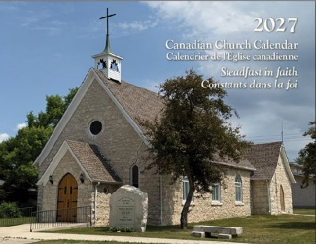
SOCKTOBER begins next Sunday. For 4 weeks we will join with people around the world to collect new socks for our unhoused neighbours. These will then be given to Manna Homeless Society for distribution during the cold, wet months to come. Since St. Mark's folks are so generous we are putting out a laundry hamper rather than a bucket — together we can fill it and give a warm hug to someone who is cold and wet.
CANADIAN CHURCH CALENDARS FOR 2027 are now available for purchase ($10) at the church office (Tues. – Thurs.).

We are still receiving donations toward the Nepal Disaster Response Fund. Enclose cash or cheque (made payable to St. Mark’s Church with “Nepal” on the memo line) in an envelope marked ‘Nepal’ and we will write a combined cheque from St. Mark.
If you need a new name tag, please print your name on the clipboard in the narthex. Wearing your name tag will help us get to know you. We are also trying to update the St. Mark’s Parish Family photo board in the library area of the hall with current photos. Please speak to one of the wardens to arrange to have a photo taken.
Please drop off your ‘rinsed’ empty pop cans, beer cans, wine boxes, liquor bottles and returnable juice and water bottles to help the de Candole’s granddaughters raise funds for attending Innovate School of Dance. The bin is located outside the church hall beside the garbage storage bin. (Or contact Emily at em.med.smith@gmail.com or 250-240-7808 for pick-up.) Thanks.

CALENDAR: September 28 – October 4

Monday, September 28
12:30 – 3:30 pm — Alpine Garden Club

Tuesday, September 29
9:15 – 11:00 am — Men’s Study Group
9:00 am – 3:00 pm — Seaside Quilters
4:00 – 5:00 pm — Handbells

Wednesday, September 30
10:00 – 11:00 am — Sermon Circle
11:30 am – 12:00 pm — Morning Prayer
12:30 – 2:30 pm — The Chosen
5:30 pm — NAC (downstairs)

Thursday, October 1
11:15 am — Choir

Sunday, October 4
8:30 am — BCP — Holy Eucharist
10:00 am — BAS — Holy Eucharist

