Holy Trinity Evangelical Lutheran Church

18^{h} Sunday After Pentecost

September 27, 2026 at 10:30 am

Pastor Tina Crog

*Prelude

* Welcome and Announcements Worship Assistant

*Opening Hymn "God is Here!" ELW 526
One License A-700000

1.God is here! As we your people meet to offer praise and prayer,
may we find in fuller measure what it is in Christ we share.
Here, as in the world around us, all our varied skills and arts wait
the coming of the Spirit into open minds and hearts.

2.Here are symbols to remind us of our lifelong for need of grace; here are table, font, and pulpit; here the cross has central place. Here in honesty of preaching, here in silence, as in speech, here, in newness and renewal, God the Spirit comes to each.

3.Here our children find a welcome in the Shepherd’s flock and
fold; here as bread and wine are taken, Christ sustains us as of old. Here the servants of the Servant seek in worship to
explore what it means in daily living to believe and to adore.

4.Lord of all, of church and kingdom, in an age of change and doubt, keep is faithful to the gospel; help us work your purpose out. Here, in this day’s dedication, all we have to give, receive; we, who cannot live without you, we adore you!
We believe!

* Confession and Forgiveness Pastor Tina
Blessed be the holy Trinity, ☩ one God, who pours love into our hearts and healing upon the earth. Amen.

Confident that God justifies us by grace through faith, let us confess our sin.

Compassionate God, we confess that we struggle to embody your goodness in the world and in our own hearts. Creation groans from overuse. Jealousy and bitterness strain our relationships. Divisions disrupt your call to show genuine love to others. Turn our hearts back to you. Restore our world and reconcile us to one another. Renew us to live as your holy people, following the way of Jesus Christ. Amen.

Hear this good news: We have peace with God through ☩ Jesus Christ, in whom there is no condemnation, but only forgiveness and the promise of eternal life. Receive freely this healing gift of grace. Amen.

* Canticle of Prais “Change My Heart, O God” ELW 801
CCLI-11222261
Change my heart, O God; make it ever true.
Change my heart, O God; may I be like you.
You are the potter; I am the clay,
Mold me and make me; this is what I pray.

*Greeting Pastor Tina

*Prayer of the Day worship Assistant
God of love, giver of life, you know our frailties and failings. Give us your grace to overcome them, keep us from those things that harm us, and guide us in the way of salvation, through Jesus Christ, our Savior and Lord. Amen.

* Passing of the Peace Worship assistant
may the peace of christ be with you always. and also with you.

Share the peace of Christ with one another with a wave.

*Children’s Moment Pastor Tina

*First Lesson: Exodus 17:1-7 Reader
¹ From the wilderness of Sin the whole congregation of the Israelites journeyed by stages, as the Lord commanded. They camped at Rephidim, but there was no water for the people to drink. ² The people quarreled with Moses and said, “Give us water to drink.” Moses said to them, “Why do you quarrel with me? Why do you test the Lord?” ³ But the people thirsted there for water, and the people complained against Moses and said, “Why did you bring us out of Egypt, to kill us and our children and livestock with thirst?” ⁴ So Moses cried out to the Lord, “What shall I do for this people? They are almost ready to stone me.” ⁵ The Lord said to Moses, “Go on ahead of the people and take some of the elders of Israel with you; take in your hand the staff with which you struck the Nile and go. ⁶ I will be standing there in front of you on the rock at Horeb. Strike the rock, and water will come out of it, so that the people may drink.” Moses did so, in the sight of the elders of Israel. ⁷ He called the place Massah and Meribah, because the Israelites quarreled and tested the Lord, saying, “Is the Lord among us or not?”
The Word of the Lord. Thanks be to God.

*Psalm 78:1-4, 12-16 Reader
¹ Give ear, O my people, to my teaching;
incline your ears to the words of my mouth.
² I will open my mouth in a parable;
I will utter dark sayings from of old,
³ things that we have heard and known,
that our ancestors have told us.
⁴ We will not hide them from their children;
we will tell to the coming generation
the glorious deeds of the Lord and his might
and the wonders that he has done.
¹² In the sight of their ancestors he worked marvels
in the land of Egypt, in the fields of Zoan.
¹³ He divided the sea and let them pass through it
and made the waters stand like a heap.
¹⁴ In the daytime he led them with a cloud
and all night long with a fiery light.
¹⁵ He split rocks open in the wilderness
and gave them drink abundantly as from the deep.
¹⁶ He made streams come out of the rock
and caused waters to flow down like rivers.

*Second Lesson: Philippians 2:1-13 Reader
¹ If, then, there is any comfort in Christ, any consolation from love, any partnership in the Spirit, any tender affection and sympathy, ² make my joy complete: be of the same mind, having the same love, being in full accord and of one mind. ³ Do nothing from selfish ambition or empty conceit, but in humility regard others as better than yourselves. ⁴ Let each of you look not to your own interests but to the interests of others. ⁵ Let the same mind be in you that was in Christ Jesus,
⁶ who, though he existed in the form of God,
did not regard equality with God
as something to be grasped,
⁷ but emptied himself,
taking the form of a slave,
assuming human likeness.
And being found in appearance as a human,
⁸ he humbled himself
and became obedient to the point of death—
even death on a cross.
⁹ Therefore God exalted him even more highly
and gave him the name
that is above every other name,
¹⁰ so that at the name given to Jesus
every knee should bend,
in heaven and on earth and under the earth,
¹¹ and every tongue should confess
that Jesus Christ is Lord,
to the glory of God the Father.
¹² Therefore, my beloved, just as you have always obeyed me, not only in my presence but much more now in my absence, work on your own salvation with fear and trembling, ¹³ for it is God who is at work in you, enabling you both to will and to work for his good pleasure.
The Word of the Lord. Thanks be to God.

* Acclamation “Alleluia” ELW pg. 205
Al-le-lu-ia! Lord and Savior: open now your saving word.
Let it burn like fire within us; speak until our hearts are stirred.
AL-le-lu-ia! Lord, we sing for the good news that you bring.

* Gospel: Matthew 21:23-32 Pastor Tina Crog
The Holy Gospel according to Matthew, the 21st chapter. Glory to you, O Lord.
²³ When [Jesus] entered the temple, the chief priests and the elders of the people came to him as he was teaching and said, “By what authority are you doing these things, and who gave you this authority?” ²⁴ Jesus said to them, “I will also ask you one question; if you tell me the answer, then I will also tell you by what authority I do these things. ²⁵ Did the baptism of John come from heaven, or was it of human origin?” And they argued with one another, “If we say, ‘From heaven,’ he will say to us, ‘Why, then, did you not believe him?’ ²⁶ But if we say, ‘Of human origin,’ we are afraid of the crowd, for all regard John as a prophet.” ²⁷ So they answered Jesus, “We do not know.” And he said to them, “Neither will I tell you by what authority I am doing these things.
²⁸ “What do you think? A man had two sons; he went to the first and said, ‘Son, go and work in the vineyard today.’ ²⁹ He answered, ‘I will not,’ but later he changed his mind and went. ³⁰ The father went to the second and said the same, and he answered, ‘I go, sir,’ but he did not go. ³¹ Which of the two did the will of his father?” They said, “The first.” Jesus said to them, “Truly I tell you, the tax collectors and the prostitutes are going into the kingdom of God ahead of you. ³² For John came to you in the way of righteousness, and you did not believe him, but the tax collectors and the prostitutes believed him, and even after you saw it you did not change your minds and believe him.”
The Gospel of the Lord. Praise to you, O Christ.

*Sermon Pastor Tina Crog

* Hymn of the Day "O That the Lord Would Guide My Ways"
ELW 772
Public Domain

1.Oh, that the Lord would guide my ways to keep his statutes still! Oh, that my God would grant me grace to know and do his will!

2.Order my footsteps by your word and make my heart sincere;
let sin have no dominion, Lord, but keep my conscience clear.

3.Assist my soul, too apt to stray, a stricter watch to keep;
and should I e’er forget your way. Restore your wand’ring sheep.

4. Make me to walk in your commands, ‘tis a delightful road;
nor let my head or heart or hands offend against my God.

* Apostle’s Creed Worship Assistant
let us proclaim our faith in the words of the Apostle’s Creed.
I believe in God, the Father almighty,
creator of heaven and earth.
I believe in Jesus Christ, God's only Son, our Lord,
who was conceived by the power of the Holy Spirit,
born of the Virgin Mary,
suffered under Pontius Pilate,
was crucified, died, and was buried;
he descended to the dead.
On the third day he rose again;
he ascended into heaven,
he is seated at the right hand of the Father,
and he will come to judge the living and the dead.
I believe in the Holy Spirit,
the holy catholic Church,
the communion of saints,
the forgiveness of sins,
the resurrection of the body,
and the life everlasting. Amen.

* Prayers of Intercession Be Seated
Pastor Tina Crog
prayer Requests or joys to share
Reminded of God’s gracious and abundant love, we offer our prayers, confident that God hears us.

Center your church in humility as we strive to follow in your way. Help us listen to the cries of those who have been unfairly hurt by the church and dare to name difficult truths. Show all your love. Hear us, O God. Your mercy is great.

You call us to care for your creation. Lead us into your promise of a better world through sustainable practices and respect for your handiwork. Hear us, O God. Your mercy is great.

Inspire all in positions of authority to act honorably. Remind them of their call to use their authority for the sake of the common good. Give them the gift of humility. Hear us, O God. Your mercy is great.

Comfort those who come before you in fear and trembling. Calm troubled hearts with your forgiveness. Help all those in need (especially). Grant us your salvation. Hear us, O God. Your mercy is great.

Change this congregation’s heart when we say no to your call. Open us to courageous learning and service in our community, especially in new or challenging places. Hear us, O God. Your mercy is great.

Your steadfast love holds all the saints who have finished their work and are at rest. As we grieve, remind us of your mercy so we may also give thanks. Hear us, O God. Your mercy is great.

Grant the prayers we have offered, what we have forgotten to ask, and whatever else you see that we need. We ask this in Jesus’ name. Amen.

*Offering Worship assistant
The monthly mission for September is “Faith in Action.” Let us give to God what he has first given us.

*Offering Music by Jared

*Offering Hymn “This is Christ’s Body” ACS 967
One License A-700000

* Offering Prayer Worship assistant and congregation
God of creation, you send rain and the earth springs forth abundantly. All blessings are from you; make us generous with what we have. Use our gifts, our abilities, and our hearts in service to you and in love to our neighbors, today and always. Amen.

*The Great Thanksgiving (spoken) Pastor Tina
The Lord be with you.
And also with you.
Lift up your hearts,
We lift them to the Lord.
Let us give thanks to the Lord, our God.
It is right to give God our thanks and praise.

* Preface

*Holy, Holy, Holy ELW pg. 207
Holy, holy, holy Lord, God of power and might, heaven and earth are full of your glory. Hosanna in the highest. Blessed is he who comes in the name of the Lord. Hosana in the highest, hosanna in the highest.

* Eucharistic Prayer and Words of Institution

* Lord’s Prayer ELW pg 208
Our Father, who art in Heaven, hallowed be thy name, Thy kingdom come, Thy will be done, on earth as it is in heaven.
Give us this day our daily bread, and forgive us our trespasses,
as we forgive those who trespass against us; and lead us not into temptation, but deliver us from evil. For thine is the kingdom, and the power, and the glory, forever and ever. Amen.
*Lamb of God ELW pg. 208
1. O Lamb of God, you bear the sin of all the world away;
you suffered death our lives to save: have mercy now, we pray.

2.O Lamb of God, you bear the sin of all the world away;
you set us free from guilt and grave: have mercy now, we pray.

3. O Lamb of God, you bear the sin of all the world away;
eternal peace with God you made: give us your peace, we pray.

*Special Music by Jared

*Post Communion Blessing Pastor Tina

* Post Communion Hymn "Glory to God, Whose Goodness Shines" ACS 1087
One License A-700000
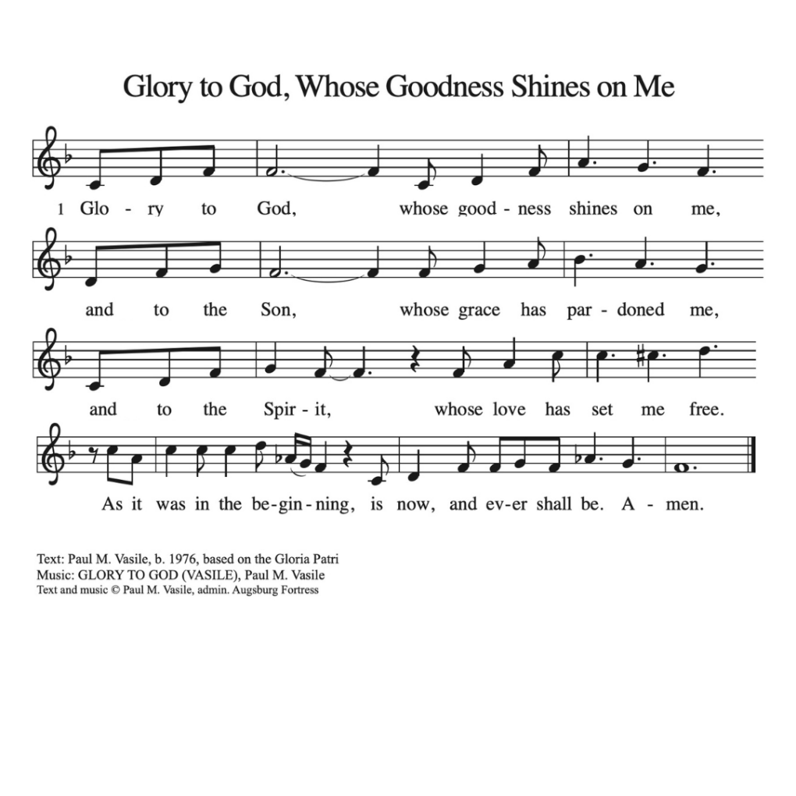

* Prayer After Communion Pastor Tina and Congregation
Sustaining God, with this bread and cup, you nourish us with mercy and abundant life. By your Spirit, send us from this table to serve a needy world. Make us living signs of your liberation, healing, and love, following the way of Jesus, in whose name we pray. Amen.

* Blessing Pastor Tina

* Closing Hymn "O Master, Let Me Walk with You" ELW 818
Public Domain

1.O Master, let me walk with you in lowly paths of service true;
tell me your secret; help me hear the strain of toil, the fret of care.

2.Help me the slow of heart to move by some clear, winning word of love; teach me the wayward feet to stay, and guide them in the homeward way.

3.Teach me your patience, share with me a closer, dearer company, in work that keeps faith sweet and strong, in trust that
triumphs over wrong.

4. In hope that sends a shining ray far down the future’s broad’ning way, in peace that only you can give; with you, O
Master, let me live.

* Dismissal Worship Assistant
Go out in joy. Be led forth in peace. Thanks be to God!

*Postlude

