

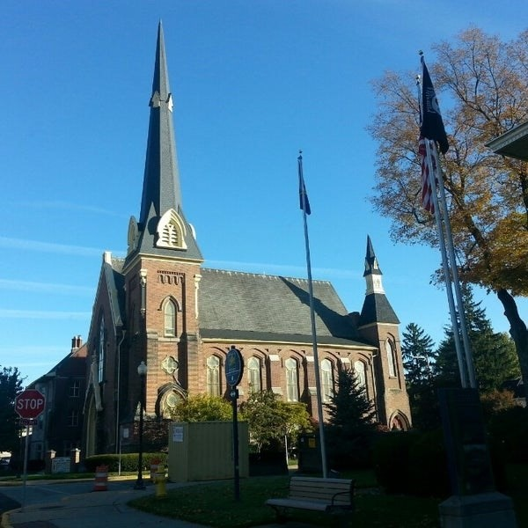
September 23,2026

A Global Methodist Church
214 S. 5th Street
Goshen, IN 46528
Phone: 574-533-9518
Web Site: goshenfirstgmc.org

Office Hours: Monday-Thursday,
8:00 a.m.-1:00 p.m.
Worship: 9:00 a.m.
Sunday School: 10:30 a.m.
Pastor Jeff & Lisa
Associate Pastor Rich Hull
OUR VISION: “Growing in Faith, Gathering in Community, and Giving in Love”.

Gerald Humerickhouse Arrangements
Visitation is Sunday September 27th at Yoder Culp from 1-5pm. Visitation is also Monday at Goshen First at 10:00am with the funeral at 11:00am.
Grief Share
Grief Share is meeting from 6pm to 7pm at the church and will continue through November 11th. Sue Wirt is leading the class. If you plan on attending the class please contact Sue at 574-238-2894.

Come join us for Wednesday Night Church!!! The meal starts at 5:30p.m. and classes start at 6:00p.m. Choir at 7:00p.m. Exciting things happening here, don’t miss out!!
The Missions Committee will be hosting a work day at The Post, 301 E. Lincoln Avenue in Goshen, on Tuesday, October 20th. The Post is a Christ centered after school youth program. They would appreciate our help with cleaning, organizing, painting, and yard work. There will be two work peroids, from 9:30a.m- 11:30a.m. and noon- 2p.m. People from both groups are invited to bring their own lunch from 11:30-noon while the Executive Director, Christy Matthews, speaks to us about the kids and programming of the Post. Please sign up for this local mission opportunity in the gym after worship, beginning on 10-4. Or contact Linda Russell at 574-238-2084.
The Newsletter will be bi-monthly starting in October. It will go out the first Wednesday and third Wednesday of the month.

VOLUNTEERS – Thank you for your service - Sunday morning, September 27
Greeters: Mateo & Rachel Tenorio Family VIP: Patty Krebs
Elevator Hosts: Dan and Brenda Becker
Ushers: Randy Cripe, Pam Lichty, Dan Seltenright, Mateo Tenorio, Williston Tenorio
Scripture Reader: Ken Smith
Elementary Junior Church: Patty, Karen & Marcia
Junior High Church: Loraine Troyer
Coffee Hour: Faith Weavers
Bus Driver: Al Eppert
Be sure to join us for worship at 9 a.m. in the sanctuary or on Facebook.



