

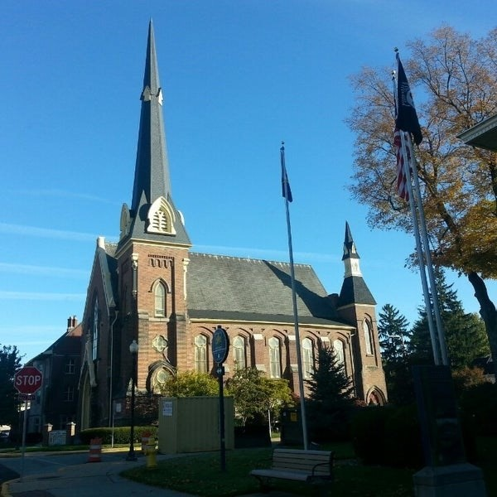
August 26, 2026

A Global Methodist Church
214 S. 5th Street
Goshen, IN 46528
Phone: 574-533-9518
Web Site: goshenfirstgmc.org

Office Hours: Monday-Thursday,
8:00 a.m.-1:00 p.m.
Worship: 9:00 a.m.
Sunday School: 10:30 a.m.
Pastor Jeff & Lisa
Associate Pastor Rich Hull
OUR VISION: “Growing in Faith, Gathering in Community, and Giving in Love”.

Grief Share
Grief Share will start on August 12th from 6pm to 7pm at the church and will continue through November 11th. Sue Wirt will be leading the class. If you plan on attending the class please contact Sue at 574-238-2894.

The Monday morning Bible Study continues to meet this summer. They are
studying the book, “Knowing God,” by J.I. Packer. All are welcome.

Waterford School wants to thank you for all of your generosity in providing granola bars, staff lunch and umbrellas. They appreciate your kindness.

The office will be closed on September 7th for Labor Day.

SHRED 60 Class
Shred 60 class will start back up August 13th -Every Tuesday and Thursday from
9- 9:45am here at the church in the gym.
Walking/ Piyo Class will start August 17th from 10:45-11:45am on Mondays. We will meet outside at different parks/ locations in Goshen. We will meet in the church gym if it is raining. If you have any questions contact Mindi Swihart
574-370-3172.

VOLUNTEERS – Thank you for your service - Sunday morning, August 23rd
Greeters: Sandy Priem, Sharon Hull VIP: Kelley Leeper
Elevator Hosts: Terry & Karen Andrews
Ushers: Chuck Rink, Max Leatherman, Kent Evans, Mary Ann Eash, Carter Martin
Scripture Reader: Ann Stutsman
Elementary Junior Church: Patty Krebs, Lori Warner
Junior High Church:
Coffee Hour: Ben’s / Twigbenders/ Bob’s SS Class
Bus Driver: Steve Warner



